**Introduction to Request Dispatcher**

**RequestDispatcher** is an interface, implementation of which defines an object which can dispatch request to any resources(such as HTML, Image, JSP, Servlet) on the server.

**Methods of RequestDispatcher**

**RequestDispatcher** interface provides two important methods

|  |  |
| --- | --- |
| **Methods** | **Description** |
| void forward(ServletRequest request, ServletResponse response) | forwards a request from a servlet to another resource (servlet, JSP file, or HTML file) on the server |
| void include(ServletRequest request, ServletResponse response) | includes the content of a resource (servlet, JSP page, HTML file) in the response |

**How to get an Object of RequestDispatcher**

getRequestDispatcher() method of **ServletRequest** returns the object of **RequestDispatcher**.

RequestDispatcher *rs* = request.**getRequestDispatcher**("hello.html");

rs.**forward**(request,response);

**OR**

RequestDispatcher *rs* = request.**getRequestDispatcher**("hello.html");

rs.**include**(request,response);

**Example demonstrating usage of RequestDispatcher**

In this example, we will show you how RequestDispatcher is used to **forward** or **include** response of a resource in a Servlet. Here we are using **index.html** to get username and password from the user, **Validate** Servlet will validate the password entered by the user, if the user has entered "studytonight" as password, then he will be forwarded to **Welcome** Servlet else the user will stay on the index.html page and an error message will be displayed.

**Files to be created :**

* **index.html** will have form fields to get user information.
* **Validate.java** will validate the data entered by the user.
* **Welcome.java** will be the welcome page.
* **web.xml** , the deployment descriptor.

**index.html**

<form method="**post**" action="**Validate**">

Name:<input type="text" name="user" /><br/>

Password:<input type="password" name="pass" ><br/>

<input type="submit" value="submit">

</form>

**Validate.java**

import java.io.*;

import javax.servlet.*;

import javax.servlet.http.*;

public class *Validate* **extends** HttpServlet {

protected void **doPost**(HttpServletRequest request, HttpServletResponse response)

throws ServletException, IOException {

response.setContentType("text/html;charset=UTF-8");

PrintWriter out = response.getWriter();

try {

String **name** = request.getParameter("user");

String **password** = request.getParameter("pass");

if(**password**.equals("studytonight"))

{

RequestDispatcher *rd* = request.**getRequestDispatcher**("Welcome");

rd.**forward**(request, response);

}

else

{

out.println("<font color='red'><b>You have entered incorrect password</b></font>");

RequestDispatcher *rd* = request.**getRequestDispatcher**("index.html");

rd.**include**(request, response);

}

}finally {

out.close();

}

}

}

**Welcome.java**

import java.io.*;

import javax.servlet.*;

import javax.servlet.http.*;

public class *Welcome* **extends** HttpServlet {

protected void **doPost**(HttpServletRequest request, HttpServletResponse response)

throws ServletException, IOException {

response.setContentType("text/html;charset=UTF-8");

PrintWriter **out** = response.getWriter();

try {

out.println("<h2>Welcome user</h2>");

} finally {

out.close();

}

}

}

**web.xml**

<web-app>

<servlet>

<servlet-name>Validate</servlet-name>

<servlet-class>Validate</servlet-class>

</servlet>

<servlet>

<servlet-name>Welcome</servlet-name>

<servlet-class>Welcome</servlet-class>

</servlet>

<servlet-mapping>

<servlet-name>Validate</servlet-name>

<url-pattern>/Validate</url-pattern>

</servlet-mapping>

<servlet-mapping>

<servlet-name>Welcome</servlet-name>

<url-pattern>/Welcome</url-pattern>

</servlet-mapping>

<welcome-file-list>

<welcome-file>index.html</welcome-file>

</welcome-file-list>

</web-app>

This will be the first screen. You can enter your Username and Password here.

When you click on Submit, Password will be validated, if it is not 'studytonight' , error message will be displayed.

Enter any Username, but enter 'studytonight' as password.

Password will be successfully validated and you will be directed to the Welcome Servlet.

# Life Cycle of a Servlet (Servlet Life Cycle)

1. [Life Cycle of a Servlet](http://www.javatpoint.com/life-cycle-of-a-servlet)
   1. [Servlet class is loaded](http://www.javatpoint.com/life-cycle-of-a-servlet#servletlifecycle1)
   2. [Servlet instance is created](http://www.javatpoint.com/life-cycle-of-a-servlet#servletlifecycle2)
   3. [init method is invoked](http://www.javatpoint.com/life-cycle-of-a-servlet#servletlifecycle3)
   4. [service method is invoked](http://www.javatpoint.com/life-cycle-of-a-servlet#servletlifecycle4)
   5. [destroy method is invoked](http://www.javatpoint.com/life-cycle-of-a-servlet#servletlifecycle5)

The web container maintains the life cycle of a servlet instance. Let's see the life cycle of the servlet:

1. Servlet class is loaded.
2. Servlet instance is created.
3. init method is invoked.
4. service method is invoked.
5. destroy method is invoked.

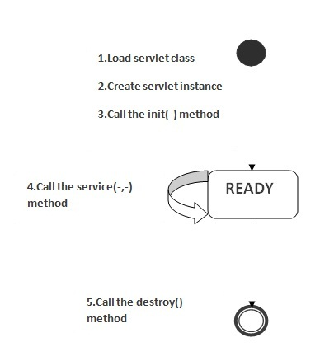

As displayed in the above diagram, there are three states of a servlet: new, ready and end. The servlet is in new state if servlet instance is created. After invoking the init() method, Servlet comes in the ready state. In the ready state, servlet performs all the tasks. When the web container invokes the destroy() method, it shifts to the end state.

### 1) Servlet class is loaded

The classloader is responsible to load the servlet class. The servlet class is loaded when the first request for the servlet is received by the web container.

### 2) Servlet instance is created

The web container creates the instance of a servlet after loading the servlet class. The servlet instance is created only once in the servlet life cycle.

### 3) init method is invoked

|  |
| --- |
| The web container calls the init method only once after creating the servlet instance. The init method is used to initialize the servlet. It is the life cycle method of the javax.servlet.Servlet interface. Syntax of the init method is given below: |

[copy to clipboard](http://www.javatpoint.com/life-cycle-of-a-servlet)

1. public void init(ServletConfig config) throws ServletException



### 4) service method is invoked

The web container calls the service method each time when request for the servlet is received. If servlet is not initialized, it follows the first three steps as described above then calls the service method. If servlet is initialized, it calls the service method. Notice that servlet is initialized only once. The syntax of the service method of the Servlet interface is given below:

[copy to clipboard](http://www.javatpoint.com/life-cycle-of-a-servlet)

1. public void service(ServletRequest request, ServletResponse response)
2. throws ServletException, IOException



### 5) destroy method is invoked

The web container calls the destroy method before removing the servlet instance from the service. It gives the servlet an opportunity to clean up any resource for example memory, thread etc. The syntax of the destroy method of the Servlet interface is given below:

[copy to clipboard](http://www.javatpoint.com/life-cycle-of-a-servlet)

1. public void destroy()

# Steps to create a servlet example

1. [Steps to create the servlet using Tomcat server](http://www.javatpoint.com/steps-to-create-a-servlet-using-tomcat-server)
   1. [Create a directory structure](http://www.javatpoint.com/steps-to-create-a-servlet-using-tomcat-server#servletstep1)
   2. [Create a Servlet](http://www.javatpoint.com/steps-to-create-a-servlet-using-tomcat-server#servletstep2)
   3. [Compile the Servlet](http://www.javatpoint.com/steps-to-create-a-servlet-using-tomcat-server#servletstep3)
   4. [Create a deployment descriptor](http://www.javatpoint.com/steps-to-create-a-servlet-using-tomcat-server#servletstep4)
   5. [Start the server and deploy the application](http://www.javatpoint.com/steps-to-create-a-servlet-using-tomcat-server#servletstep5)

There are given 6 steps to create a **servlet example**. These steps are required for all the servers.

The servlet example can be created by three ways:

1. By implementing Servlet interface,
2. By inheriting GenericServlet class, (or)
3. By inheriting HttpServlet class

The mostly used approach is by extending HttpServlet because it provides http request specific method such as doGet(), doPost(), doHead() etc.

Here, we are going to use **apache tomcat server** in this example. The steps are as follows:

1. Create a directory structure
2. Create a Servlet
3. Compile the Servlet
4. Create a deployment descriptor
5. Start the server and deploy the project
6. Access the servlet

[download this example of servlet](http://www.javatpoint.com/src/servlet/firstservlet.zip)  
[download example of servlet by extending GenericServlet](http://www.javatpoint.com/src/servlet/genericexample.zip)  
[download example of servlet by implementing Servlet interface](http://www.javatpoint.com/src/servlet/servletexample.zip)

### 1)Create a directory structures

The **directory structure** defines that where to put the different types of files so that web container may get the information and respond to the client.

The Sun Microsystem defines a unique standard to be followed by all the server vendors. Let's see the directory structure that must be followed to create the servlet.

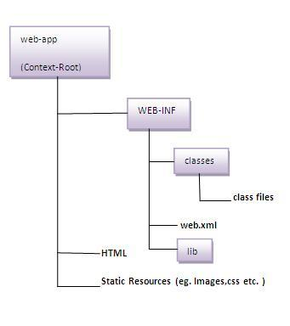

As you can see that the servlet class file must be in the classes folder. The web.xml file must be under the WEB-INF folder.

### 2)Create a Servlet

|  |
| --- |
| There are three ways to create the servlet.   1. By implementing the Servlet interface 2. By inheriting the GenericServlet class 3. By inheriting the HttpServlet class   The HttpServlet class is widely used to create the servlet because it provides methods to handle http requests such as doGet(), doPost, doHead() etc. |
| In this example we are going to create a servlet that extends the HttpServlet class. In this example, we are inheriting the HttpServlet class and providing the implementation of the doGet() method. Notice that get request is the default request. |

**DemoServlet.java**

[copy to clipboard](http://www.javatpoint.com/steps-to-create-a-servlet-using-tomcat-server)

1. import javax.servlet.http.*;
2. import javax.servlet.*;
3. import java.io.*;
4. public class DemoServlet extends HttpServlet{
5. public void doGet(HttpServletRequest req,HttpServletResponse res)
6. throws ServletException,IOException
7. {
8. res.setContentType("text/html");//setting the content type
9. PrintWriter pw=res.getWriter();//get the stream to write the data
11. //writing html in the stream
12. pw.println("<html><body>");
13. pw.println("Welcome to servlet");
14. pw.println("</body></html>");
16. pw.close();//closing the stream
17. }}



### 3)Compile the servlet

For compiling the Servlet, jar file is required to be loaded. Different Servers provide different jar files:

|  |  |
| --- | --- |
| **Jar file** | **Server** |
| 1) servlet-api.jar | Apache Tomcat |
| 2) weblogic.jar | Weblogic |
| 3) javaee.jar | Glassfish |
| 4) javaee.jar | JBoss |

### Two ways to load the jar file

1. set classpath
2. paste the jar file in JRE/lib/ext folder

Put the java file in any folder. After compiling the java file, paste the class file of servlet in **WEB-INF/classes** directory.

### 4)Create the deployment descriptor (web.xml file)

The **deployment descriptor** is an xml file, from which Web Container gets the information about the servet to be invoked.

The web container uses the Parser to get the information from the web.xml file. There are many xml parsers such as SAX, DOM and Pull.

There are many elements in the web.xml file. Here is given some necessary elements to run the simple servlet program.

**web.xml file**

[copy to clipboard](http://www.javatpoint.com/steps-to-create-a-servlet-using-tomcat-server)

1. <web-app>
3. <servlet>
4. <servlet-name>sonoojaiswal</servlet-name>
5. <servlet-class>DemoServlet</servlet-class>
6. </servlet>
8. <servlet-mapping>
9. <servlet-name>sonoojaiswal</servlet-name>
10. <url-pattern>/welcome</url-pattern>
11. </servlet-mapping>
13. </web-app>



### Description of the elements of web.xml file

There are too many elements in the web.xml file. Here is the illustration of some elements that is used in the above web.xml file. The elements are as follows:

|  |
| --- |
| **<web-app>** represents the whole application. |
| **<servlet>** is sub element of <web-app> and represents the servlet. |
| **<servlet-name>** is sub element of <servlet> represents the name of the servlet. |
| **<servlet-class>** is sub element of <servlet> represents the class of the servlet. |
| **<servlet-mapping>** is sub element of <web-app>. It is used to map the servlet. |
| **<url-pattern>** is sub element of <servlet-mapping>. This pattern is used at client side to invoke the servlet. |

### 5)Start the Server and deploy the project

To start Apache Tomcat server, double click on the startup.bat file under apache-tomcat/bin directory.

### One Time Configuration for Apache Tomcat Server

You need to perform 2 tasks:

1. set JAVA_HOME or JRE_HOME in environment variable (It is required to start server).
2. Change the port number of tomcat (optional). It is required if another server is running on same port (8080).

#### 1) How to set JAVA_HOME in environment variable?

To start Apache Tomcat server JAVA_HOME and JRE_HOME must be set in Environment variables.

Go to My Computer properties -> Click on advanced tab then environment variables -> Click on the new tab of user variable -> Write JAVA_HOME in variable name and paste the path of jdk folder in variable value -> ok -> ok -> ok.

Go to My Computer properties:



Click on advanced system settings tab then environment variables:

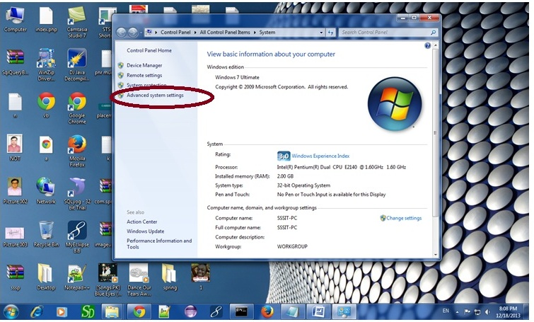

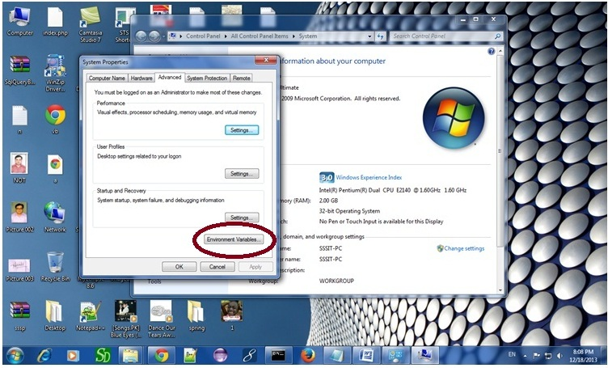

Click on the new tab of user variable or system variable:

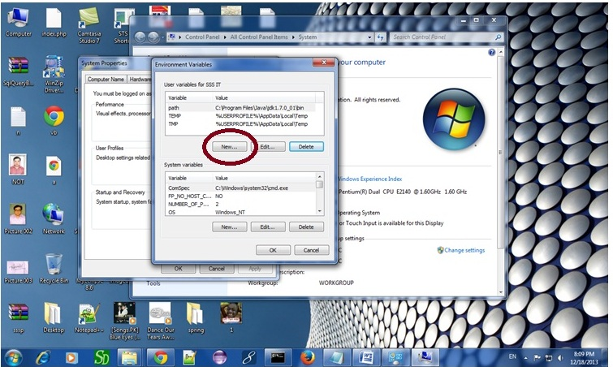

Write JAVA_HOME in variable name and paste the path of jdk folder in variable value:

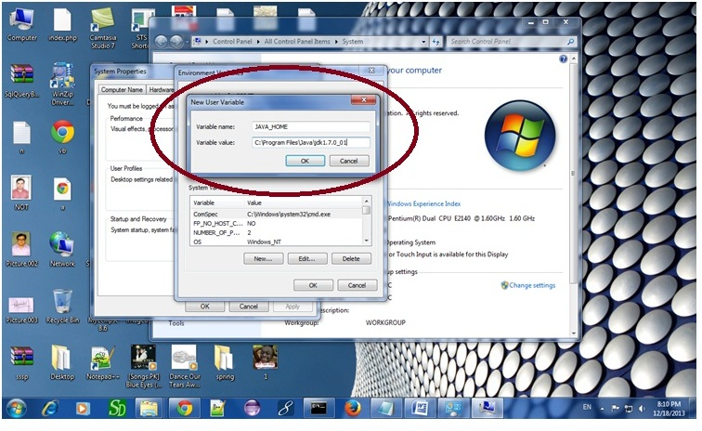

There must not be semicolon (;) at the end of the path.

|  |
| --- |
| After setting the JAVA_HOME double click on the startup.bat file in apache tomcat/bin. |
| Note: There are two types of tomcat available:   1. Apache tomcat that needs to extract only (no need to install) 2. Apache tomcat that needs to install |
| It is the example of apache tomcat that needs to extract only. |

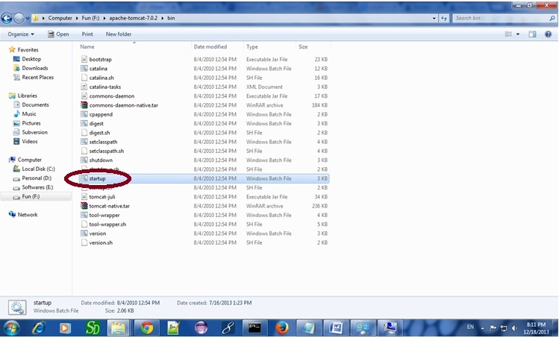

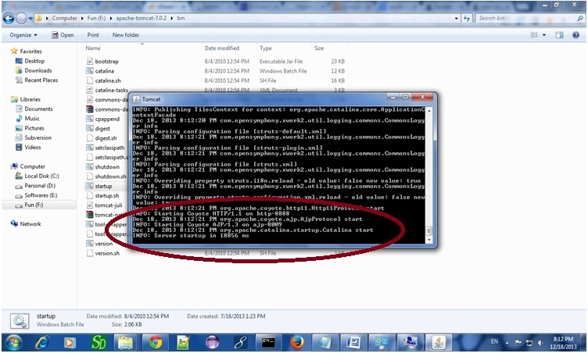

Now server is started successfully.

### 2) How to change port number of apache tomcat

Changing the port number is required if there is another server running on the same system with same port number.Suppose you have installed oracle, you need to change the port number of apache tomcat because both have the default port number 8080.

Open **server.xml file** in notepad. It is located inside the **apache-tomcat/conf** directory . Change the Connector port = 8080 and replace 8080 by any four digit number instead of 8080. Let us replace it by 9999 and save this file.

### 5) How to deploy the servlet project

Copy the project and paste it in the webapps folder under apache tomcat.

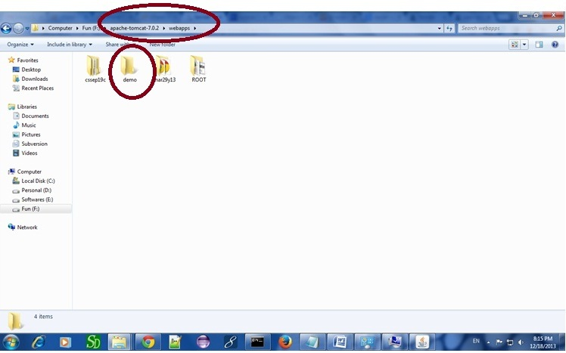

But there are several ways to deploy the project. They are as follows:

* By copying the context(project) folder into the webapps directory
* By copying the war folder into the webapps directory
* By selecting the folder path from the server
* By selecting the war file from the server

Here, we are using the first approach.

You can also create war file, and paste it inside the webapps directory. To do so, you need to use jar tool to create the war file. Go inside the project directory (before the WEB-INF), then write:

[copy to clipboard](http://www.javatpoint.com/steps-to-create-a-servlet-using-tomcat-server)

1. projectfolder> jar cvf myproject.war *



Creating war file has an advantage that moving the project from one location to another takes less time.

### 6) How to access the servlet

Open broser and write http://hostname:portno/contextroot/urlpatternofservlet. For example:

[copy to clipboard](http://www.javatpoint.com/steps-to-create-a-servlet-using-tomcat-server)

1. http://localhost:9999/demo/welcome



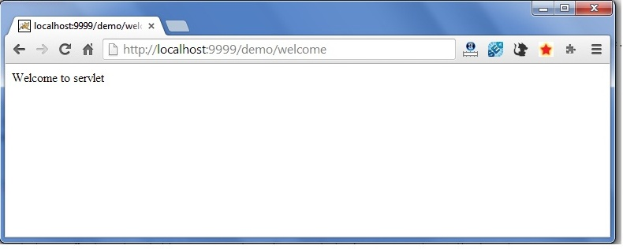

[download this example of servlet (using notepad)](http://www.javatpoint.com/src/servlet/firstservlet.zip)  
[download example of servlet by extending GenericServlet](http://www.javatpoint.com/src/servlet/genericexample.zip)  
[download example of servlet by implementing Servlet interface](http://www.javatpoint.com/src/servlet/servletexample.zip)

# How Servlet works?

It is important to learn how servlet works for understanding the servlet well. Here, we are going to get the internal detail about the first servlet program.

The server checks if the servlet is requested **for the first time**.

**If yes,** web container does the following tasks:

* loads the servlet class.
* instantiates the servlet class.
* calls the init method passing the ServletConfig object

**else**

* calls the service method passing request and response objects

The web container calls the destroy method when it needs to remove the servlet such as at time of stopping server or undeploying the project.

### How web container handles the servlet request?

The web container is responsible to handle the request. Let's see how it handles the request.

* maps the request with the servlet in the web.xml file.
* creates request and response objects for this request
* calls the service method on the thread
* The public service method internally calls the protected service method
* The protected service method calls the doGet method depending on the type of request.
* The doGet method generates the response and it is passed to the client.
* After sending the response, the web container deletes the request and response objects. The thread is contained in the thread pool or deleted depends on the server implementation.

### What is written inside the public service method?

The public service method converts the ServletRequest object into the HttpServletRequest type and ServletResponse object into the HttpServletResponse type. Then, calls the service method passing these objects. Let's see the internal code:

[copy to clipboard](http://www.javatpoint.com/how-servlet-works)

1. public void service(ServletRequest req, ServletResponse res)
2. throws ServletException, IOException
3. {
4. HttpServletRequest request;
5. HttpServletResponse response;
6. try
7. {
8. request = (HttpServletRequest)req;
9. response = (HttpServletResponse)res;
10. }
11. catch(ClassCastException e)
12. {
13. throw new ServletException("non-HTTP request or response");
14. }
15. service(request, response);
16. }



### What is written inside the protected service method?

The protected service method checks the type of request, if request type is get, it calls doGet method, if request type is post, it calls doPost method, so on. Let's see the internal code:

[copy to clipboard](http://www.javatpoint.com/how-servlet-works)

1. protected void service(HttpServletRequest req, HttpServletResponse resp)
2. throws ServletException, IOException
3. {
4. String method = req.getMethod();
5. if(method.equals("GET"))
6. {
7. long lastModified = getLastModified(req);
8. if(lastModified == -1L)
9. {
10. doGet(req, resp);
11. }
12. ....
13. //rest of the code
14. }
15. }

# War File

A **war (web archive) File** contains files of a web project. It may have servlet, xml, jsp, image, html, css, js etc. files.

Here, we will discuss what is war file, how to create war file, how to deploy war file and how to extract war file.

## What is war file?

web archive (war) file contains all the contents of a web application. It reduces the time duration for transferring file.

## Advantage of war file

**saves time**: The war file combines all the files into a single unit. So it takes less time while transferring file from client to server.

## How to create war file?

To create war file, you need to use **jar tool** of JDK. You need to use **-c** switch of jar, to create the war file.

Go inside the project directory of your project (outside the WEB-INF), then write the following command:

[copy to clipboard](http://www.javatpoint.com/war-file)

1. jar -cvf projectname.war *



Here, **-c** is used to create file, **-v** to generate the verbose output and **-f** to specify the arhive file name.

The **\* (asterisk) symbol** signifies that all the files of this directory (including sub directory).

## How to deploy the war file?

There are two ways to deploy the war file.

1. By server console panel
2. By manually having the war file in specific folder of server.

If you want to deploy the war file in **apache tomcat** server manually, go to the **webapps** directory of apache tomcat and paste the war file here.

Now, you are able to access the web project through browser.

#### *Note: server will extract the war file internally.*

## How to extract war file manually?

To extract the war file, you need to use **-x switch** of **jar tool** of JDK. Let's see the command to extract the war file.

[copy to clipboard](http://www.javatpoint.com/war-file)

1. jar -xvf projectname.war

# welcome-file-list in web.xml

The **welcome-file-list** element of **web-app**, is used to define a list of welcome files. Its sub element is **welcome-file** that is used to define the welcome file.

A **welcome file** is the file that is invoked automatically by the server, if you don't specify any file name.

By default server looks for the welcome file in following order:

1. welcome-file-list in web.xml
2. index.html
3. index.htm
4. index.jsp

If none of these files are found, server renders 404 error.

If you have specified welcome-file in web.xml, and all the files index.html, index.htm and index.jsp exists, priority goes to welcome-file.

If welcome-file-list entry doesn't exist in web.xml file, priority goes to index.html file then index.htm and at last index.jsp file.

Let's see the web.xml file that defines the welcome files.

*web.xml*

[copy to clipboard](http://www.javatpoint.com/welcome-file-list)

1. <web-app>
2. ....
4. <welcome-file-list>
5. <welcome-file>home.html</welcome-file>
6. <welcome-file>default.html</welcome-file>
7. </welcome-file-list>
8. </web-app>



Now, home.html and default.html will be the welcome files.

If you have the welcome file, you can directory invoke the project as given below:

[copy to clipboard](http://www.javatpoint.com/welcome-file-list)

1. http://localhost:8888/myproject



As you can see, we have not specified any file name after the project.

# load on startup in web.xml

The **load-on-startup** element of **web-app** loads the servlet at the time of deployment or server start if value is positive. It is also known as **pre initialization of servlet**.

You can pass positive and negative value for the servlet.

#### Advantage of load-on-startup element

As you know well, servlet is loaded at first request. That means it consumes more time at first request. If you specify the load-on-startup in web.xml, servlet will be loaded at project deployment time or server start. So, it will take **less time** for responding to first request.

#### Passing positive value

If you pass the positive value, the lower integer value servlet will be loaded before the higher integer value servlet. In other words, container loads the servlets in ascending integer value. The 0 value will be loaded first then 1, 2, 3 and so on.

Let's try to understand it by the example given below:

*web.xml*

[copy to clipboard](http://www.javatpoint.com/load-on-startup)

1. <web-app>
2. ....
4. <servlet>
5. <servlet-name>servlet1</servlet-name>
6. <servlet-class>com.javatpoint.FirstServlet</servlet-class>
7. <load-on-startup>0</load-on-startup>
8. </servlet>
10. <servlet>
11. <servlet-name>servlet2</servlet-name>
12. <servlet-class>com.javatpoint.SecondServlet</servlet-class>
13. <load-on-startup>1</load-on-startup>
14. </servlet>
16. ...
17. </web-app>



There are defined 2 servlets, both servlets will be loaded at the time of project deployment or server start. But, servlet1 will be loaded first then servlet2.

#### Passing negative value

If you pass the negative value, servlet will be loaded at request time, at first request.

# RequestDispatcher in Servlet

1. [RequestDispatcher Interface](http://www.javatpoint.com/requestdispatcher-in-servlet)
2. [Methods of RequestDispatcher interface](http://www.javatpoint.com/requestdispatcher-in-servlet#rdmethod)
   1. [forward method](http://www.javatpoint.com/requestdispatcher-in-servlet#rdforward)
   2. [include method](http://www.javatpoint.com/requestdispatcher-in-servlet#rdinclude)
3. [How to get the object of RequestDispatcher](http://www.javatpoint.com/requestdispatcher-in-servlet#rdhow)
4. [Example of RequestDispatcher interface](http://www.javatpoint.com/requestdispatcher-in-servlet#rdex)

The RequestDispatcher interface provides the facility of dispatching the request to another resource it may be html, servlet or jsp. This interface can also be used to include the content of another resource also. It is one of the way of servlet collaboration.

There are two methods defined in the RequestDispatcher interface.

### Methods of RequestDispatcher interface

The RequestDispatcher interface provides two methods. They are:

1. **public void forward(ServletRequest request,ServletResponse response)throws ServletException,java.io.IOException:**Forwards a request from a servlet to another resource (servlet, JSP file, or HTML file) on the server.
2. **public void include(ServletRequest request,ServletResponse response)throws ServletException,java.io.IOException:**Includes the content of a resource (servlet, JSP page, or HTML file) in the response.

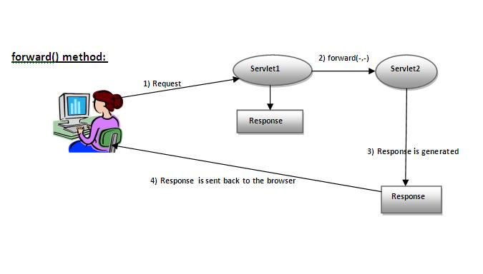

As you see in the above figure, response of second servlet is sent to the client. Response of the first servlet is not displayed to the user.

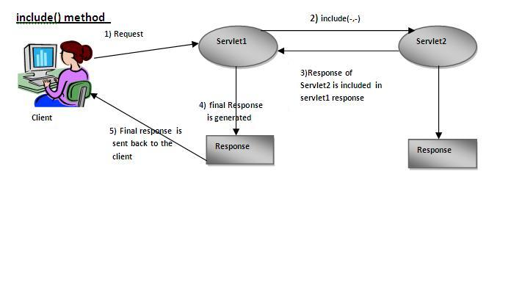

|  |
| --- |
| As you can see in the above figure, response of second servlet is included in the response of the first servlet that is being sent to the client. |

### How to get the object of RequestDispatcher

The getRequestDispatcher() method of ServletRequest interface returns the object of RequestDispatcher. Syntax:

#### Syntax of getRequestDispatcher method

[copy to clipboard](http://www.javatpoint.com/requestdispatcher-in-servlet)

1. public RequestDispatcher getRequestDispatcher(String resource);



#### Example of using getRequestDispatcher method

[copy to clipboard](http://www.javatpoint.com/requestdispatcher-in-servlet)

1. RequestDispatcher rd=request.getRequestDispatcher("servlet2");
2. //servlet2 is the url-pattern of the second servlet
4. rd.forward(request, response);//method may be include or forward



### Example of RequestDispatcher interface

In this example, we are validating the password entered by the user. If password is servlet, it will forward the request to the WelcomeServlet, otherwise will show an error message: sorry username or password error!. In this program, we are cheking for hardcoded information. But you can check it to the database also that we will see in the development chapter. In this example, we have created following files:

* **index.html file:** for getting input from the user.
* **Login.java file:** a servlet class for processing the response. If password is servet, it will forward the request to the welcome servlet.
* **WelcomeServlet.java file:** a servlet class for displaying the welcome message.
* **web.xml file:** a deployment descriptor file that contains the information about the servlet.

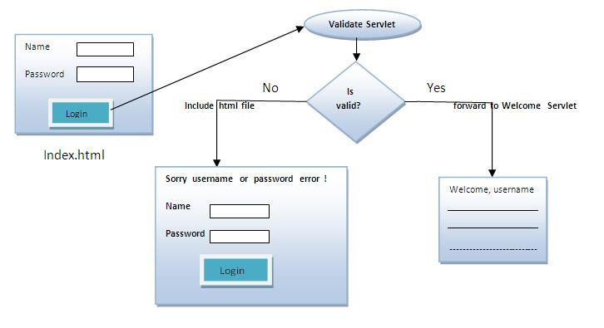

**index.html**

[copy to clipboard](http://www.javatpoint.com/requestdispatcher-in-servlet)

1. <form action="servlet1" method="post">
2. Name:<input type="text" name="userName"/><br/>
3. Password:<input type="password" name="userPass"/><br/>
4. <input type="submit" value="login"/>
5. </form>



**Login.java**

[copy to clipboard](http://www.javatpoint.com/requestdispatcher-in-servlet)

1. import java.io.*;
2. import javax.servlet.*;
3. import javax.servlet.http.*;

6. public class Login extends HttpServlet {
8. public void doPost(HttpServletRequest request, HttpServletResponse response)
9. throws ServletException, IOException {
11. response.setContentType("text/html");
12. PrintWriter out = response.getWriter();
14. String n=request.getParameter("userName");
15. String p=request.getParameter("userPass");
17. if(p.equals("servlet"){
18. RequestDispatcher rd=request.getRequestDispatcher("servlet2");
19. rd.forward(request, response);
20. }
21. else{
22. out.print("Sorry UserName or Password Error!");
23. RequestDispatcher rd=request.getRequestDispatcher("/index.html");
24. rd.include(request, response);
26. }
27. }
29. }



**WelcomeServlet.java**

[copy to clipboard](http://www.javatpoint.com/requestdispatcher-in-servlet)

1. import java.io.*;
2. import javax.servlet.*;
3. import javax.servlet.http.*;
5. public class WelcomeServlet extends HttpServlet {
7. public void doPost(HttpServletRequest request, HttpServletResponse response)
8. throws ServletException, IOException {
10. response.setContentType("text/html");
11. PrintWriter out = response.getWriter();
13. String n=request.getParameter("userName");
14. out.print("Welcome "+n);
15. }
17. }



**web.xml**

[copy to clipboard](http://www.javatpoint.com/requestdispatcher-in-servlet)

1. <web-app>
2. <servlet>
3. <servlet-name>Login</servlet-name>
4. <servlet-class>Login</servlet-class>
5. </servlet>
6. <servlet>
7. <servlet-name>WelcomeServlet</servlet-name>
8. <servlet-class>WelcomeServlet</servlet-class>
9. </servlet>

12. <servlet-mapping>
13. <servlet-name>Login</servlet-name>
14. <url-pattern>/servlet1</url-pattern>
15. </servlet-mapping>
16. <servlet-mapping>
17. <servlet-name>WelcomeServlet</servlet-name>
18. <url-pattern>/servlet2</url-pattern>
19. </servlet-mapping>
21. <welcome-file-list>
22. <welcome-file>index.html</welcome-file>
23. </welcome-file-list>
24. </web-app>



[download this example](http://www.javatpoint.com/src/servlet/requestdispatcher.zip)  
[download this example (developed in Myeclipse IDE)](http://www.javatpoint.com/src/servlet/requestdispatcherm.zip)  
[download this example (developed in eclipse IDE)](http://www.javatpoint.com/src/servlet/eclipse/requestdispatcher.zip)  
[download this example (developed in netbeans IDE)](http://www.javatpoint.com/src/servlet/netbeans/requestdispatcher.zip)

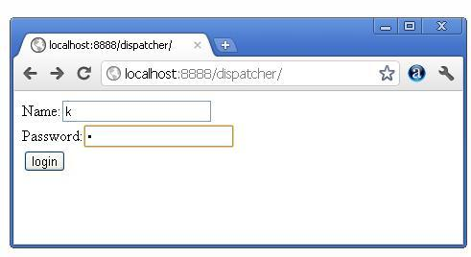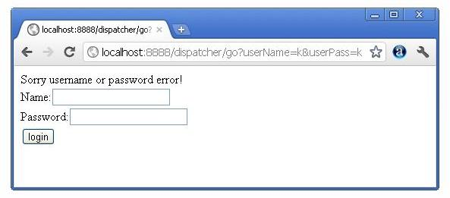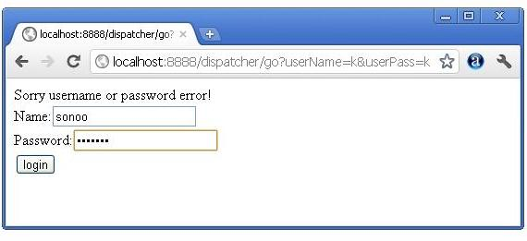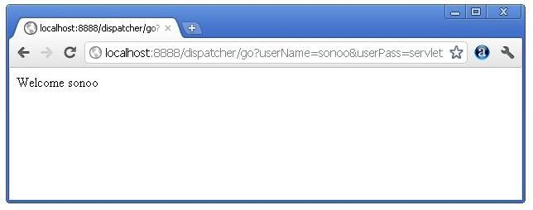

Next Topic[SendRedirect() Method](http://www.javatpoint.com/sendRedirect()-method)

# SendRedirect in servlet

1. [sendRedirect method](http://www.javatpoint.com/sendRedirect()-method)
2. [Syntax of sendRedirect() method](http://www.javatpoint.com/sendRedirect()-method#redirectsyn)
3. [Example of RequestDispatcher interface](http://www.javatpoint.com/sendRedirect()-method#redirectex)

The **sendRedirect()** method of **HttpServletResponse** interface can be used to redirect response to another resource, it may be servlet, jsp or html file.

It accepts relative as well as absolute URL.

It works at client side because it uses the url bar of the browser to make another request. So, it can work inside and outside the server.

## Difference between forward() and sendRedirect() method

There are many differences between the forward() method of RequestDispatcher and sendRedirect() method of HttpServletResponse interface. They are given below:

|  |  |
| --- | --- |
| **forward() method** | **sendRedirect() method** |
| The forward() method works at server side. | The sendRedirect() method works at client side. |
| It sends the same request and response objects to another servlet. | It always sends a new request. |
| It can work within the server only. | It can be used within and outside the server. |
| Example: request.getRequestDispacher("servlet2").forward(request,response); | Example: response.sendRedirect("servlet2"); |

### Syntax of sendRedirect() method

[copy to clipboard](http://www.javatpoint.com/sendRedirect()-method)

1. public void sendRedirect(String URL)throws IOException;



### Example of sendRedirect() method

[copy to clipboard](http://www.javatpoint.com/sendRedirect()-method)

1. response.sendRedirect("http://www.javatpoint.com");



### Full example of sendRedirect method in servlet

|  |
| --- |
| In this example, we are redirecting the request to the google server. Notice that sendRedirect method works at client side, that is why we can our request to anywhere. We can send our request within and outside the server. |

*DemoServlet.java*

[copy to clipboard](http://www.javatpoint.com/sendRedirect()-method)

1. import java.io.*;
2. import javax.servlet.*;
3. import javax.servlet.http.*;
5. public class DemoServlet extends HttpServlet{
6. public void doGet(HttpServletRequest req,HttpServletResponse res)
7. throws ServletException,IOException
8. {
9. res.setContentType("text/html");
10. PrintWriter pw=res.getWriter();
12. response.sendRedirect("http://www.google.com");
14. pw.close();
15. }}



### Creating custom google search using sendRedirect

In this example, we are using sendRedirect method to send request to google server with the request data.

*index.html*

[copy to clipboard](http://www.javatpoint.com/sendRedirect()-method)

1. <!DOCTYPE html>
2. <html>
3. <head>
4. <meta charset="ISO-8859-1">
5. <title>sendRedirect example</title>
6. </head>
7. <body>

10. <form action="MySearcher">
11. <input type="text" name="name">
12. <input type="submit" value="Google Search">
13. </form>
15. </body>
16. </html>



*MySearcher.java*

[copy to clipboard](http://www.javatpoint.com/sendRedirect()-method)

1. import java.io.IOException;
2. import javax.servlet.ServletException;
3. import javax.servlet.http.HttpServlet;
4. import javax.servlet.http.HttpServletRequest;
5. import javax.servlet.http.HttpServletResponse;
7. public class MySearcher extends HttpServlet {
8. protected void doGet(HttpServletRequest request, HttpServletResponse response)
9. throws ServletException, IOException {
11. String name=request.getParameter("name");
12. response.sendRedirect("https://www.google.co.in/#q="+name);
13. }
14. }



[download this example (developed in Eclipse)](http://www.javatpoint.com/src/servlet/eclipse/GoogleSearcher.zip)

#### Output

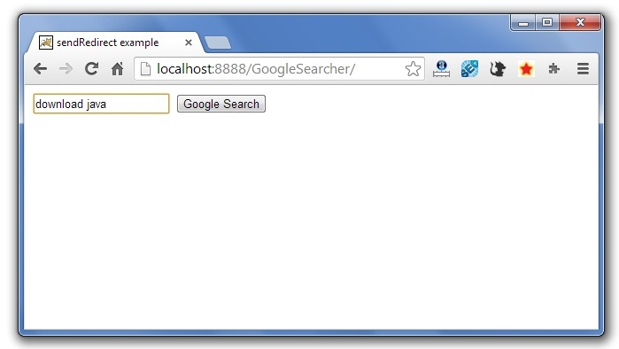  
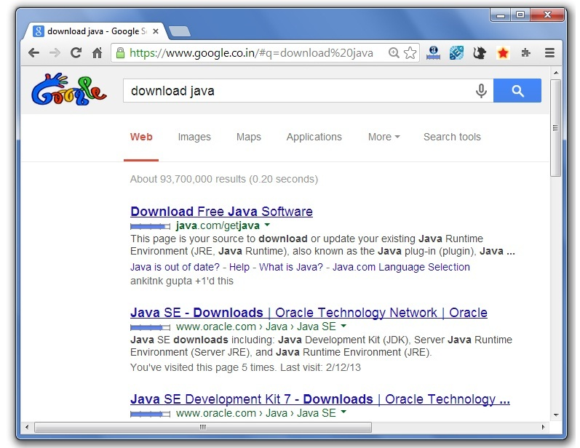

Next Topic[Servletconfig Example](http://www.javatpoint.com/servletconfig)

# ServletConfig Interface

1. [ServletConfig Interface](http://www.javatpoint.com/servletconfig)
2. [Methods of ServletConfig interface](http://www.javatpoint.com/servletconfig#configmethod)
3. [How to get the object of ServletConfig](http://www.javatpoint.com/servletconfig#configobject)
4. [Syntax to provide the initialization parameter for a servlet](http://www.javatpoint.com/servletconfig#configsyntax)
5. [Example of ServletConfig to get initialization parameter](http://www.javatpoint.com/servletconfig#configex1)
6. [Example of ServletConfig to get all the initialization parameter](http://www.javatpoint.com/servletconfig#configex2)

An object of ServletConfig is created by the web container for each servlet. This object can be used to get configuration information from web.xml file.

If the configuration information is modified from the web.xml file, we don't need to change the servlet. So it is easier to manage the web application if any specific content is modified from time to time.

### Advantage of ServletConfig

The core advantage of ServletConfig is that you don't need to edit the servlet file if information is modified from the web.xml file.

### Methods of ServletConfig interface

1. **public String getInitParameter(String name):**Returns the parameter value for the specified parameter name.
2. **public Enumeration getInitParameterNames():**Returns an enumeration of all the initialization parameter names.
3. **public String getServletName():**Returns the name of the servlet.
4. **public ServletContext getServletContext():**Returns an object of ServletContext.

### How to get the object of ServletConfig

1. **getServletConfig() method** of Servlet interface returns the object of ServletConfig.

#### Syntax of getServletConfig() method

[copy to clipboard](http://www.javatpoint.com/servletconfig)

1. public ServletConfig getServletConfig();



#### Example of getServletConfig() method

[copy to clipboard](http://www.javatpoint.com/servletconfig)

1. ServletConfig config=getServletConfig();
2. //Now we can call the methods of ServletConfig interface



### Syntax to provide the initialization parameter for a servlet

The init-param sub-element of servlet is used to specify the initialization parameter for a servlet.

[copy to clipboard](http://www.javatpoint.com/servletconfig)

1. <web-app>
2. <servlet>
3. ......
5. <init-param>
6. <param-name>parametername</param-name>
7. <param-value>parametervalue</param-value>
8. </init-param>
9. ......
10. </servlet>
11. </web-app>



### Example of ServletConfig to get initialization parameter

In this example, we are getting the one initialization parameter from the web.xml file and printing this information in the servlet.

**DemoServlet.java**

[copy to clipboard](http://www.javatpoint.com/servletconfig)

1. import java.io.*;
2. import javax.servlet.*;
3. import javax.servlet.http.*;
5. public class DemoServlet extends HttpServlet {
6. public void doGet(HttpServletRequest request, HttpServletResponse response)
7. throws ServletException, IOException {
9. response.setContentType("text/html");
10. PrintWriter out = response.getWriter();
12. ServletConfig config=getServletConfig();
13. String driver=config.getInitParameter("driver");
14. out.print("Driver is: "+driver);
16. out.close();
17. }
19. }



**web.xml**

[copy to clipboard](http://www.javatpoint.com/servletconfig)

1. <web-app>
3. <servlet>
4. <servlet-name>DemoServlet</servlet-name>
5. <servlet-class>DemoServlet</servlet-class>
7. <init-param>
8. <param-name>driver</param-name>
9. <param-value>sun.jdbc.odbc.JdbcOdbcDriver</param-value>
10. </init-param>
12. </servlet>
14. <servlet-mapping>
15. <servlet-name>DemoServlet</servlet-name>
16. <url-pattern>/servlet1</url-pattern>
17. </servlet-mapping>
19. </web-app>



[download this example (developed in Myeclipse IDE)](http://www.javatpoint.com/src/servlet/config1.zip)  
[download this example(developed in Eclipse IDE)](http://www.javatpoint.com/src/servlet/eclipse/config1.zip)  
[download this example(developed in Netbeans IDE)](http://www.javatpoint.com/src/servlet/netbeans/config4.zip)

### Example of ServletConfig to get all the initialization parameters

In this example, we are getting all the initialization parameter from the web.xml file and printing this information in the servlet.

**DemoServlet.java**

[copy to clipboard](http://www.javatpoint.com/servletconfig)

1. import java.io.IOException;
2. import java.io.PrintWriter;
3. import java.util.Enumeration;
5. import javax.servlet.ServletConfig;
6. import javax.servlet.ServletException;
7. import javax.servlet.http.HttpServlet;
8. import javax.servlet.http.HttpServletRequest;
9. import javax.servlet.http.HttpServletResponse;

12. public class DemoServlet extends HttpServlet {
13. public void doGet(HttpServletRequest request, HttpServletResponse response)
14. throws ServletException, IOException {
16. response.setContentType("text/html");
17. PrintWriter out = response.getWriter();
19. ServletConfig config=getServletConfig();
20. Enumeration<String> e=config.getInitParameterNames();
22. String str="";
23. while(e.hasMoreElements()){
24. str=e.nextElement();
25. out.print("<br>Name: "+str);
26. out.print(" value: "+config.getInitParameter(str));
27. }
29. out.close();
30. }
32. }



**web.xml**

[copy to clipboard](http://www.javatpoint.com/servletconfig)

1. <web-app>
3. <servlet>
4. <servlet-name>DemoServlet</servlet-name>
5. <servlet-class>DemoServlet</servlet-class>
7. <init-param>
8. <param-name>username</param-name>
9. <param-value>system</param-value>
10. </init-param>
12. <init-param>
13. <param-name>password</param-name>
14. <param-value>oracle</param-value>
15. </init-param>
17. </servlet>
19. <servlet-mapping>
20. <servlet-name>DemoServlet</servlet-name>
21. <url-pattern>/servlet1</url-pattern>
22. </servlet-mapping>
24. </web-app>



[download this example (developed in Myeclipse IDE)](http://www.javatpoint.com/src/servlet/config2.zip)  
[download this example(developed in Eclipse IDE)](http://www.javatpoint.com/src/servlet/eclipse/config2.zip)  
[download this example(developed in Netbeans IDE)](http://www.javatpoint.com/src/servlet/netbeans/config5.zip)

# ServletContext Interface

1. [ServletContext Interface](http://www.javatpoint.com/servletcontext)
2. [Usage of ServletContext Interface](http://www.javatpoint.com/servletcontext#contextusage)
3. [Methods of ServletContext interface](http://www.javatpoint.com/servletcontext#contextmethods)
4. [How to get the object of ServletContext](http://www.javatpoint.com/servletcontext#contextobject)
5. [Syntax to provide the initialization parameter in Context scope](http://www.javatpoint.com/servletcontext#contextsyn)
6. [Example of ServletContext to get initialization parameter](http://www.javatpoint.com/servletcontext#contextex1)
7. [Example of ServletContext to get all the initialization parameter](http://www.javatpoint.com/servletcontext#contextex2)

An object of ServletContext is created by the web container at time of deploying the project. This object can be used to get configuration information from web.xml file. There is only one ServletContext object per web application.

If any information is shared to many servlet, it is better to provide it from the web.xml file using the **<context-param>** element.

### Advantage of ServletContext

**Easy to maintain** if any information is shared to all the servlet, it is better to make it available for all the servlet. We provide this information from the web.xml file, so if the information is changed, we don't need to modify the servlet. Thus it removes maintenance problem.

### Usage of ServletContext Interface

There can be a lot of usage of ServletContext object. Some of them are as follows:

1. The object of ServletContext provides an interface between the container and servlet.
2. The ServletContext object can be used to get configuration information from the web.xml file.
3. The ServletContext object can be used to set, get or remove attribute from the web.xml file.
4. The ServletContext object can be used to provide inter-application communication.

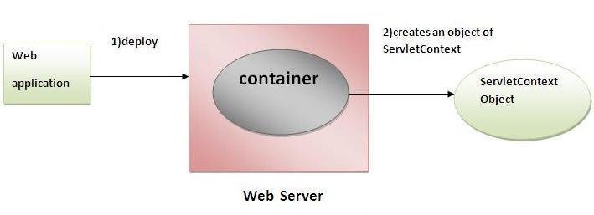

### Commonly used methods of ServletContext interface

|  |
| --- |
| There is given some commonly used methods of ServletContext interface.   1. **public String getInitParameter(String name):**Returns the parameter value for the specified parameter name. 2. **public Enumeration getInitParameterNames():**Returns the names of the context's initialization parameters. 3. **public void setAttribute(String name,Object object):**sets the given object in the application scope. 4. **public Object getAttribute(String name):**Returns the attribute for the specified name. 5. **public Enumeration getInitParameterNames():**Returns the names of the context's initialization parameters as an Enumeration of String objects. 6. **public void removeAttribute(String name):**Removes the attribute with the given name from the servlet context. |

### How to get the object of ServletContext interface

1. **getServletContext() method** of ServletConfig interface returns the object of ServletContext.
2. **getServletContext() method** of GenericServlet class returns the object of ServletContext.

#### Syntax of getServletContext() method

[copy to clipboard](http://www.javatpoint.com/servletcontext)

1. public ServletContext getServletContext()



#### Example of getServletContext() method

[copy to clipboard](http://www.javatpoint.com/servletcontext)

1. //We can get the ServletContext object from ServletConfig object
2. ServletContext application=getServletConfig().getServletContext();
4. //Another convenient way to get the ServletContext object
5. ServletContext application=getServletContext();



### Syntax to provide the initialization parameter in Context scope

|  |
| --- |
| The **context-param** element, subelement of web-app, is used to define the initialization parameter in the application scope. The param-name and param-value are the sub-elements of the context-param. The param-name element defines parameter name and and param-value defines its value. |

[copy to clipboard](http://www.javatpoint.com/servletcontext)

1. <web-app>
2. ......
4. <context-param>
5. <param-name>parametername</param-name>
6. <param-value>parametervalue</param-value>
7. </context-param>
8. ......
9. </web-app>



### Example of ServletContext to get the initialization parameter

|  |
| --- |
| In this example, we are getting the initialization parameter from the web.xml file and printing the value of the initialization parameter. Notice that the object of ServletContext represents the application scope. So if we change the value of the parameter from the web.xml file, all the servlet classes will get the changed value. So we don't need to modify the servlet. So it is better to have the common information for most of the servlets in the web.xml file by context-param element. Let's see the simple example: |

**DemoServlet.java**

[copy to clipboard](http://www.javatpoint.com/servletcontext)

1. import java.io.*;
2. import javax.servlet.*;
3. import javax.servlet.http.*;

6. public class DemoServlet extends HttpServlet{
7. public void doGet(HttpServletRequest req,HttpServletResponse res)
8. throws ServletException,IOException
9. {
10. res.setContentType("text/html");
11. PrintWriter pw=res.getWriter();
13. //creating ServletContext object
14. ServletContext context=getServletContext();
16. //Getting the value of the initialization parameter and printing it
17. String driverName=context.getInitParameter("dname");
18. pw.println("driver name is="+driverName);
20. pw.close();
22. }}



**web.xml**

[copy to clipboard](http://www.javatpoint.com/servletcontext)

1. <web-app>
3. <servlet>
4. <servlet-name>sonoojaiswal</servlet-name>
5. <servlet-class>DemoServlet</servlet-class>
6. </servlet>
8. <context-param>
9. <param-name>dname</param-name>
10. <param-value>sun.jdbc.odbc.JdbcOdbcDriver</param-value>
11. </context-param>
13. <servlet-mapping>
14. <servlet-name>sonoojaiswal</servlet-name>
15. <url-pattern>/context</url-pattern>
16. </servlet-mapping>
18. </web-app>



### Example of ServletContext to get all the initialization parameters

|  |
| --- |
| In this example, we are getting all the initialization parameter from the web.xml file. For getting all the parameters, we have used the getInitParameterNames() method in the servlet class. |

**DemoServlet.java**

[copy to clipboard](http://www.javatpoint.com/servletcontext)

1. import java.io.*;
2. import javax.servlet.*;
3. import javax.servlet.http.*;

6. public class DemoServlet extends HttpServlet{
7. public void doGet(HttpServletRequest req,HttpServletResponse res)
8. throws ServletException,IOException
9. {
10. res.setContentType("text/html");
11. PrintWriter out=res.getWriter();
13. ServletContext context=getServletContext();
14. Enumeration<String> e=context.getInitParameterNames();
16. String str="";
17. while(e.hasMoreElements()){
18. str=e.nextElement();
19. out.print("<br> "+context.getInitParameter(str));
20. }
21. }}



**web.xml**

[copy to clipboard](http://www.javatpoint.com/servletcontext)

1. <web-app>
3. <servlet>
4. <servlet-name>sonoojaiswal</servlet-name>
5. <servlet-class>DemoServlet</servlet-class>
6. </servlet>
8. <context-param>
9. <param-name>dname</param-name>
10. <param-value>sun.jdbc.odbc.JdbcOdbcDriver</param-value>
11. </context-param>
13. <context-param>
14. <param-name>username</param-name>
15. <param-value>system</param-value>
16. </context-param>
18. <context-param>
19. <param-name>password</param-name>
20. <param-value>oracle</param-value>
21. </context-param>
23. <servlet-mapping>
24. <servlet-name>sonoojaiswal</servlet-name>
25. <url-pattern>/context</url-pattern>
26. </servlet-mapping>
28. </web-app>

# Attribute in Servlet

1. [Attribute in Servlet](http://www.javatpoint.com/attribute)
2. [Attribute specific methods](http://www.javatpoint.com/attribute#attributemethod)
3. [Example of ServletContext to set and get attribute](http://www.javatpoint.com/attribute#attributeex)
4. [Difference between ServletConfig and ServletContext](http://www.javatpoint.com/attribute#diffcontext)

An **attribute in servlet** is an object that can be set, get or removed from one of the following scopes:

1. request scope
2. session scope
3. application scope

The servlet programmer can pass informations from one servlet to another using attributes. It is just like passing object from one class to another so that we can reuse the same object again and again.

### Attribute specific methods of ServletRequest, HttpSession and ServletContext interface

|  |
| --- |
| There are following 4 attribute specific methods. They are as follows:   1. **public void setAttribute(String name,Object object):**sets the given object in the application scope. 2. **public Object getAttribute(String name):**Returns the attribute for the specified name. 3. **public Enumeration getInitParameterNames():**Returns the names of the context's initialization parameters as an Enumeration of String objects. 4. **public void removeAttribute(String name):**Removes the attribute with the given name from the servlet context. |

### Example of ServletContext to set and get attribute

|  |
| --- |
| In this example, we are setting the attribute in the application scope and getting that value from another servlet. |

### DemoServlet1.java

[copy to clipboard](http://www.javatpoint.com/attribute)

1. import java.io.*;
2. import javax.servlet.*;
3. import javax.servlet.http.*;

6. public class DemoServlet1 extends HttpServlet{
7. public void doGet(HttpServletRequest req,HttpServletResponse res)
8. {
9. try{
11. res.setContentType("text/html");
12. PrintWriter out=res.getWriter();
14. ServletContext context=getServletContext();
15. context.setAttribute("company","IBM");
17. out.println("Welcome to first servlet");
18. out.println("<a href='servlet2'>visit</a>");
19. out.close();
21. }catch(Exception e){out.println(e);}
23. }}

import java.io.*;

import javax.servlet.*;

import javax.servlet.http.*;

public class DemoServlet1 extends HttpServlet{

public void doGet(HttpServletRequest req,HttpServletResponse res)

{

try{

res.setContentType("text/html");

PrintWriter out=res.getWriter();

ServletContext context=getServletContext();

context.setAttribute("company","IBM");

out.println("Welcome to first servlet");

out.println("<a href='servlet2'>visit</a>");

out.close();

}catch(Exception e){out.println(e);}

}}

### DemoServlet2.java

[copy to clipboard](http://www.javatpoint.com/attribute)

1. import java.io.*;
2. import javax.servlet.*;
3. import javax.servlet.http.*;

6. public class DemoServlet2 extends HttpServlet{
7. public void doGet(HttpServletRequest req,HttpServletResponse res)
8. {
9. try{
11. res.setContentType("text/html");
12. PrintWriter out=res.getWriter();
14. ServletContext context=getServletContext();
15. String n=(String)context.getAttribute("company");
17. out.println("Welcome to "+n);
18. out.close();
20. }catch(Exception e){out.println(e);}
22. }}

import java.io.*;

import javax.servlet.*;

import javax.servlet.http.*;

public class DemoServlet2 extends HttpServlet{

public void doGet(HttpServletRequest req,HttpServletResponse res)

{

try{

res.setContentType("text/html");

PrintWriter out=res.getWriter();

ServletContext context=getServletContext();

String n=(String)context.getAttribute("company");

out.println("Welcome to "+n);

out.close();

}catch(Exception e){out.println(e);}

}}

### web.xml

[copy to clipboard](http://www.javatpoint.com/attribute)

1. <web-app>
3. <servlet>
4. <servlet-name>s1</servlet-name>
5. <servlet-class>DemoServlet1</servlet-class>
6. </servlet>
8. <servlet-mapping>
9. <servlet-name>s1</servlet-name>
10. <url-pattern>/servlet1</url-pattern>
11. </servlet-mapping>
13. <servlet>
14. <servlet-name>s2</servlet-name>
15. <servlet-class>DemoServlet2</servlet-class>
16. </servlet>
18. <servlet-mapping>
19. <servlet-name>s2</servlet-name>
20. <url-pattern>/servlet2</url-pattern>
21. </servlet-mapping>
23. </web-app>

<web-app>

<servlet>

<servlet-name>s1</servlet-name>

<servlet-class>DemoServlet1</servlet-class>

</servlet>

<servlet-mapping>

<servlet-name>s1</servlet-name>

<url-pattern>/servlet1</url-pattern>

</servlet-mapping>

<servlet>

<servlet-name>s2</servlet-name>

<servlet-class>DemoServlet2</servlet-class>

</servlet>

<servlet-mapping>

<servlet-name>s2</servlet-name>

<url-pattern>/servlet2</url-pattern>

</servlet-mapping>

</web-app>

### Difference between ServletConfig and ServletContext

|  |
| --- |
| The servletconfig object refers to the single servlet whereas servletcontext object refers to the whole web application. |

Next Topic[Session Tracking in Servlets](http://www.javatpoint.com/session-tracking-in-servlets)

# Session Tracking in Servlets

1. [Session Tracking](http://www.javatpoint.com/session-tracking-in-servlets#session1)
2. [Session Tracking Techniques](http://www.javatpoint.com/session-tracking-in-servlets#session1tech)

**Session** simply means a particular interval of time.

**Session Tracking** is a way to maintain state (data) of an user. It is also known as **session management** in servlet.

Http protocol is a stateless so we need to maintain state using session tracking techniques. Each time user requests to the server, server treats the request as the new request. So we need to maintain the state of an user to recognize to particular user.

HTTP is stateless that means each request is considered as the new request. It is shown in the figure given below:

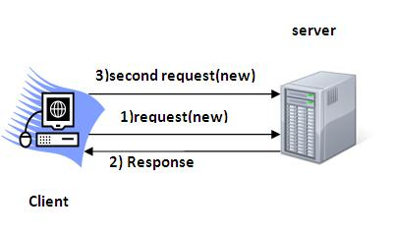

### Why use Session Tracking?

**To recognize the user** It is used to recognize the particular user.

### Session Tracking Techniques

There are four techniques used in Session tracking:

1. **Cookies**
2. **Hidden Form Field**
3. **URL Rewriting**
4. **HttpSession**

# Cookies in Servlet

A **cookie** is a small piece of information that is persisted between the multiple client requests.

A cookie has a name, a single value, and optional attributes such as a comment, path and domain qualifiers, a maximum age, and a version number.

### How Cookie works

By default, each request is considered as a new request. In cookies technique, we add cookie with response from the servlet. So cookie is stored in the cache of the browser. After that if request is sent by the user, cookie is added with request by default. Thus, we recognize the user as the old user.

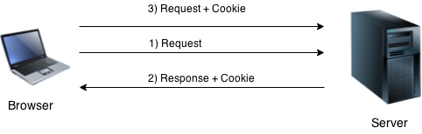

### Types of Cookie

There are 2 types of cookies in servlets.

1. Non-persistent cookie
2. Persistent cookie

### Non-persistent cookie

It is **valid for single session** only. It is removed each time when user closes the browser.

### Persistent cookie

It is **valid for multiple session** . It is not removed each time when user closes the browser. It is removed only if user logout or signout.

### Advantage of Cookies

1. Simplest technique of maintaining the state.
2. Cookies are maintained at client side.

### Disadvantage of Cookies

1. It will not work if cookie is disabled from the browser.
2. Only textual information can be set in Cookie object.

#### *Note: Gmail uses cookie technique for login. If you disable the cookie, gmail won't work.*

### Cookie class

**javax.servlet.http.Cookie** class provides the functionality of using cookies. It provides a lot of useful methods for cookies.

### Constructor of Cookie class

|  |  |
| --- | --- |
| **Constructor** | **Description** |
| Cookie() | constructs a cookie. |
| Cookie(String name, String value) | constructs a cookie with a specified name and value. |

### Useful Methods of Cookie class

There are given some commonly used methods of the Cookie class.

|  |  |
| --- | --- |
| **Method** | **Description** |
| public void setMaxAge(int expiry) | Sets the maximum age of the cookie in seconds. |
| public String getName() | Returns the name of the cookie. The name cannot be changed after creation. |
| public String getValue() | Returns the value of the cookie. |
| public void setName(String name) | changes the name of the cookie. |
| public void setValue(String value) | changes the value of the cookie. |

### Other methods required for using Cookies

|  |
| --- |
| For adding cookie or getting the value from the cookie, we need some methods provided by other interfaces. They are:   1. **public void addCookie(Cookie ck):**method of HttpServletResponse interface is used to add cookie in response object. 2. **public Cookie[] getCookies():**method of HttpServletRequest interface is used to return all the cookies from the browser. |

### How to create Cookie?

Let's see the simple code to create cookie.

[copy to clipboard](http://www.javatpoint.com/cookies-in-servlet)

1. Cookie ck=new Cookie("user","sonoo jaiswal");//creating cookie object
2. response.addCookie(ck);//adding cookie in the response



### How to delete Cookie?

Let's see the simple code to delete cookie. It is mainly used to logout or signout the user.

[copy to clipboard](http://www.javatpoint.com/cookies-in-servlet)

1. Cookie ck=new Cookie("user","");//deleting value of cookie
2. ck.setMaxAge(0);//changing the maximum age to 0 seconds
3. response.addCookie(ck);//adding cookie in the response



### How to get Cookies?

Let's see the simple code to get all the cookies.

[copy to clipboard](http://www.javatpoint.com/cookies-in-servlet)

1. Cookie ck[]=request.getCookies();
2. for(int i=0;i<ck.length;i++){
3. out.print("<br>"+ck[i].getName()+" "+ck[i].getValue());//printing name and value of cookie
4. }



### Simple example of Servlet Cookies

In this example, we are storing the name of the user in the cookie object and accessing it in another servlet. As we know well that session corresponds to the particular user. So if you access it from too many browsers with different values, you will get the different value.

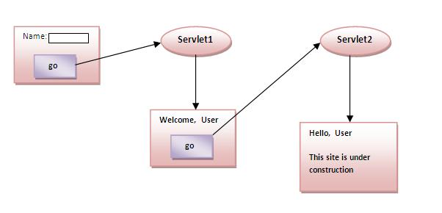

### index.html

[copy to clipboard](http://www.javatpoint.com/cookies-in-servlet)

1. <form action="servlet1" method="post">
2. Name:<input type="text" name="userName"/><br/>
3. <input type="submit" value="go"/>
4. </form>



### FirstServlet.java

[copy to clipboard](http://www.javatpoint.com/cookies-in-servlet)

1. import java.io.*;
2. import javax.servlet.*;
3. import javax.servlet.http.*;

6. public class FirstServlet extends HttpServlet {
8. public void doPost(HttpServletRequest request, HttpServletResponse response){
9. try{
11. response.setContentType("text/html");
12. PrintWriter out = response.getWriter();
14. String n=request.getParameter("userName");
15. out.print("Welcome "+n);
17. Cookie ck=new Cookie("uname",n);//creating cookie object
18. response.addCookie(ck);//adding cookie in the response
20. //creating submit button
21. out.print("<form action='servlet2'>");
22. out.print("<input type='submit' value='go'>");
23. out.print("</form>");
25. out.close();
27. }catch(Exception e){System.out.println(e);}
28. }
29. }



### SecondServlet.java

[copy to clipboard](http://www.javatpoint.com/cookies-in-servlet)

1. import java.io.*;
2. import javax.servlet.*;
3. import javax.servlet.http.*;
5. public class SecondServlet extends HttpServlet {
7. public void doPost(HttpServletRequest request, HttpServletResponse response){
8. try{
10. response.setContentType("text/html");
11. PrintWriter out = response.getWriter();
13. Cookie ck[]=request.getCookies();
14. out.print("Hello "+ck[0].getValue());
16. out.close();
18. }catch(Exception e){System.out.println(e);}
19. }

22. }



### web.xml

[copy to clipboard](http://www.javatpoint.com/cookies-in-servlet)

1. <web-app>
3. <servlet>
4. <servlet-name>s1</servlet-name>
5. <servlet-class>FirstServlet</servlet-class>
6. </servlet>
8. <servlet-mapping>
9. <servlet-name>s1</servlet-name>
10. <url-pattern>/servlet1</url-pattern>
11. </servlet-mapping>
13. <servlet>
14. <servlet-name>s2</servlet-name>
15. <servlet-class>SecondServlet</servlet-class>
16. </servlet>
18. <servlet-mapping>
19. <servlet-name>s2</servlet-name>
20. <url-pattern>/servlet2</url-pattern>
21. </servlet-mapping>
23. </web-app>



[download this example (developed using Myeclipse IDE)](http://www.javatpoint.com/src/servlet/myeclipse/cookies.zip)  
[download this example (developed using Eclipse IDE)](http://www.javatpoint.com/src/servlet/eclipse/cookies.zip)  
[download this example (developed using Netbeans IDE)](http://www.javatpoint.com/src/servlet/netbeans/cookies.zip)

#### Output

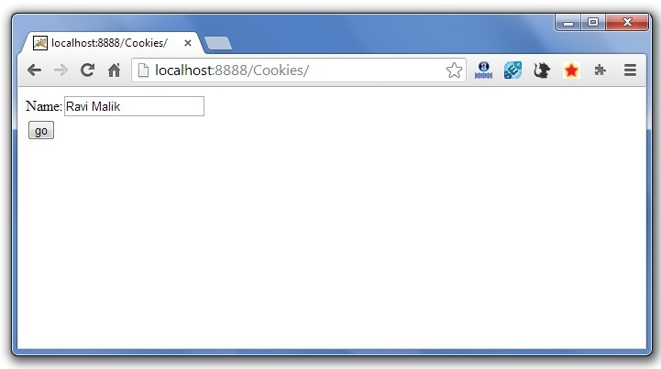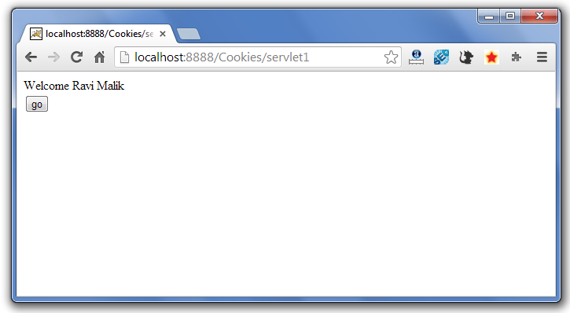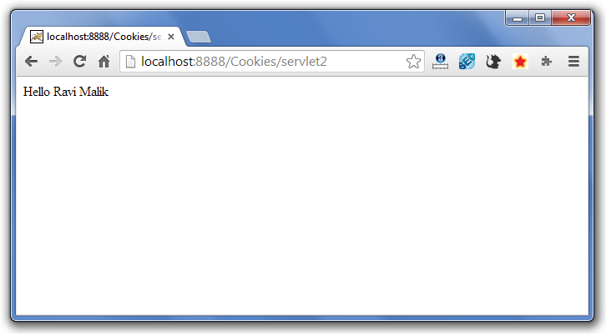

Next Topic[servlet login and logout example using cookies (Real Login App)](http://www.javatpoint.com/servlet-login-and-logout-example-using-cookies)

# Servlet Login and Logout Example using Cookies

A **cookie** is a kind of information that is stored at client side.

In the previous page, we learned a lot about cookie e.g. how to create cookie, how to delete cookie, how to get cookie etc.

Here, we are going to create a login and logout example using servlet cookies.

In this example, we are creating 3 links: login, logout and profile. User can't go to profile page until he/she is logged in. If user is logged out, he need to login again to visit profile.

In this application, we have created following files.

1. index.html
2. link.html
3. login.html
4. LoginServlet.java
5. LogoutServlet.java
6. ProfileServlet.java
7. web.xml

File: index.html

[copy to clipboard](http://www.javatpoint.com/servlet-login-and-logout-example-using-cookies)

1. <!DOCTYPE html>
2. <html>
3. <head>
4. <meta charset="ISO-8859-1">
5. <title>Servlet Login Example</title>
6. </head>
7. <body>
9. <h1>Welcome to Login App by Cookie</h1>
10. <a href="login.html">Login</a>|
11. <a href="LogoutServlet">Logout</a>|
12. <a href="ProfileServlet">Profile</a>
14. </body>
15. </html>



File: link.html

[copy to clipboard](http://www.javatpoint.com/servlet-login-and-logout-example-using-cookies)

1. <a href="login.html">Login</a> |
2. <a href="LogoutServlet">Logout</a> |
3. <a href="ProfileServlet">Profile</a>
4. <hr>



File: login.html

[copy to clipboard](http://www.javatpoint.com/servlet-login-and-logout-example-using-cookies)

1. <form action="LoginServlet" method="post">
2. Name:<input type="text" name="name"><br>
3. Password:<input type="password" name="password"><br>
4. <input type="submit" value="login">
5. </form>



File: LoginServlet.java

[copy to clipboard](http://www.javatpoint.com/servlet-login-and-logout-example-using-cookies)

1. package com.javatpoint;
3. import java.io.IOException;
4. import java.io.PrintWriter;
5. import javax.servlet.ServletException;
6. import javax.servlet.http.Cookie;
7. import javax.servlet.http.HttpServlet;
8. import javax.servlet.http.HttpServletRequest;
9. import javax.servlet.http.HttpServletResponse;
10. public class LoginServlet extends HttpServlet {
11. protected void doPost(HttpServletRequest request, HttpServletResponse response)
12. throws ServletException, IOException {
13. response.setContentType("text/html");
14. PrintWriter out=response.getWriter();
16. request.getRequestDispatcher("link.html").include(request, response);
18. String name=request.getParameter("name");
19. String password=request.getParameter("password");
21. if(password.equals("admin123")){
22. out.print("You are successfully logged in!");
23. out.print("<br>Welcome, "+name);
25. Cookie ck=new Cookie("name",name);
26. response.addCookie(ck);
27. }else{
28. out.print("sorry, username or password error!");
29. request.getRequestDispatcher("login.html").include(request, response);
30. }
32. out.close();
33. }
35. }



File: LogoutServlet.java

[copy to clipboard](http://www.javatpoint.com/servlet-login-and-logout-example-using-cookies)

1. package com.javatpoint;
3. import java.io.IOException;
4. import java.io.PrintWriter;
5. import javax.servlet.ServletException;
6. import javax.servlet.http.Cookie;
7. import javax.servlet.http.HttpServlet;
8. import javax.servlet.http.HttpServletRequest;
9. import javax.servlet.http.HttpServletResponse;
10. public class LogoutServlet extends HttpServlet {
11. protected void doGet(HttpServletRequest request, HttpServletResponse response)
12. throws ServletException, IOException {
13. response.setContentType("text/html");
14. PrintWriter out=response.getWriter();

17. request.getRequestDispatcher("link.html").include(request, response);
19. Cookie ck=new Cookie("name","");
20. ck.setMaxAge(0);
21. response.addCookie(ck);
23. out.print("you are successfully logged out!");
24. }
25. }



File: ProfileServlet.java

[copy to clipboard](http://www.javatpoint.com/servlet-login-and-logout-example-using-cookies)

1. package com.javatpoint;
3. import java.io.IOException;
4. import java.io.PrintWriter;
5. import javax.servlet.ServletException;
6. import javax.servlet.http.Cookie;
7. import javax.servlet.http.HttpServlet;
8. import javax.servlet.http.HttpServletRequest;
9. import javax.servlet.http.HttpServletResponse;
10. public class ProfileServlet extends HttpServlet {
11. protected void doGet(HttpServletRequest request, HttpServletResponse response)
12. throws ServletException, IOException {
13. response.setContentType("text/html");
14. PrintWriter out=response.getWriter();
16. request.getRequestDispatcher("link.html").include(request, response);
18. Cookie ck[]=request.getCookies();
19. if(ck!=null){
20. String name=ck[0].getValue();
21. if(!name.equals("")||name!=null){
22. out.print("<b>Welcome to Profile</b>");
23. out.print("<br>Welcome, "+name);
24. }
25. }else{
26. out.print("Please login first");
27. request.getRequestDispatcher("login.html").include(request, response);
28. }
29. out.close();
30. }
31. }



File: web.xml

[copy to clipboard](http://www.javatpoint.com/servlet-login-and-logout-example-using-cookies)

1. <?xml version="1.0" encoding="UTF-8"?>
2. <web-app xmlns:xsi="http://www.w3.org/2001/XMLSchema-instance"
3. xmlns="http://java.sun.com/xml/ns/javaee" xsi:schemaLocation="http://java.sun.com/xml/ns/javaee
4. http://java.sun.com/xml/ns/javaee/web-app_2_5.xsd" id="WebApp_ID" version="2.5">
6. <servlet>
7. <description></description>
8. <display-name>LoginServlet</display-name>
9. <servlet-name>LoginServlet</servlet-name>
10. <servlet-class>com.javatpoint.LoginServlet</servlet-class>
11. </servlet>
12. <servlet-mapping>
13. <servlet-name>LoginServlet</servlet-name>
14. <url-pattern>/LoginServlet</url-pattern>
15. </servlet-mapping>
16. <servlet>
17. <description></description>
18. <display-name>ProfileServlet</display-name>
19. <servlet-name>ProfileServlet</servlet-name>
20. <servlet-class>com.javatpoint.ProfileServlet</servlet-class>
21. </servlet>
22. <servlet-mapping>
23. <servlet-name>ProfileServlet</servlet-name>
24. <url-pattern>/ProfileServlet</url-pattern>
25. </servlet-mapping>
26. <servlet>
27. <description></description>
28. <display-name>LogoutServlet</display-name>
29. <servlet-name>LogoutServlet</servlet-name>
30. <servlet-class>com.javatpoint.LogoutServlet</servlet-class>
31. </servlet>
32. <servlet-mapping>
33. <servlet-name>LogoutServlet</servlet-name>
34. <url-pattern>/LogoutServlet</url-pattern>
35. </servlet-mapping>
36. </web-app>



[download this example (developed using Eclipse IDE)](http://www.javatpoint.com/src/servlet/eclipse/loginappcookie.zip)

#### Output

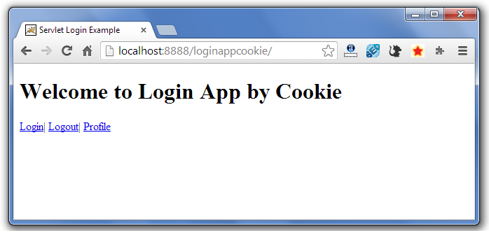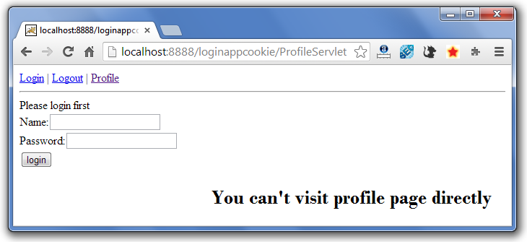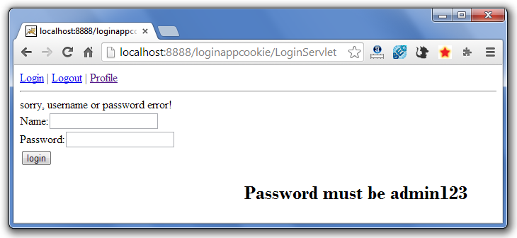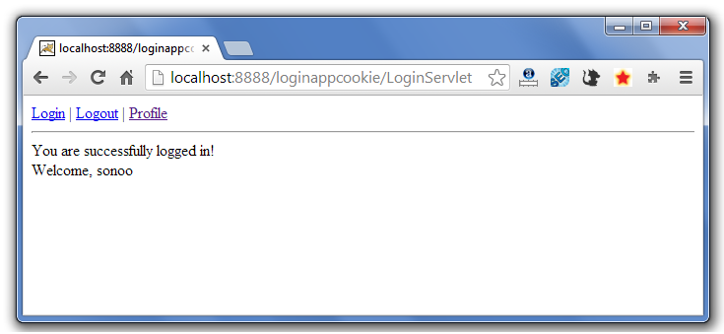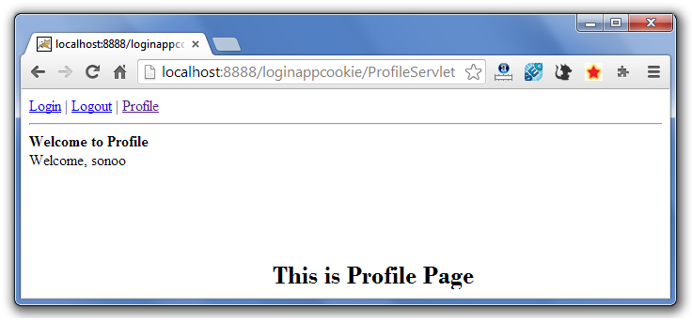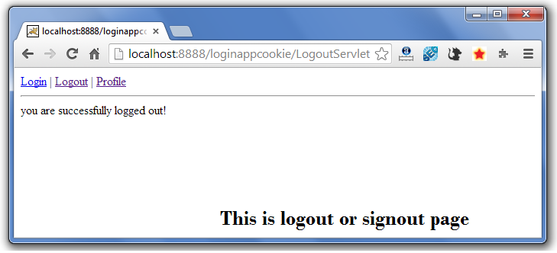

If again you click on the profile link, you need to login first.

Next Topic[Hidden Form Field In Session Tracking](http://www.javatpoint.com/hidden-form-field-in-session-tracking)

# 2) Hidden Form Field

1. [Hidden Form Field](http://www.javatpoint.com/hidden-form-field-in-session-tracking)
2. [Example of Hidden Form Field](http://www.javatpoint.com/hidden-form-field-in-session-tracking#session2ex)

In case of Hidden Form Field **a hidden (invisible) textfield** is used for maintaining the state of an user.

In such case, we store the information in the hidden field and get it from another servlet. This approach is better if we have to submit form in all the pages and we don't want to depend on the browser.

Let's see the code to store value in hidden field.

[copy to clipboard](http://www.javatpoint.com/hidden-form-field-in-session-tracking)

1. <input type="hidden" name="uname" value="Vimal Jaiswal">



Here, uname is the hidden field name and Vimal Jaiswal is the hidden field value.

### Real application of hidden form field

It is widely used in comment form of a website. In such case, we store page id or page name in the hidden field so that each page can be uniquely identified.

### Advantage of Hidden Form Field

1. It will always work whether cookie is disabled or not.

### Disadvantage of Hidden Form Field:

1. It is maintained at server side.
2. Extra form submission is required on each pages.
3. Only textual information can be used.

### Example of using Hidden Form Field

In this example, we are storing the name of the user in a hidden textfield and getting that value from another servlet.

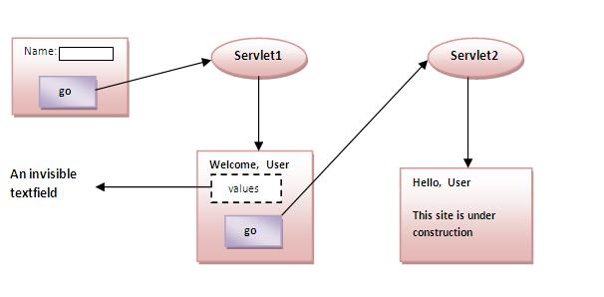

### index.html

[copy to clipboard](http://www.javatpoint.com/hidden-form-field-in-session-tracking)

1. <form action="servlet1">
2. Name:<input type="text" name="userName"/><br/>
3. <input type="submit" value="go"/>
4. </form>



### FirstServlet.java

[copy to clipboard](http://www.javatpoint.com/hidden-form-field-in-session-tracking)

1. import java.io.*;
2. import javax.servlet.*;
3. import javax.servlet.http.*;
5. public class FirstServlet extends HttpServlet {
6. public void doGet(HttpServletRequest request, HttpServletResponse response){
7. try{
9. response.setContentType("text/html");
10. PrintWriter out = response.getWriter();
12. String n=request.getParameter("userName");
13. out.print("Welcome "+n);
15. //creating form that have invisible textfield
16. out.print("<form action='servlet2'>");
17. out.print("<input type='hidden' name='uname' value='"+n+"'>");
18. out.print("<input type='submit' value='go'>");
19. out.print("</form>");
20. out.close();
22. }catch(Exception e){System.out.println(e);}
23. }
25. }



### SecondServlet.java

[copy to clipboard](http://www.javatpoint.com/hidden-form-field-in-session-tracking)

1. import java.io.*;
2. import javax.servlet.*;
3. import javax.servlet.http.*;
4. public class SecondServlet extends HttpServlet {
5. public void doGet(HttpServletRequest request, HttpServletResponse response)
6. try{
7. response.setContentType("text/html");
8. PrintWriter out = response.getWriter();
10. //Getting the value from the hidden field
11. String n=request.getParameter("uname");
12. out.print("Hello "+n);
14. out.close();
15. }catch(Exception e){System.out.println(e);}
16. }
17. }



### web.xml

[copy to clipboard](http://www.javatpoint.com/hidden-form-field-in-session-tracking)

1. <web-app>
3. <servlet>
4. <servlet-name>s1</servlet-name>
5. <servlet-class>FirstServlet</servlet-class>
6. </servlet>
8. <servlet-mapping>
9. <servlet-name>s1</servlet-name>
10. <url-pattern>/servlet1</url-pattern>
11. </servlet-mapping>
13. <servlet>
14. <servlet-name>s2</servlet-name>
15. <servlet-class>SecondServlet</servlet-class>
16. </servlet>
18. <servlet-mapping>
19. <servlet-name>s2</servlet-name>
20. <url-pattern>/servlet2</url-pattern>
21. </servlet-mapping>
23. </web-app>



[download this example (developed using Myeclipse IDE)](http://www.javatpoint.com/src/servlet/myeclipse/hiddenformfield.zip)  
[download this example (developed using Eclipse IDE)](http://www.javatpoint.com/src/servlet/eclipse/hiddenformfield.zip)  
[download this example (developed using Netbeans IDE)](http://www.javatpoint.com/src/servlet/netbeans/hiddenformfield.zip)

Next Topic[Url Rewriting In Session Tracking](http://www.javatpoint.com/url-rewriting-in-session-tracking)

# 3)URL Rewriting

1. [URL Rewriting](http://www.javatpoint.com/url-rewriting-in-session-tracking)
2. [Advantage of URL Rewriting](http://www.javatpoint.com/url-rewriting-in-session-tracking#urladv)
3. [Disadvantage of URL Rewriting](http://www.javatpoint.com/url-rewriting-in-session-tracking#urldisadv)
4. [Example of URL Rewriting](http://www.javatpoint.com/url-rewriting-in-session-tracking#urlex)

In URL rewriting, we append a token or identifier to the URL of the next Servlet or the next resource. We can send parameter name/value pairs using the following format:

url?name1=value1&name2=value2&??

A name and a value is separated using an equal = sign, a parameter name/value pair is separated from another parameter using the ampersand(&). When the user clicks the hyperlink, the parameter name/value pairs will be passed to the server. From a Servlet, we can use getParameter() method to obtain a parameter value.

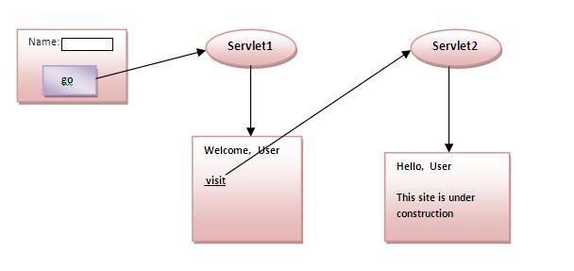

### Advantage of URL Rewriting

1. It will always work whether cookie is disabled or not (browser independent).
2. Extra form submission is not required on each pages.

### Disadvantage of URL Rewriting

1. It will work only with links.
2. It can send Only textual information.

### Example of using URL Rewriting

In this example, we are maintaning the state of the user using link. For this purpose, we are appending the name of the user in the query string and getting the value from the query string in another page.

### index.html

[copy to clipboard](http://www.javatpoint.com/url-rewriting-in-session-tracking)

1. <form action="servlet1">
2. Name:<input type="text" name="userName"/><br/>
3. <input type="submit" value="go"/>
4. </form>



### FirstServlet.java

[copy to clipboard](http://www.javatpoint.com/url-rewriting-in-session-tracking)

1. import java.io.*;
2. import javax.servlet.*;
3. import javax.servlet.http.*;

6. public class FirstServlet extends HttpServlet {
8. public void doGet(HttpServletRequest request, HttpServletResponse response){
9. try{
11. response.setContentType("text/html");
12. PrintWriter out = response.getWriter();
14. String n=request.getParameter("userName");
15. out.print("Welcome "+n);
17. //appending the username in the query string
18. out.print("<a href='servlet2?uname="+n+"'>visit</a>");
20. out.close();
22. }catch(Exception e){System.out.println(e);}
23. }
25. }



### SecondServlet.java

[copy to clipboard](http://www.javatpoint.com/url-rewriting-in-session-tracking)

1. import java.io.*;
2. import javax.servlet.*;
3. import javax.servlet.http.*;
5. public class SecondServlet extends HttpServlet {
7. public void doGet(HttpServletRequest request, HttpServletResponse response)
8. try{
10. response.setContentType("text/html");
11. PrintWriter out = response.getWriter();
13. //getting value from the query string
14. String n=request.getParameter("uname");
15. out.print("Hello "+n);
17. out.close();
19. }catch(Exception e){System.out.println(e);}
20. }

23. }



### web.xml

[copy to clipboard](http://www.javatpoint.com/url-rewriting-in-session-tracking)

1. <web-app>
3. <servlet>
4. <servlet-name>s1</servlet-name>
5. <servlet-class>FirstServlet</servlet-class>
6. </servlet>
8. <servlet-mapping>
9. <servlet-name>s1</servlet-name>
10. <url-pattern>/servlet1</url-pattern>
11. </servlet-mapping>
13. <servlet>
14. <servlet-name>s2</servlet-name>
15. <servlet-class>SecondServlet</servlet-class>
16. </servlet>
18. <servlet-mapping>
19. <servlet-name>s2</servlet-name>
20. <url-pattern>/servlet2</url-pattern>
21. </servlet-mapping>
23. </web-app>



[download this example (developed using Myeclipse IDE)](http://www.javatpoint.com/src/servlet/myeclipse/urlrewriting.zip)  
[download this example (developed using Eclipse IDE)](http://www.javatpoint.com/src/servlet/eclipse/urlrewriting.zip)  
[download this example (developed using Netbeans IDE)](http://www.javatpoint.com/src/servlet/netbeans/urlrewriting.zip)

Next Topic[Http Session In Session Tracking](http://www.javatpoint.com/http-session-in-session-tracking)

# ) HttpSession interface

1. [HttpSession interface](http://www.javatpoint.com/http-session-in-session-tracking)
2. [How to get the HttpSession object](http://www.javatpoint.com/http-session-in-session-tracking#httpsessionhow)
3. [Commonly used methods of HttpSession interface](http://www.javatpoint.com/http-session-in-session-tracking#httpsessionmethod)
4. [Example of using HttpSession](http://www.javatpoint.com/http-session-in-session-tracking#httpsessionex)

In such case, container creates a session id for each user.The container uses this id to identify the particular user.An object of HttpSession can be used to perform two tasks:

1. bind objects
2. view and manipulate information about a session, such as the session identifier, creation time, and last accessed time.

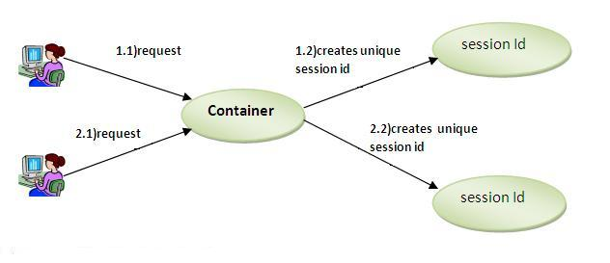

### How to get the HttpSession object ?

The HttpServletRequest interface provides two methods to get the object of HttpSession:

1. **public HttpSession getSession():**Returns the current session associated with this request, or if the request does not have a session, creates one.
2. **public HttpSession getSession(boolean create):**Returns the current HttpSession associated with this request or, if there is no current session and create is true, returns a new session.

### Commonly used methods of HttpSession interface

1. **public String getId():**Returns a string containing the unique identifier value.
2. **public long getCreationTime():**Returns the time when this session was created, measured in milliseconds since midnight January 1, 1970 GMT.
3. **public long getLastAccessedTime():**Returns the last time the client sent a request associated with this session, as the number of milliseconds since midnight January 1, 1970 GMT.
4. **public void invalidate():**Invalidates this session then unbinds any objects bound to it.

### Example of using HttpSession

In this example, we are setting the attribute in the session scope in one servlet and getting that value from the session scope in another servlet. To set the attribute in the session scope, we have used the setAttribute() method of HttpSession interface and to get the attribute, we have used the getAttribute method.

### index.html

[copy to clipboard](http://www.javatpoint.com/http-session-in-session-tracking)

1. <form action="servlet1">
2. Name:<input type="text" name="userName"/><br/>
3. <input type="submit" value="go"/>
4. </form>



### FirstServlet.java

[copy to clipboard](http://www.javatpoint.com/http-session-in-session-tracking)

1. import java.io.*;
2. import javax.servlet.*;
3. import javax.servlet.http.*;

6. public class FirstServlet extends HttpServlet {
8. public void doGet(HttpServletRequest request, HttpServletResponse response){
9. try{
11. response.setContentType("text/html");
12. PrintWriter out = response.getWriter();
14. String n=request.getParameter("userName");
15. out.print("Welcome "+n);
17. HttpSession session=request.getSession();
18. session.setAttribute("uname",n);
20. out.print("<a href='servlet2'>visit</a>");
22. out.close();
24. }catch(Exception e){System.out.println(e);}
25. }
27. }



### SecondServlet.java

[copy to clipboard](http://www.javatpoint.com/http-session-in-session-tracking)

1. import java.io.*;
2. import javax.servlet.*;
3. import javax.servlet.http.*;
5. public class SecondServlet extends HttpServlet {
7. public void doGet(HttpServletRequest request, HttpServletResponse response)
8. try{
10. response.setContentType("text/html");
11. PrintWriter out = response.getWriter();
13. HttpSession session=request.getSession(false);
14. String n=(String)session.getAttribute("uname");
15. out.print("Hello "+n);
17. out.close();
19. }catch(Exception e){System.out.println(e);}
20. }

23. }



### web.xml

[copy to clipboard](http://www.javatpoint.com/http-session-in-session-tracking)

1. <web-app>
3. <servlet>
4. <servlet-name>s1</servlet-name>
5. <servlet-class>FirstServlet</servlet-class>
6. </servlet>
8. <servlet-mapping>
9. <servlet-name>s1</servlet-name>
10. <url-pattern>/servlet1</url-pattern>
11. </servlet-mapping>
13. <servlet>
14. <servlet-name>s2</servlet-name>
15. <servlet-class>SecondServlet</servlet-class>
16. </servlet>
18. <servlet-mapping>
19. <servlet-name>s2</servlet-name>
20. <url-pattern>/servlet2</url-pattern>
21. </servlet-mapping>
23. </web-app>



[download this example (developed using Myeclipse IDE)](http://www.javatpoint.com/src/servlet/myeclipse/HttpSession.zip)  
[download this example (developed using Eclipse IDE)](http://www.javatpoint.com/src/servlet/eclipse/HttpSession.zip)  
[download this example (developed using Netbeans IDE)](http://www.javatpoint.com/src/servlet/netbeans/HttpSession.zip)

Next Topic[Servlet HttpSession login and logout example](http://www.javatpoint.com/servlet-http-session-login-and-logout-example)

# Servlet HttpSession Login and Logout Example

We can bind the objects on HttpSession instance and get the objects by using setAttribute and getAttribute methods.

In the previous page, we have learnt about what is HttpSession, How to store and get data from session object etc.

Here, we are going to create a real world login and logout application without using database code. We are assuming that password is admin123.

Visit here for login and logout application using cookies only [servlet login and logout example using cookies](http://www.javatpoint.com/servlet-login-and-logout-example-using-cookies)

In this example, we are creating 3 links: login, logout and profile. User can't go to profile page until he/she is logged in. If user is logged out, he need to login again to visit profile.

In this application, we have created following files.

1. index.html
2. link.html
3. login.html
4. LoginServlet.java
5. LogoutServlet.java
6. ProfileServlet.java
7. web.xml

File: index.html

[copy to clipboard](http://www.javatpoint.com/servlet-http-session-login-and-logout-example)

1. <!DOCTYPE html>
2. <html>
3. <head>
4. <meta charset="ISO-8859-1">
5. <title>Servlet Login Example</title>
6. </head>
7. <body>
9. <h1>Login App using HttpSession</h1>
10. <a href="login.html">Login</a>|
11. <a href="LogoutServlet">Logout</a>|
12. <a href="ProfileServlet">Profile</a>
14. </body>
15. </html>



File: link.html

[copy to clipboard](http://www.javatpoint.com/servlet-http-session-login-and-logout-example)

1. <a href="login.html">Login</a> |
2. <a href="LogoutServlet">Logout</a> |
3. <a href="ProfileServlet">Profile</a>
4. <hr>



File: login.html

[copy to clipboard](http://www.javatpoint.com/servlet-http-session-login-and-logout-example)

1. <form action="LoginServlet" method="post">
2. Name:<input type="text" name="name"><br>
3. Password:<input type="password" name="password"><br>
4. <input type="submit" value="login">
5. </form>



File: LoginServlet.java

[copy to clipboard](http://www.javatpoint.com/servlet-http-session-login-and-logout-example)

1. import java.io.IOException;
2. import java.io.PrintWriter;
4. import javax.servlet.ServletException;
5. import javax.servlet.http.HttpServlet;
6. import javax.servlet.http.HttpServletRequest;
7. import javax.servlet.http.HttpServletResponse;
8. import javax.servlet.http.HttpSession;
9. public class LoginServlet extends HttpServlet {
10. protected void doPost(HttpServletRequest request, HttpServletResponse response)
11. throws ServletException, IOException {
12. response.setContentType("text/html");
13. PrintWriter out=response.getWriter();
14. request.getRequestDispatcher("link.html").include(request, response);
16. String name=request.getParameter("name");
17. String password=request.getParameter("password");
19. if(password.equals("admin123")){
20. out.print("Welcome, "+name);
21. HttpSession session=request.getSession();
22. session.setAttribute("name",name);
23. }
24. else{
25. out.print("Sorry, username or password error!");
26. request.getRequestDispatcher("login.html").include(request, response);
27. }
28. out.close();
29. }
30. }



File: LogoutServlet.java

[copy to clipboard](http://www.javatpoint.com/servlet-http-session-login-and-logout-example)

1. import java.io.IOException;
2. import java.io.PrintWriter;
4. import javax.servlet.ServletException;
5. import javax.servlet.http.HttpServlet;
6. import javax.servlet.http.HttpServletRequest;
7. import javax.servlet.http.HttpServletResponse;
8. import javax.servlet.http.HttpSession;
9. public class LogoutServlet extends HttpServlet {
10. protected void doGet(HttpServletRequest request, HttpServletResponse response)
11. throws ServletException, IOException {
12. response.setContentType("text/html");
13. PrintWriter out=response.getWriter();
15. request.getRequestDispatcher("link.html").include(request, response);
17. HttpSession session=request.getSession();
18. session.invalidate();
20. out.print("You are successfully logged out!");
22. out.close();
23. }
24. }



File: ProfileServlet.java

[copy to clipboard](http://www.javatpoint.com/servlet-http-session-login-and-logout-example)

1. import java.io.IOException;
2. import java.io.PrintWriter;
3. import javax.servlet.ServletException;
4. import javax.servlet.http.HttpServlet;
5. import javax.servlet.http.HttpServletRequest;
6. import javax.servlet.http.HttpServletResponse;
7. import javax.servlet.http.HttpSession;
8. public class ProfileServlet extends HttpServlet {
9. protected void doGet(HttpServletRequest request, HttpServletResponse response)
10. throws ServletException, IOException {
11. response.setContentType("text/html");
12. PrintWriter out=response.getWriter();
13. request.getRequestDispatcher("link.html").include(request, response);
15. HttpSession session=request.getSession(false);
16. if(session!=null){
17. String name=(String)session.getAttribute("name");
19. out.print("Hello, "+name+" Welcome to Profile");
20. }
21. else{
22. out.print("Please login first");
23. request.getRequestDispatcher("login.html").include(request, response);
24. }
25. out.close();
26. }
27. }



File: web.xml

[copy to clipboard](http://www.javatpoint.com/servlet-http-session-login-and-logout-example)

1. <?xml version="1.0" encoding="UTF-8"?>
2. <web-app xmlns:xsi="http://www.w3.org/2001/XMLSchema-instance"
3. xmlns="http://java.sun.com/xml/ns/javaee" xsi:schemaLocation="http://java.sun.com/xml/ns/javaee
4. http://java.sun.com/xml/ns/javaee/web-app_2_5.xsd" id="WebApp_ID" version="2.5">
6. <servlet>
7. <description></description>
8. <display-name>LoginServlet</display-name>
9. <servlet-name>LoginServlet</servlet-name>
10. <servlet-class>LoginServlet</servlet-class>
11. </servlet>
12. <servlet-mapping>
13. <servlet-name>LoginServlet</servlet-name>
14. <url-pattern>/LoginServlet</url-pattern>
15. </servlet-mapping>
16. <servlet>
17. <description></description>
18. <display-name>ProfileServlet</display-name>
19. <servlet-name>ProfileServlet</servlet-name>
20. <servlet-class>ProfileServlet</servlet-class>
21. </servlet>
22. <servlet-mapping>
23. <servlet-name>ProfileServlet</servlet-name>
24. <url-pattern>/ProfileServlet</url-pattern>
25. </servlet-mapping>
26. <servlet>
27. <description></description>
28. <display-name>LogoutServlet</display-name>
29. <servlet-name>LogoutServlet</servlet-name>
30. <servlet-class>LogoutServlet</servlet-class>
31. </servlet>
32. <servlet-mapping>
33. <servlet-name>LogoutServlet</servlet-name>
34. <url-pattern>/LogoutServlet</url-pattern>
35. </servlet-mapping>
36. </web-app>



[download this example (developed using Eclipse IDE)](http://www.javatpoint.com/src/servlet/eclipse/httpsessionlogin.zip)

#### Output

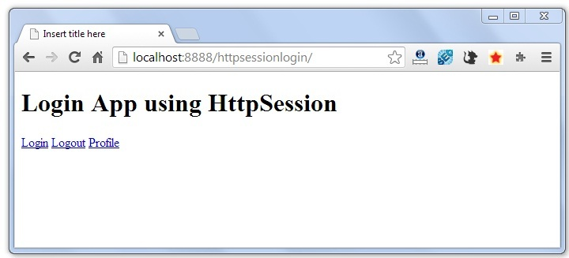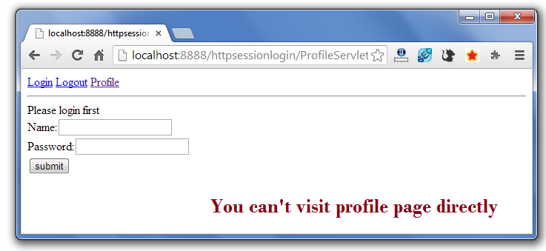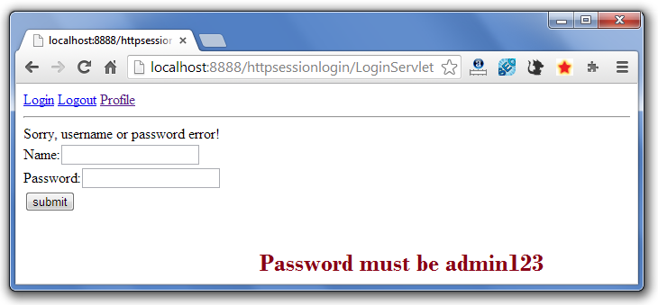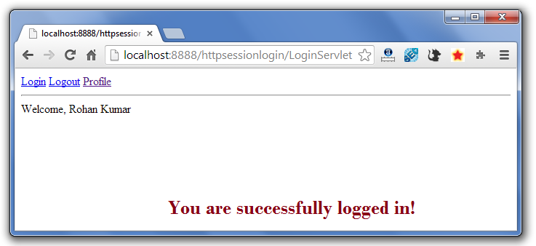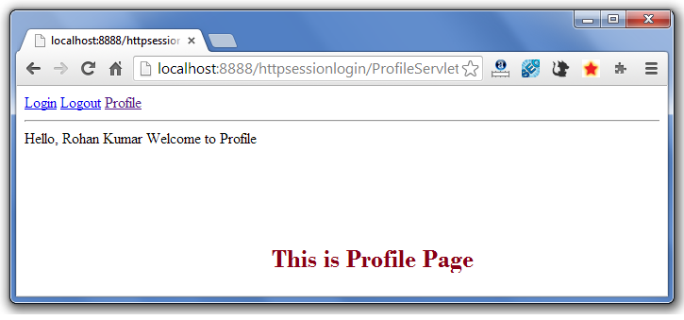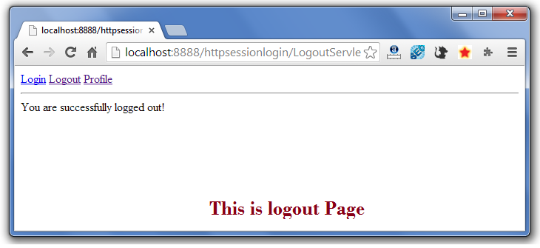

If again you click on the profile link, you need to login first.

Next Topic[Event and Listener in Servlet](http://www.javatpoint.com/Event-and-Listener-in-Servlet)

# Event and Listener in Servlet

1. [Event and Listener in Servlet](http://www.javatpoint.com/Event-and-Listener-in-Servlet)
2. [Event classes](http://www.javatpoint.com/Event-and-Listener-in-Servlet#eventclasses)
3. [Event interfaces](http://www.javatpoint.com/Event-and-Listener-in-Servlet#eventinterfaces)

|  |
| --- |
| Events are basically occurrence of something. Changing the state of an object is known as an event. |
| We can perform some important tasks at the occurrence of these exceptions, such as counting total and current logged-in users, creating tables of the database at time of deploying the project, creating database connection object etc. |
| There are many Event classes and Listener interfaces in the javax.servlet and javax.servlet.http packages. |

### Event classes

The event classes are as follows:

1. ServletRequestEvent
2. ServletContextEvent
3. ServletRequestAttributeEvent
4. ServletContextAttributeEvent
5. HttpSessionEvent
6. HttpSessionBindingEvent

### Event interfaces

The event interfaces are as follows:

1. ServletRequestListener
2. ServletRequestAttributeListener
3. ServletContextListener
4. ServletContextAttributeListener
5. HttpSessionListener
6. HttpSessionAttributeListener
7. HttpSessionBindingListener
8. HttpSessionActivationListener

### Upcoming topics in Servlet Events and Listeners

[ServletContextEvent](http://www.javatpoint.com/ServletContextEvent)

Let's see the simple example of ServletContextEvent and ServletContextListener

[HttpSessionEvent](http://www.javatpoint.com/HttpSessionEvent)

Let's see the simple example of HttpSessionEvent and HttpSessionListener

[ServletRequestEvent](http://www.javatpoint.com/ServletRequestEvent)

Let's see the simple example of ServletRequestEvent and ServletRequestListener

[ServletContext AttributeEvent](http://www.javatpoint.com/ServletContextAttributeEvent)

Let's see the simple example of ServletContextAttributeEvent and ServletContextAttributeListener

[HttpSessionBindingEvent](http://www.javatpoint.com/HttpSessionBindingEvent)

Let's see the simple example of HttpSessionBindingEvent and HttpSessionAttributeListener

[ServletRequestAttributeEvent](http://www.javatpoint.com/ServletRequestAttributeEvent)

Let's see the simple example of ServletRequestAttributeEvent and ServletRequestAttributeEvent

Next Topic[Filter](http://www.javatpoint.com/filter)

# Servlet Filter

1. [Filter](http://www.javatpoint.com/servlet-filter)
2. [Usage of Filter](http://www.javatpoint.com/servlet-filter#filterusage)
3. [Advantage of Filter](http://www.javatpoint.com/servlet-filter#filteradvantage)
4. [Filter API](http://www.javatpoint.com/servlet-filter#filterapi)
   1. [Filter interface](http://www.javatpoint.com/servlet-filter#filterinterface)
   2. [FilterChain interface](http://www.javatpoint.com/servlet-filter#filterchain)
   3. [FilterConfig interface](http://www.javatpoint.com/servlet-filter#filterconfig)
5. [Simple Example of Filter](http://www.javatpoint.com/servlet-filter#filterex)

A **filter** is an object that is invoked at the preprocessing and postprocessing of a request.

It is mainly used to perform filtering tasks such as conversion, logging, compression, encryption and decryption, input validation etc.

The **servlet filter is pluggable**, i.e. its entry is defined in the web.xml file, if we remove the entry of filter from the web.xml file, filter will be removed automatically and we don't need to change the servlet.

So maintenance cost will be less.

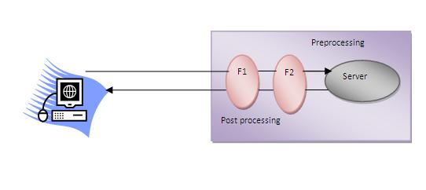

#### *Note: Unlike Servlet, One filter doesn't have dependency on another filter.*

### Usage of Filter

* recording all incoming requests
* logs the IP addresses of the computers from which the requests originate
* conversion
* data compression
* encryption and decryption
* input validation etc.

### Advantage of Filter

1. Filter is pluggable.
2. One filter don't have dependency onto another resource.
3. Less Maintenance

### Filter API

Like servlet filter have its own API. The javax.servlet package contains the three interfaces of Filter API.

1. Filter
2. FilterChain
3. FilterConfig

### 1) Filter interface

For creating any filter, you must implement the Filter interface. Filter interface provides the life cycle methods for a filter.

|  |  |
| --- | --- |
| **Method** | **Description** |
| public void init(FilterConfig config) | init() method is invoked only once. It is used to initialize the filter. |
| public void doFilter(HttpServletRequest request,HttpServletResponse response, FilterChain chain) | doFilter() method is invoked every time when user request to any resource, to which the filter is mapped.It is used to perform filtering tasks. |
| public void destroy() | This is invoked only once when filter is taken out of the service. |

### 2) FilterChain interface

The object of FilterChain is responsible to invoke the next filter or resource in the chain.This object is passed in the doFilter method of Filter interface.The FilterChain interface contains only one method:

1. **public void doFilter(HttpServletRequest request, HttpServletResponse response):** it passes the control to the next filter or resource.

### How to define Filter

We can define filter same as servlet. Let's see the elements of filter and filter-mapping.

[copy to clipboard](http://www.javatpoint.com/servlet-filter)

1. <web-app>
3. <filter>
4. <filter-name>...</filter-name>
5. <filter-class>...</filter-class>
6. </filter>
8. <filter-mapping>
9. <filter-name>...</filter-name>
10. <url-pattern>...</url-pattern>
11. </filter-mapping>
13. </web-app>



For mapping filter we can use, either url-pattern or servlet-name. The url-pattern elements has an advantage over servlet-name element i.e. it can be applied on servlet, JSP or HTML.

### Simple Example of Filter

In this example, we are simply displaying information that filter is invoked automatically after the post processing of the request.

### index.html

[copy to clipboard](http://www.javatpoint.com/servlet-filter)

1. <a href="servlet1">click here</a>



### MyFilter.java

[copy to clipboard](http://www.javatpoint.com/servlet-filter)

1. import java.io.IOException;
2. import java.io.PrintWriter;
4. import javax.servlet.*;
6. public class MyFilter implements Filter{
8. public void init(FilterConfig arg0) throws ServletException {}
10. public void doFilter(ServletRequest req, ServletResponse resp,
11. FilterChain chain) throws IOException, ServletException {
13. PrintWriter out=resp.getWriter();
14. out.print("filter is invoked before");
16. chain.doFilter(req, resp);//sends request to next resource
18. out.print("filter is invoked after");
19. }
20. public void destroy() {}
21. }



### HelloServlet.java

[copy to clipboard](http://www.javatpoint.com/servlet-filter)

1. import java.io.IOException;
2. import java.io.PrintWriter;
4. import javax.servlet.ServletException;
5. import javax.servlet.http.*;
7. public class HelloServlet extends HttpServlet {
8. public void doGet(HttpServletRequest request, HttpServletResponse response)
9. throws ServletException, IOException {
11. response.setContentType("text/html");
12. PrintWriter out = response.getWriter();
14. out.print("<br>welcome to servlet<br>");
16. }
18. }



**web.xml**

|  |
| --- |
| For defining the filter, filter element of web-app must be defined just like servlet. |

[copy to clipboard](http://www.javatpoint.com/servlet-filter)

1. <web-app>
3. <servlet>
4. <servlet-name>s1</servlet-name>
5. <servlet-class>HelloServlet</servlet-class>
6. </servlet>
8. <servlet-mapping>
9. <servlet-name>s1</servlet-name>
10. <url-pattern>/servlet1</url-pattern>
11. </servlet-mapping>
13. <filter>
14. <filter-name>f1</filter-name>
15. <filter-class>MyFilter</filter-class>
16. </filter>
18. <filter-mapping>
19. <filter-name>f1</filter-name>
20. <url-pattern>/servlet1</url-pattern>
21. </filter-mapping>

24. </web-app>



[download this example (developed using Myeclipse IDE)](http://www.javatpoint.com/src/servlet/filter1.zip)  
[download this example (developed using Eclipse IDE)](http://www.javatpoint.com/src/servlet/eclipse/filter1.zip)  
[download this example (developed using Netbeans IDE)](http://www.javatpoint.com/src/servlet/netbeans/filter1.zip)

Next Topic[Authentication Filter](http://www.javatpoint.com/authentication-filter)

# Authentication Filter

We can perform authentication in filter. Here, we are going to check to password given by the user in filter class, if given password is admin, it will forward the request to the WelcomeAdmin servlet otherwise it will display error message.

### Example of authenticating user using filter

Let's see the simple example of authenticating user using filter.

Here, we have created 4 files:

* index.html
* MyFilter.java
* AdminServlet.java
* web.xml

**index.html**

[copy to clipboard](http://www.javatpoint.com/authentication-filter)

1. <form action="servlet1">
2. Name:<input type="text" name="name"/><br/>
3. Password:<input type="password" name="password"/><br/>
5. <input type="submit" value="login">
7. </form>



**MyFilter.java**

[copy to clipboard](http://www.javatpoint.com/authentication-filter)

1. import java.io.IOException;
2. import java.io.PrintWriter;
3. import javax.servlet.*;
5. public class MyFilter implements Filter{
7. public void init(FilterConfig arg0) throws ServletException {}
9. public void doFilter(ServletRequest req, ServletResponse resp,
10. FilterChain chain) throws IOException, ServletException {
12. PrintWriter out=resp.getWriter();
14. String password=req.getParameter("password");
15. if(password.equals("admin")){
16. chain.doFilter(req, resp);//sends request to next resource
17. }
18. else{
19. out.print("username or password error!");
20. RequestDispatcher rd=req.getRequestDispatcher("index.html");
21. rd.include(req, resp);
22. }
24. }
25. public void destroy() {}
27. }



**AdminServlet.java**

[copy to clipboard](http://www.javatpoint.com/authentication-filter)

1. import java.io.IOException;
2. import java.io.PrintWriter;
4. import javax.servlet.ServletException;
5. import javax.servlet.http.*;
7. public class AdminServlet extends HttpServlet {
8. public void doGet(HttpServletRequest request, HttpServletResponse response)
9. throws ServletException, IOException {
11. response.setContentType("text/html");
12. PrintWriter out = response.getWriter();
14. out.print("welcome ADMIN");
15. out.close();
16. }
17. }



**web.xml**

[copy to clipboard](http://www.javatpoint.com/authentication-filter)

1. <web-app>
2. <servlet>
3. <servlet-name>AdminServlet</servlet-name>
4. <servlet-class>AdminServlet</servlet-class>
5. </servlet>
7. <servlet-mapping>
8. <servlet-name>AdminServlet</servlet-name>
9. <url-pattern>/servlet1</url-pattern>
10. </servlet-mapping>
12. <filter>
13. <filter-name>f1</filter-name>
14. <filter-class>MyFilter</filter-class>
15. </filter>
16. <filter-mapping>
17. <filter-name>f1</filter-name>
18. <url-pattern>/servlet1</url-pattern>
19. </filter-mapping>
21. </web-app>



[download this example (developed using Myeclipse IDE)](http://www.javatpoint.com/src/servlet/filterauth.zip)  
[download this example (developed using Eclipse IDE)](http://www.javatpoint.com/src/servlet/eclipse/filterauth.zip)  
[download this example (developed using Netbeans IDE)](http://www.javatpoint.com/src/servlet/netbeans/filterauth.zip)

Next Topic[Filter Config](http://www.javatpoint.com/filter-config)

# FilterConfig

An object of FilterConfig is created by the web container. This object can be used to get the configuration information from the web.xml file.

## Methods of FilterConfig interface

There are following 4 methods in the FilterConfig interface.

1. **public void init(FilterConfig config):** init() method is invoked only once it is used to initialize the filter.
2. **public String getInitParameter(String parameterName):** Returns the parameter value for the specified parameter name.
3. **public java.util.Enumeration getInitParameterNames():** Returns an enumeration containing all the parameter names.
4. **public ServletContext getServletContext():** Returns the ServletContext object.

### Example of FilterConfig

In this example, if you change the param-value to no, request will be forwarded to the servlet otherwise filter will create the response with the message: this page is underprocessing. Let's see the simple example of FilterConfig. Here, we have created 4 files:

* index.html
* MyFilter.java
* HelloServlet.java
* web.xml

**index.html**

[copy to clipboard](http://www.javatpoint.com/filter-config)

1. <a href="servlet1">click here</a>



**MyFilter.java**

[copy to clipboard](http://www.javatpoint.com/filter-config)

1. import java.io.IOException;
2. import java.io.PrintWriter;
4. import javax.servlet.*;
6. public class MyFilter implements Filter{
7. FilterConfig config;
9. public void init(FilterConfig config) throws ServletException {
10. this.config=config;
11. }
13. public void doFilter(ServletRequest req, ServletResponse resp,
14. FilterChain chain) throws IOException, ServletException {
16. PrintWriter out=resp.getWriter();
18. String s=config.getInitParameter("construction");
20. if(s.equals("yes")){
21. out.print("This page is under construction");
22. }
23. else{
24. chain.doFilter(req, resp);//sends request to next resource
25. }
27. }
28. public void destroy() {}
29. }



**HelloServlet.java**

[copy to clipboard](http://www.javatpoint.com/filter-config)

1. import java.io.IOException;
2. import java.io.PrintWriter;
4. import javax.servlet.ServletException;
5. import javax.servlet.http.*;
7. public class HelloServlet extends HttpServlet {
8. public void doGet(HttpServletRequest request, HttpServletResponse response)
9. throws ServletException, IOException {
11. response.setContentType("text/html");
12. PrintWriter out = response.getWriter();
14. out.print("<br>welcome to servlet<br>");
16. }
18. }



**web.xml**

[copy to clipboard](http://www.javatpoint.com/filter-config)

1. <web-app>
3. <servlet>
4. <servlet-name>HelloServlet</servlet-name>
5. <servlet-class>HelloServlet</servlet-class>
6. </servlet>
8. <servlet-mapping>
9. <servlet-name>HelloServlet</servlet-name>
10. <url-pattern>/servlet1</url-pattern>
11. </servlet-mapping>
13. <filter>
14. <filter-name>f1</filter-name>
15. <filter-class>MyFilter</filter-class>
16. <init-param>
17. <param-name>construction</param-name>
18. <param-value>no</param-value>
19. </init-param>
20. </filter>
21. <filter-mapping>
22. <filter-name>f1</filter-name>
23. <url-pattern>/servlet1</url-pattern>
24. </filter-mapping>

27. </web-app>



[download this example (developed using Myeclipse IDE)](http://www.javatpoint.com/src/servlet/filterconfig.zip)  
[download this example (developed using Eclipse IDE)](http://www.javatpoint.com/src/servlet/eclipse/filterconfig.zip)  
[download this example (developed using Netbeans IDE)](http://www.javatpoint.com/src/servlet/netbeans/filterconfig.zip)

Next Topic[Useful Example Of Filter](http://www.javatpoint.com/filter2)

# Useful Filter Examples

There is given some useful examples of filter.

### Example of sending response by filter only

**MyFilter.java**

[copy to clipboard](http://www.javatpoint.com/filter2)

1. import java.io.*;
2. import javax.servlet.*;
4. public class MyFilter implements Filter{
5. public void init(FilterConfig arg0) throws ServletException {}
7. public void doFilter(ServletRequest req, ServletResponse res,
8. FilterChain chain) throws IOException, ServletException {
10. PrintWriter out=res.getWriter();
12. out.print("<br/>this site is underconstruction..");
13. out.close();
15. }
16. public void destroy() {}
17. }



### Example of counting number of visitors for a single page

**MyFilter.java**

[copy to clipboard](http://www.javatpoint.com/filter2)

1. import java.io.*;
2. import javax.servlet.*;
4. public class MyFilter implements Filter{
5. static int count=0;
6. public void init(FilterConfig arg0) throws ServletException {}
8. public void doFilter(ServletRequest req, ServletResponse res,
9. FilterChain chain) throws IOException, ServletException {
11. PrintWriter out=res.getWriter();
12. chain.doFilter(request,response);
14. out.print("<br/>Total visitors "+(++count));
15. out.close();
17. }
18. public void destroy() {}
19. }



### Example of checking total response time in filter

**MyFilter.java**

[copy to clipboard](http://www.javatpoint.com/filter2)

1. import java.io.*;
2. import javax.servlet.*;
4. public class MyFilter implements Filter{
5. static int count=0;
6. public void init(FilterConfig arg0) throws ServletException {}
8. public void doFilter(ServletRequest req, ServletResponse res,
9. FilterChain chain) throws IOException, ServletException {
11. PrintWriter out=res.getWriter();
12. long before=System.currentTimeMillis();
14. chain.doFilter(request,response);
16. long after=System.currentTimeMillis();
17. out.print("<br/>Total response time "+(after-before)+" miliseconds");
18. out.close();
20. }
21. public void destroy() {}
22. }



Next Topic[ServletInputStream Class](http://www.javatpoint.com/ServletInputStream-class)

# ServletInputStream class

1. [ServletInputStream class](http://www.javatpoint.com/ServletInputStream-class)
2. [Method of ServletInputStream class](http://www.javatpoint.com/ServletInputStream-class)

**ServletInputStream** class provides stream to read binary data such as image etc. from the request object. It is an abstract class.

The **getInputStream()** method of **ServletRequest** interface returns the instance of ServletInputStream class. So can be get as:

[copy to clipboard](http://www.javatpoint.com/ServletInputStream-class)

1. ServletInputStream sin=request.getInputStream();



### Method of ServletInputStream class

There are only one method defined in the ServletInputStream class.

1. **int readLine(byte[] b, int off, int len)** it reads the input stream.

Next Topic[ServletOutputStream Class](http://www.javatpoint.com/ServletOutputStream-class)

# ServletOutputStream class

1. [ServletOutputStream class](http://www.javatpoint.com/ServletOutputStream-class)
2. [Methods of ServletOutputStream class](http://www.javatpoint.com/ServletOutputStream-class#method)
3. [Example of ServletOutputStream class](http://www.javatpoint.com/ServletOutputStream-class)

**ServletOutputStream** class provides a stream to write binary data into the response. It is an abstract class.

The **getOutputStream()** method of **ServletResponse** interface returns the instance of ServletOutputStream class. It may be get as:

[copy to clipboard](http://www.javatpoint.com/ServletOutputStream-class)

1. ServletOutputStream out=response.getOutputStream();



### Methods of ServletOutputStream class

The ServletOutputStream class provides print() and println() methods that are overloaded.

1. void print(boolean b){}
2. void print(char c){}
3. void print(int i){}
4. void print(long l){}
5. void print(float f){}
6. void print(double d){}
7. void print(String s){}
8. void println{}
9. void println(boolean b){}
10. void println(char c){}
11. void println(int i){}
12. void println(long l){}
13. void println(float f){}
14. void println(double d){}
15. void println(String s){}

### Example of ServletOutputStream class

[**Example of ServletOutputStream class to write image**](http://www.javatpoint.com/example-to-display-image-using-servlet)

Next Topic[Servlet With Annotation](http://www.javatpoint.com/servlet-with-annotation)

# Servlet with Annotation (feature of servlet3):

1. [Servlet with Annotation](http://www.javatpoint.com/servlet-with-annotation)
2. [Example of simple servlet by annotation](http://www.javatpoint.com/servlet-with-annotation#ex)

Annotation represents the metadata. If you use annotation, deployment descriptor (web.xml file) is not required. But you should have tomcat7 as it will not run in the previous versions of tomcat. @WebServlet annotation is used to map the servlet with the specified name.

### Example of simple servlet by annotation

There is given the simple example of servlet with annotation.

### Simple.java

[copy to clipboard](http://www.javatpoint.com/servlet-with-annotation)

1. import java.io.IOException;
2. import java.io.PrintWriter;
4. import javax.servlet.ServletException;
5. import javax.servlet.annotation.WebServlet;
6. import javax.servlet.http.HttpServlet;
7. import javax.servlet.http.HttpServletRequest;
8. import javax.servlet.http.HttpServletResponse;
10. @WebServlet("/Simple")
11. public class Simple extends HttpServlet {
12. private static final long serialVersionUID = 1L;
14. protected void doGet(HttpServletRequest request, HttpServletResponse response)
15. throws ServletException, IOException {

18. response.setContentType("text/html");
19. PrintWriter out=response.getWriter();
21. out.print("<html><body>");
22. out.print("<h3>Hello Servlet</h3>");
23. out.print("</body></html>");
24. }
25. }



[download this example (developed without IDE)](http://www.javatpoint.com/src/servlet/servletannotation.zip)  
[download this example (developed using Eclipse IDE)](http://www.javatpoint.com/src/servlet/eclipse/servletannotation.zip)  
[download this example (developed using Netbeans IDE)](http://www.javatpoint.com/src/servlet/netbeans/servletannotation.zip)

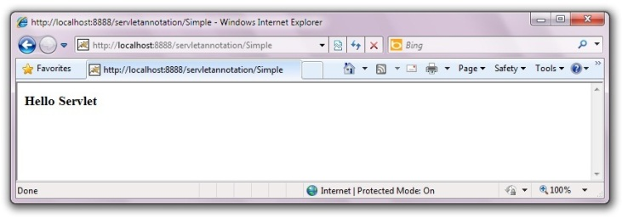

Next Topic[SingleThreadModel Interface](http://www.javatpoint.com/SingleThreadModel-interface)

# SingleThreadModel interface

1. [SingleThreadModel interface](http://www.javatpoint.com/SingleThreadModel-interface)
2. [Example of SingleThreadModel interface](http://www.javatpoint.com/SingleThreadModel-interface#ex)

The servlet programmer should implement SingleThreadModel interface to ensure that servlet can handle only one request at a time. It is a marker interface, means have no methods.

This interface is currently deprecated since Servlet API 2.4 because it doesn't solves all the thread-safety issues such as static variable and session attributes can be accessed by multiple threads at the same time even if we have implemented the SingleThreadModel interface. So it is recommended to use other means to resolve these thread safety issues such as synchronized block etc.

### Example of SingleThreadModel interface

Let's see the simple example of implementing the SingleThreadModel interface.

[copy to clipboard](http://www.javatpoint.com/SingleThreadModel-interface)

1. import java.io.IOException;
2. import java.io.PrintWriter;
3. import javax.servlet.ServletException;
4. import javax.servlet.SingleThreadModel;
5. import javax.servlet.http.HttpServlet;
6. import javax.servlet.http.HttpServletRequest;
7. import javax.servlet.http.HttpServletResponse;

10. public class MyServlet extends HttpServlet implements SingleThreadModel{
12. public void doGet(HttpServletRequest request, HttpServletResponse response)
13. throws ServletException, IOException {
15. response.setContentType("text/html");
16. PrintWriter out = response.getWriter();
18. out.print("welcome");
19. try{Thread.sleep(10000);}catch(Exception e){e.printStackTrace();}
20. out.print(" to servlet");

23. out.close();
24. }
26. }



[download this example (developed using Myeclipse IDE)](http://www.javatpoint.com/src/servlet/stm.zip)  
[download this example (developed usingEclipse IDE)](http://www.javatpoint.com/src/servlet/eclipse/stm.zip)  
[download this example (developed using Netbeans IDE)](http://www.javatpoint.com/src/servlet/netbeans/stm.zip)

Next Topic[Server Side Include](http://www.javatpoint.com/server-side-include)

# Server Side Include (SSI)

Thanks for your visit. This page is currently under processing....

Next Topic[Example Of Registration Form In Servlet](http://www.javatpoint.com/example-of-registration-form-in-servlet)

# Example of Registration form in servlet

Here, you will learn that how to create simple registration form in servlet. We are using oracle10g database. So you need to create a table first as given below:

[copy to clipboard](http://www.javatpoint.com/example-of-registration-form-in-servlet)

1. CREATE TABLE  "REGISTERUSER"
2. (    "NAME" VARCHAR2(4000),
3. "PASS" VARCHAR2(4000),
4. "EMAIL" VARCHAR2(4000),
5. "COUNTRY" VARCHAR2(4000)
6. )
7. /



To create the registration page in servlet, we can separate the database logic from the servlet. But here, we are mixing the database logic in the servlet only for simplicity of the program. We will develop this page in JSP following DAO, DTO and Singleton design pattern later.

### Example of Registration form in servlet

In this example, we have created the three pages.

* register.html
* Register.java
* web.xml

**register.html**

In this page, we have getting input from the user using text fields and combobox. The information entered by the user is forwarded to Register servlet, which is responsible to store the data into the database.

[copy to clipboard](http://www.javatpoint.com/example-of-registration-form-in-servlet)

1. <html>
2. <body>
3. <form action="servlet/Register" method="post">
5. Name:<input type="text" name="userName"/><br/><br/>
6. Password:<input type="password" name="userPass"/><br/><br/>
7. Email Id:<input type="text" name="userEmail"/><br/><br/>
8. Country:
9. <select name="userCountry">
10. <option>India</option>
11. <option>Pakistan</option>
12. <option>other</option>
13. </select>
15. <br/><br/>
16. <input type="submit" value="register"/>
18. </form>
19. </body>
20. </html>



**Register.java**

This servlet class receives all the data entered by user and stores it into the database. Here, we are performing the database logic. But you may separate it, which will be better for the web application.

[copy to clipboard](http://www.javatpoint.com/example-of-registration-form-in-servlet)

1. import java.io.*;
2. import java.sql.*;
3. import javax.servlet.ServletException;
4. import javax.servlet.http.*;
6. public class Register extends HttpServlet {
7. public void doPost(HttpServletRequest request, HttpServletResponse response)
8. throws ServletException, IOException {
10. response.setContentType("text/html");
11. PrintWriter out = response.getWriter();
13. String n=request.getParameter("userName");
14. String p=request.getParameter("userPass");
15. String e=request.getParameter("userEmail");
16. String c=request.getParameter("userCountry");
18. try{
19. Class.forName("oracle.jdbc.driver.OracleDriver");
20. Connection con=DriverManager.getConnection(
21. "jdbc:oracle:thin:@localhost:1521:xe","system","oracle");
23. PreparedStatement ps=con.prepareStatement(
24. "insert into registeruser values(?,?,?,?)");
26. ps.setString(1,n);
27. ps.setString(2,p);
28. ps.setString(3,e);
29. ps.setString(4,c);
31. int i=ps.executeUpdate();
32. if(i>0)
33. out.print("You are successfully registered...");

36. }catch (Exception e2) {System.out.println(e2);}
38. out.close();
39. }
41. }



**web.xml file**

The is the configuration file, providing information about the servlet.

[copy to clipboard](http://www.javatpoint.com/example-of-registration-form-in-servlet)

1. <web-app>
3. <servlet>
4. <servlet-name>Register</servlet-name>
5. <servlet-class>Register</servlet-class>
6. </servlet>
8. <servlet-mapping>
9. <servlet-name>Register</servlet-name>
10. <url-pattern>/servlet/Register</url-pattern>
11. </servlet-mapping>
13. <welcome-file-list>
14. <welcome-file>register.html</welcome-file>
15. </welcome-file-list>
17. </web-app>



[download this example](http://www.javatpoint.com/src/servlet/registeruser1.zip)  
[download the war file](http://www.javatpoint.com/src/servlet/registeruser.war)  
[download this example (developed using Myeclipse IDE)](http://www.javatpoint.com/src/servlet/mregisteruser.zip)  
[download this example (developed using Eclipse IDE)](http://www.javatpoint.com/src/servlet/eclipse/registeruser.zip)  
[download this example (developed using Netbeans IDE)](http://www.javatpoint.com/src/servlet/netbeans/registeruser.zip)

To connect java application with the Oracle database ojdbc14.jar file is required to be loaded. Put this jar file in WEB-INF/lib folder.

[download the jar file ojdbc14.jar](http://www.javatpoint.com/src/jdbc/ojdbc14.jar)

Next Topic[Example Of Fetching Result For The Given Rollno In Servlet](http://www.javatpoint.com/example-of-fetching-result-for-the-given-rollno-in-servlet)

# Example of Fetching Result for the given rollno

Here, you will learn that how to fetch result for the given rollno. I am assuming that there is a table as given below:

[copy to clipboard](http://www.javatpoint.com/example-of-fetching-result-for-the-given-rollno-in-servlet)

1. CREATE TABLE  "RESULT"
2. (    "ROLLNO" NUMBER,
3. "NAME" VARCHAR2(40),
4. "RESULT" VARCHAR2(40),
5. "GRADE" VARCHAR2(40),
6. CONSTRAINT "RESULT_PK" PRIMARY KEY ("ROLLNO") ENABLE
7. )
8. /



We are assuming there are many records in this table. In this example, we are getting the data from the database in servlet and printing it. We are doing all the database logic in servlet for simplicity of the program. But it will be better to separate it from the servlet file.

### Example of Fetching Result for the given rollno

In this example, we have create three files

* index.html
* Search.java
* web.xml

**index.html**

This page gets rollno from the user and forwards this data to servlet which is responsible to show the records based on the given rollno.

[copy to clipboard](http://www.javatpoint.com/example-of-fetching-result-for-the-given-rollno-in-servlet)

1. <html>
2. <body>
3. <form action="servlet/Search">
4. Enter your Rollno:<input type="text" name="roll"/><br/>
6. <input type="submit" value="search"/>
7. </form>
8. </body>
9. </html>



**Search.java**

This is the servlet file which gets the input from the user and maps this data with the database and prints the record for the matched data. In this page, we are displaying the column name of the database along with data, so we are using ResultSetMetaData interface.

[copy to clipboard](http://www.javatpoint.com/example-of-fetching-result-for-the-given-rollno-in-servlet)

1. import java.io.*;
2. import java.sql.*;
3. import javax.servlet.ServletException;
4. import javax.servlet.http.*;
6. public class Search extends HttpServlet {
8. public void doGet(HttpServletRequest request, HttpServletResponse response)
9. throws ServletException, IOException {
11. response.setContentType("text/html");
12. PrintWriter out = response.getWriter();
14. String rollno=request.getParameter("roll");
15. int roll=Integer.valueOf(rollno);
17. try{
18. Class.forName("oracle.jdbc.driver.OracleDriver");
19. Connection con=DriverManager.getConnection(
20. "jdbc:oracle:thin:@localhost:1521:xe","system","oracle");
22. PreparedStatement ps=con.prepareStatement("select * from result where rollno=?");
23. ps.setInt(1,roll);
25. out.print("<table width=50% border=1>");
26. out.print("<caption>Result:</caption>");
28. ResultSet rs=ps.executeQuery();
30. /* Printing column names */
31. ResultSetMetaData rsmd=rs.getMetaData();
32. int total=rsmd.getColumnCount();
33. out.print("<tr>");
34. for(int i=1;i<=total;i++)
35. {
36. out.print("<th>"+rsmd.getColumnName(i)+"</th>");
37. }
39. out.print("</tr>");
41. /* Printing result */
43. while(rs.next())
44. {
45. out.print("<tr><td>"+rs.getInt(1)+"</td><td>"+rs.getString(2)+"
46. </td><td>"+rs.getString(3)+"</td><td>"+rs.getString(4)+"</td></tr>");
48. }
50. out.print("</table>");
52. }catch (Exception e2) {e2.printStackTrace();}
54. finally{out.close();}
56. }
57. }



**web.xml file**

This is the configuration file which provides information of the servlet to the container.

[copy to clipboard](http://www.javatpoint.com/example-of-fetching-result-for-the-given-rollno-in-servlet)

1. <web-app>
3. <servlet>
4. <servlet-name>Search</servlet-name>
5. <servlet-class>Search</servlet-class>
6. </servlet>
8. <servlet-mapping>
9. <servlet-name>Search</servlet-name>
10. <url-pattern>/servlet/Search</url-pattern>
11. </servlet-mapping>
13. </web-app>



[download this example (developed without IDE)](http://www.javatpoint.com/src/servlet/getResult.zip)  
[download this example (developed using Myeclipse IDE)](http://www.javatpoint.com/src/servlet/getResultforgivenrollno.zip)  
[download this example (developed using Eclipse IDE)](http://www.javatpoint.com/src/servlet/getResult.zip)  
[download this example (developed using Netbeans IDE)](http://www.javatpoint.com/src/servlet/getResult.zip)

To connect java application with the Oracle database ojdbc14.jar file is required to be loaded. Put this jar file in WEB-INF/lib folder.

[download the jar file ojdbc14.jar](http://www.javatpoint.com/src/jdbc/ojdbc14.jar)

Next Topic[improving Servlet Performance To Fetch Records](http://www.javatpoint.com/improving-servlet-performance-to-fetch-records)

# Improving Servlet performance to fetch records from database

In this example, we are going to improve the performance of web application to fetch records from the database. To serve this, we are storing the data of the table in a collection, and reusing this collection in our servlet. So, we are not directly hitting the database again and again. By this, we are improving the performance.

To run this application, you need to create following table with some records.

[copy to clipboard](http://www.javatpoint.com/improving-servlet-performance-to-fetch-records)

1. CREATE TABLE  "CSUSER"
2. (    "USERID" NUMBER,
3. "USERNAME" VARCHAR2(4000),
4. "USERPASS" VARCHAR2(4000),
5. "USEREMAIL" VARCHAR2(4000),
6. "USERCOUNTRY" VARCHAR2(4000),
7. "CONTACT" NUMBER,
8. CONSTRAINT "CSUSER_PK" PRIMARY KEY ("USERID") ENABLE
9. )
10. /



### Example to Improve the performance of servlet to fetch records from database

In this example, we have created 6 pages.

1. **index.html**
2. **User.java**
3. **MyListener.java**
4. **MyServlet1.java**
5. **MyServlet2.java**
6. **web.xml**

**1) index.html**

This html file contains two links that sends request to the servlet.

[copy to clipboard](http://www.javatpoint.com/improving-servlet-performance-to-fetch-records)

1. <a href="servlet1">first servlet</a>|
2. <a href="servlet2">second servlet</a>



**2) User.java**

This is simple bean class containing 3 properties with its getters and setters. This class represents the table of the database.

[copy to clipboard](http://www.javatpoint.com/improving-servlet-performance-to-fetch-records)

1. public class User {
2. private int id;
3. private String name,password;
5. public int getId() {
6. return id;
7. }
8. public void setId(int id) {
9. this.id = id;
10. }
11. public String getName() {
12. return name;
13. }
14. public void setName(String name) {
15. this.name = name;
16. }
17. public String getPassword() {
18. return password;
19. }
20. public void setPassword(String password) {
21. this.password = password;
22. }

25. }



**3) MyListener.java**

It is the listener class. When the project will be deployed, contextInitialized method of ServletContextListener is invoked by default. Here, we are getting the records of the table and storing it in the User class object which is added in the ArrayList class object. At last, all the records of the table will be stored in the ArrayList class object (collection). Finally, we are storing the ArrayList object in the ServletConext object as an attribute so that we can get it in the servlet and use it.

[copy to clipboard](http://www.javatpoint.com/improving-servlet-performance-to-fetch-records)

1. import javax.servlet.ServletContext;
2. import javax.servlet.ServletContextEvent;
3. import javax.servlet.ServletContextListener;
4. import java.sql.*;
5. import java.util.ArrayList;
7. public class MyListener implements ServletContextListener{
9. public void contextInitialized(ServletContextEvent e) {
11. ArrayList list=new ArrayList();
12. try{
13. Class.forName("oracle.jdbc.driver.OracleDriver");
14. Connection con=DriverManager.getConnection(
15. "jdbc:oracle:thin:@localhost:1521:xe","system","oracle");
17. PreparedStatement ps=con.prepareStatement("select * from csuser");
18. ResultSet rs=ps.executeQuery();
19. while(rs.next()){
20. User u=new User();
21. u.setId(rs.getInt(1));
22. u.setName(rs.getString(2));
23. u.setPassword(rs.getString(3));
24. list.add(u);
25. }
26. con.close();
28. }catch(Exception ex){System.out.print(ex);}
30. //storing the ArrayList object in ServletContext
31. ServletContext context=e.getServletContext();
32. context.setAttribute("data",list);
34. }
35. public void contextDestroyed(ServletContextEvent arg0) {
36. System.out.println("project undeployed...");
37. }
39. }



**4) MyServlet1.java**

This servlet gets the information from the servlet context object and prints it.

[copy to clipboard](http://www.javatpoint.com/improving-servlet-performance-to-fetch-records)

1. import java.io.IOException;
2. import java.io.PrintWriter;
3. import java.sql.Connection;
4. import java.sql.DriverManager;
5. import java.sql.PreparedStatement;
6. import java.sql.ResultSet;
7. import java.util.Iterator;
8. import java.util.List;
10. import javax.servlet.ServletContext;
11. import javax.servlet.ServletException;
12. import javax.servlet.http.HttpServlet;
13. import javax.servlet.http.HttpServletRequest;
14. import javax.servlet.http.HttpServletResponse;

17. public class MyServlet1 extends HttpServlet {
18. public void doGet(HttpServletRequest request, HttpServletResponse
19. response)throws ServletException, IOException {
21. response.setContentType("text/html");
22. PrintWriter out = response.getWriter();
24. long before=System.currentTimeMillis();
26. ServletContext context=getServletContext();
27. List list=(List)context.getAttribute("data");
29. Iterator itr=list.iterator();
30. while(itr.hasNext()){
31. User u=(User)itr.next();
32. out.print("<br>"+u.getId()+" "+u.getName()+" "+u.getPassword());
33. }
35. long after=System.currentTimeMillis();
36. out.print("<br>total time :"+(after-before));
38. out.close();
39. }
41. }



**5) MyServlet2.java**

It is same as MyServlet1. This servlet gets the information from the servlet context object and prints it.

[copy to clipboard](http://www.javatpoint.com/improving-servlet-performance-to-fetch-records)

1. import java.io.IOException;
2. import java.io.PrintWriter;
3. import java.sql.Connection;
4. import java.sql.DriverManager;
5. import java.sql.PreparedStatement;
6. import java.sql.ResultSet;
7. import java.util.Iterator;
8. import java.util.List;
10. import javax.servlet.ServletContext;
11. import javax.servlet.ServletException;
12. import javax.servlet.http.HttpServlet;
13. import javax.servlet.http.HttpServletRequest;
14. import javax.servlet.http.HttpServletResponse;

17. public class MyServlet2 extends HttpServlet {
18. public void doGet(HttpServletRequest request, HttpServletResponse
19. response)throws ServletException, IOException {
21. response.setContentType("text/html");
22. PrintWriter out = response.getWriter();
24. long before=System.currentTimeMillis();
26. ServletContext context=getServletContext();
27. List list=(List)context.getAttribute("data");
29. Iterator itr=list.iterator();
30. while(itr.hasNext()){
31. User u=(User)itr.next();
32. out.print("<br>"+u.getId()+" "+u.getName()+" "+u.getPassword());
33. }
35. long after=System.currentTimeMillis();
36. out.print("<br>total time :"+(after-before));
38. out.close();
39. }
41. }



**6) web.xml**

Here we are containing the information about servlets and listener.

[copy to clipboard](http://www.javatpoint.com/improving-servlet-performance-to-fetch-records)

1. <?xml version="1.0" encoding="UTF-8"?>
2. <web-app version="2.5"
3. xmlns="http://java.sun.com/xml/ns/javaee"
4. xmlns:xsi="http://www.w3.org/2001/XMLSchema-instance"
5. xsi:schemaLocation="http://java.sun.com/xml/ns/javaee
6. http://java.sun.com/xml/ns/javaee/web-app_2_5.xsd">
8. <listener>
9. <listener-class>MyListener</listener-class>
10. </listener>
12. <servlet>
13. <servlet-name>MyServlet1</servlet-name>
14. <servlet-class>MyServlet1</servlet-class>
16. </servlet>
17. <servlet>
18. <servlet-name>MyServlet2</servlet-name>
19. <servlet-class>MyServlet2</servlet-class>
21. </servlet>
23. <servlet-mapping>
24. <servlet-name>MyServlet1</servlet-name>
25. <url-pattern>/servlet1</url-pattern>
26. </servlet-mapping>
27. <servlet-mapping>
28. <servlet-name>MyServlet2</servlet-name>
29. <url-pattern>/servlet2</url-pattern>
30. </servlet-mapping>
32. </web-app>



[download this example (developed using Myeclipse IDE)](http://www.javatpoint.com/src/servlet/fetchperformance.zip)  
[download this example (developed using Eclipse IDE)](http://www.javatpoint.com/src/servlet/eclipse/fetchperformance.zip)  
[download this example (developed using Netbeans IDE)](http://www.javatpoint.com/src/servlet/netbeans/fetchperformance.zip)

Next Topic[Example Of Uploading File To The Server In Servlet](http://www.javatpoint.com/example-of-uploading-file-to-the-server-in-servlet)

# Example of uploading file to the server in servlet

Here, we will learn how to upload file to the server. For uploading a file to the server, method must be post and enctype must be multipart/form-data in html file. For Example:

**index.html**

[copy to clipboard](http://www.javatpoint.com/example-of-uploading-file-to-the-server-in-servlet)

1. <html>
2. <body>
3. <form action="go" method="post" enctype="multipart/form-data">
4. Select File:<input type="file" name="fname"/><br/>
5. <input type="submit" value="upload"/>
6. </form>
7. </body>
8. </html>



### Example of uploading file to the server in servlet

Now, for uploading a file to the server, there can be various ways. But, I am going to use MultipartRequest class provided by oreilly. For using this class you must have cos.jar file. If you will download this example, we will the cos.jar file alongwith code.

**UploadServlet.java**

[copy to clipboard](http://www.javatpoint.com/example-of-uploading-file-to-the-server-in-servlet)

1. import java.io.*;
2. import javax.servlet.ServletException;
3. import javax.servlet.http.*;
4. import com.oreilly.servlet.MultipartRequest;
6. public class UploadServlet extends HttpServlet {
8. public void doPost(HttpServletRequest request, HttpServletResponse response)
9. throws ServletException, IOException {
11. response.setContentType("text/html");
12. PrintWriter out = response.getWriter();
14. MultipartRequest m=new MultipartRequest(request,"d:/new");
15. out.print("successfully uploaded");
16. }
17. }



There are two arguments passed in MultipartRequest class constructor, first one is HttpServletRequest object and second one is String object (for location). Here I am supposing that you have new folder in D driver.

**web.xml file**

This configuration file provides information about the servlet.

[copy to clipboard](http://www.javatpoint.com/example-of-uploading-file-to-the-server-in-servlet)

1. <web-app>
3. <servlet>
4. <servlet-name>UploadServlet</servlet-name>
5. <servlet-class>UploadServlet</servlet-class>
6. </servlet>
8. <servlet-mapping>
9. <servlet-name>UploadServlet</servlet-name>
10. <url-pattern>/go</url-pattern>
11. </servlet-mapping>
13. </web-app>



[download this example (developed without IDE)](http://www.javatpoint.com/src/servlet/fileupload.zip)  
[download this example (developed using Myeclipse IDE)](http://www.javatpoint.com/src/servlet/mfileupload.zip)  
[download this example (developed using Netbeans IDE)](http://www.javatpoint.com/src/servlet/netbeans/fileupload.zip)

Next Topic[Example Of Downloading File From The Server In Servlet](http://www.javatpoint.com/example-of-downloading-file-from-the-server-in-servlet)

# Example of downloading file from the server in servlet

For downloading a file from the server, here is the simple example. I am supposing you have home.jsp file in E drive that you want to download. If there is any jar or zip file, you can direct provide a link to that file. So there is no need to write the program to download. But if there is any java file or jsp file etc, you need to create a program to download that file.

### Example of downloading file from the server in servlet

In this example, we are creating three files:

* index.html
* DownloadServlet.java
* web.xml

**index.html**

This file provides a link to download the file.

[copy to clipboard](http://www.javatpoint.com/example-of-downloading-file-from-the-server-in-servlet)

1. <a href="servlet/DownloadServlet">download the jsp file</a>



**DownloadServlet.java**

This is the servlet file that reads the content of the file and writes it into the stream to send as a response. For this purpose, we need to inform the server, so we are setting the content type as APPLICATION/OCTET-STREAM .

[copy to clipboard](http://www.javatpoint.com/example-of-downloading-file-from-the-server-in-servlet)

1. import java.io.*;
2. import javax.servlet.ServletException;
3. import javax.servlet.http.*;
5. public class DownloadServlet extends HttpServlet {
7. public void doGet(HttpServletRequest request, HttpServletResponse response)
8. throws ServletException, IOException {
10. response.setContentType("text/html");
11. PrintWriter out = response.getWriter();
12. String filename = "home.jsp";
13. String filepath = "e:\\";
14. response.setContentType("APPLICATION/OCTET-STREAM");
15. response.setHeader("Content-Disposition","attachment; filename=\"" + filename + "\"");
17. FileInputStream fileInputStream = new FileInputStream(filepath + filename);
19. int i;
20. while ((i=fileInputStream.read()) != -1) {
21. out.write(i);
22. }
23. fileInputStream.close();
24. out.close();
25. }
27. }



**web.xml file**

This configuration file provides informations to the server about the servlet.

[copy to clipboard](http://www.javatpoint.com/example-of-downloading-file-from-the-server-in-servlet)

1. <web-app>
3. <servlet>
4. <servlet-name>DownloadServlet</servlet-name>
5. <servlet-class>DownloadServlet</servlet-class>
6. </servlet>
8. <servlet-mapping>
9. <servlet-name>DownloadServlet</servlet-name>
10. <url-pattern>/servlet/DownloadServlet</url-pattern>
11. </servlet-mapping>
13. </web-app>



[download this example (developed without IDE)](http://www.javatpoint.com/src/servlet/filedownload.zip)  
[download this example (developed using Myeclipse IDE)](http://www.javatpoint.com/src/servlet/mfiledownload.zip)  
[download this example (developed using Eclipse IDE)](http://www.javatpoint.com/src/servlet/eclipse/downservlet.zip)  
[download this example (developed using Netbeans IDE)](http://www.javatpoint.com/src/servlet/netbeans/downservlet.zip)

Next Topic[Sending Email Through Java Mail Api In Servlet](http://www.javatpoint.com/sending-email-through-java-mail-api-in-servlet)

# Sending email through JavaMail API in Servlet

The JavaMail API provides many classes that can be used to send email from java. The javax.mail and javax.mail.internet packages contains all the classes required for sending and receiving emails.

For better understanding of this example click [steps for sending email from javamail api](http://www.javatpoint.com/example-of-sending-email-using-java-mail-api)

For sending the email using JavaMail API, you need to load the two jar files:

* **mail.jar**
* **activation.jar**

[download these jar files](http://www.javatpoint.com/src/mail/mailactivation.zip) or go to the Oracle site to download the latest version.

### Example of Sending email through JavaMail API in Servlet

Here is the simple example of sending email from servlet. For this example we are creating 3 files:

* index.html file for input
* SendMail.java , a servlet file for handling the request and providing the response to the user. It uses the send method of Mailer class to send the email.
* Mailer.java , a java class that contains send method to send the emails to the mentioned recipient.

**index.html**

[copy to clipboard](http://www.javatpoint.com/sending-email-through-java-mail-api-in-servlet)

1. <form action="servlet/SendMail">
2. To:<input type="text" name="to"/><br/>
3. Subject:<input type="text" name="subject"><br/>
4. Text:<textarea rows="10" cols="70" name="msg"></textarea><br/>
5. <input type="submit" value="send"/>
6. </form>



**SendMail.java**

[copy to clipboard](http://www.javatpoint.com/sending-email-through-java-mail-api-in-servlet)

1. import java.io.IOException;
2. import java.io.PrintWriter;
4. import javax.servlet.ServletException;
5. import javax.servlet.http.HttpServlet;
6. import javax.servlet.http.HttpServletRequest;
7. import javax.servlet.http.HttpServletResponse;

10. public class SendMail extends HttpServlet {
11. public void doGet(HttpServletRequest request,
12. HttpServletResponse response)
13. throws ServletException, IOException {
15. response.setContentType("text/html");
16. PrintWriter out = response.getWriter();
18. String to=request.getParameter("to");
19. String subject=request.getParameter("subject");
20. String msg=request.getParameter("msg");
22. Mailer.send(to, subject, msg);
23. out.print("message has been sent successfully");
24. out.close();
25. }
27. }



**Mailer.java**

[copy to clipboard](http://www.javatpoint.com/sending-email-through-java-mail-api-in-servlet)

1. import java.util.Properties;
3. import javax.mail.*;
4. import javax.mail.internet.InternetAddress;
5. import javax.mail.internet.MimeMessage;
7. public class Mailer {
8. public static void send(String to,String subject,String msg){
10. final String user="sonoojaiswal@javatpoint.com";//change accordingly
11. final String pass="xxxxx";
13. //1st step) Get the session object
14. Properties props = new Properties();
15. props.put("mail.smtp.host", "mail.javatpoint.com");//change accordingly
16. props.put("mail.smtp.auth", "true");
18. Session session = Session.getDefaultInstance(props,
19. new javax.mail.Authenticator() {
20. protected PasswordAuthentication getPasswordAuthentication() {
21. return new PasswordAuthentication(user,pass);
22. }
23. });
24. //2nd step)compose message
25. try {
26. MimeMessage message = new MimeMessage(session);
27. message.setFrom(new InternetAddress(user));
28. message.addRecipient(Message.RecipientType.TO,new InternetAddress(to));
29. message.setSubject(subject);
30. message.setText(msg);
32. //3rd step)send message
33. Transport.send(message);
35. System.out.println("Done");
37. } catch (MessagingException e) {
38. throw new RuntimeException(e);
39. }
41. }
42. }



[download this example (developed without IDE)](http://www.javatpoint.com/src/servlet/sendmailservlet.zip)  
[download this example (developed using Eclipse IDE)](http://www.javatpoint.com/src/servlet/eclipse/sendmailservlet.zip)  
[download this example (developed using Netbeans IDE)](http://www.javatpoint.com/src/servlet/netbeans/sendmailservlet.zip)

Next Topic[How To Write Data Into PDF Using Servlet](http://www.javatpoint.com/how-to-write-data-into-PDF-using-servlet)

# How to write data into PDF using Servlet

Here, we are going to see how we can write data into PDF using servlet technology. We are simply writing some data using servlet and it will get displayed in the PDF.

To create such application, you need to have the spdf.jar file. If you download this example, you will get the example with jar file.

### Example to write data into PDF using servlet

Let's see the simple example of writing data into PDF using servlet. In this example, we have mentioned the content type application/pdf that must be specified to display data in the PDF format.

**ServletPDF.java**

[copy to clipboard](http://www.javatpoint.com/how-to-write-data-into-PDF-using-servlet)

1. package com.javatpoint;
2. import java.io.*;
3. import java.util.*;
4. import javax.servlet.*;
5. import javax.servlet.http.*;
6. import com.darwinsys.spdf.PDF;
7. import com.darwinsys.spdf.Page;
8. import com.darwinsys.spdf.Text;
9. import com.darwinsys.spdf.MoveTo;
11. public class ServletPDF extends HttpServlet {
13. public void doGet(HttpServletRequest request,
14. HttpServletResponse response) throws IOException {
16. PrintWriter out = response.getWriter();
17. response.setContentType("application/pdf");
19. response.setHeader("Content-disposition","inline; filename='javatpoint.pdf'");
21. PDF p = new PDF(out);
22. Page p1 = new Page(p);
23. p1.add(new MoveTo(p, 200, 700));
24. p1.add(new Text(p, "www.javatpoint.com"));
25. p1.add(new Text(p, "by Sonoo Jaiswal"));
27. p.add(p1);
28. p.setAuthor("Ian F. Darwin");
30. p.writePDF();
32. }
33. }



[download this example (developed using Myeclipse IDE)](http://www.javatpoint.com/src/servlet/pdfservlet.zip)  
[download this example (developed using Eclipse IDE)](http://www.javatpoint.com/src/servlet/eclipse/pdfservlet.zip)  
[download this example (developed using Netbeans IDE)](http://www.javatpoint.com/src/servlet/netbeans/pdfservlet.zip)

Next Topic[Example Of Login Form In Servlet](http://www.javatpoint.com/example-of-login-form-in-servlet)

# Example of Login Form in Servlet Tutorial

Here, we are going to create the simple example to create the login form using servlet. We have used oracle10g as the database. There are 5 files required for this application.

* index.html
* FirstServlet.java
* LoginDao.java
* SecondServlet.java
* web.xml

You must need to create a table userreg with name and pass fields. Moreover, it must have contained some data. The table should be as:

[copy to clipboard](http://www.javatpoint.com/example-of-login-form-in-servlet)

1. create table userreg(name varchar2(40),pass varchar2(40));



**index.html**

[copy to clipboard](http://www.javatpoint.com/example-of-login-form-in-servlet)

1. <form action="servlet1" method="post">
2. Name:<input type="text" name="username"/><br/><br/>
3. Password:<input type="password" name="userpass"/><br/><br/>
4. <input type="submit" value="login"/>
5. </form>



**FirstServlet.java**

[copy to clipboard](http://www.javatpoint.com/example-of-login-form-in-servlet)

1. import java.io.IOException;
2. import java.io.PrintWriter;
4. import javax.servlet.RequestDispatcher;
5. import javax.servlet.ServletException;
6. import javax.servlet.http.HttpServlet;
7. import javax.servlet.http.HttpServletRequest;
8. import javax.servlet.http.HttpServletResponse;

11. public class FirstServlet extends HttpServlet {
12. public void doPost(HttpServletRequest request, HttpServletResponse response)
13. throws ServletException, IOException {
15. response.setContentType("text/html");
16. PrintWriter out = response.getWriter();
18. String n=request.getParameter("username");
19. String p=request.getParameter("userpass");
21. if(LoginDao.validate(n, p)){
22. RequestDispatcher rd=request.getRequestDispatcher("servlet2");
23. rd.forward(request,response);
24. }
25. else{
26. out.print("Sorry username or password error");
27. RequestDispatcher rd=request.getRequestDispatcher("index.html");
28. rd.include(request,response);
29. }
31. out.close();
32. }
33. }



**LoginDao.java**

[copy to clipboard](http://www.javatpoint.com/example-of-login-form-in-servlet)

1. import java.sql.*;
3. public class LoginDao {
4. public static boolean validate(String name,String pass){
5. boolean status=false;
6. try{
7. Class.forName("oracle.jdbc.driver.OracleDriver");
8. Connection con=DriverManager.getConnection(
9. "jdbc:oracle:thin:@localhost:1521:xe","system","oracle");
11. PreparedStatement ps=con.prepareStatement(
12. "select * from userreg where name=? and pass=?");
13. ps.setString(1,name);
14. ps.setString(2,pass);
16. ResultSet rs=ps.executeQuery();
17. status=rs.next();
19. }catch(Exception e){System.out.println(e);}
20. return status;
21. }
22. }



**WelcomeServlet.java**

[copy to clipboard](http://www.javatpoint.com/example-of-login-form-in-servlet)

1. import java.io.IOException;
2. import java.io.PrintWriter;
4. import javax.servlet.ServletException;
5. import javax.servlet.http.HttpServlet;
6. import javax.servlet.http.HttpServletRequest;
7. import javax.servlet.http.HttpServletResponse;
9. public class WelcomeServlet extends HttpServlet {
10. public void doPost(HttpServletRequest request, HttpServletResponse response)
11. throws ServletException, IOException {
13. response.setContentType("text/html");
14. PrintWriter out = response.getWriter();
16. String n=request.getParameter("username");
17. out.print("Welcome "+n);
19. out.close();
20. }
22. }



[download this example](http://www.javatpoint.com/src/servlet/loginservlet.zip)

Next Topic[Example To Display Image Using Servlet](http://www.javatpoint.com/example-to-display-image-using-servlet)

# Example to display image using Servlet

In this example, we are using **FileInputStream** class to read image and **ServletOutputStream** class for writing this image content as a response. To make the performance faster, we have used BufferedInputStream and BufferedOutputStream class.

You need to use the content type **image/jpeg**.

In this example, we are assuming that you have java.jpg image inside the c:\test directory. You may change the location accordingly.

To create this application, we have created three files:

1. index.html
2. DisplayImage.java
3. web.xml

**index.html**

This file creates a link that invokes the servlet. The url-pattern of the servlet is servlet1.

[copy to clipboard](http://www.javatpoint.com/example-to-display-image-using-servlet)

1. <a href="servlet1">click for photo</a>



**DisplayImage.java**

This servlet class reads the image from the mentioned directory and writes the content in the response object using ServletOutputStream and BufferedOutputStream classes.

[copy to clipboard](http://www.javatpoint.com/example-to-display-image-using-servlet)

1. package com.javatpoint;
2. import java.io.*;
3. import javax.servlet.*;
4. import javax.servlet.http.*;
5. public class DisplayImage extends HttpServlet {
7. public void doGet(HttpServletRequest request,HttpServletResponse response)
8. throws IOException
9. {
10. response.setContentType("image/jpeg");
11. ServletOutputStream out;
12. out = response.getOutputStream();
13. FileInputStream fin = new FileInputStream("c:\\test\\java.jpg");
15. BufferedInputStream bin = new BufferedInputStream(fin);
16. BufferedOutputStream bout = new BufferedOutputStream(out);
17. int ch =0; ;
18. while((ch=bin.read())!=-1)
19. {
20. bout.write(ch);
21. }
23. bin.close();
24. fin.close();
25. bout.close();
26. out.close();
27. }
28. }



[download this example (developed using Myeclipse IDE)](http://www.javatpoint.com/src/servlet/imageinservlet.zip)  
[download this example (developed using Eclipse IDE)](http://www.javatpoint.com/src/servlet/eclipse/imageinservlet.zip)  
[download this example (developed using Netbeans IDE)](http://www.javatpoint.com/src/servlet/netbeans/imageinservlet.zip)

Next Topic[Servlet Quiz](http://www.javatpoint.com/servlet-quiz)

# Servlet Quiz | Servlet Online Test

There are a list of Servlet quizzes that will clear your Servlet concepts. Our servlet quiz covers servlet fundamentals, request, response, session, cookies, filter and listener topics.

We have categorized the Servlet quiz in core, advance and miscellaneous.

## Servlet Basics Quiz

[Servlet Basics Quiz-1](http://www.javatpoint.com/directload.jsp?val=198)  
[Servlet Basics Quiz-2](http://www.javatpoint.com/directload.jsp?val=199)  
[Servlet Basics Quiz-3](http://www.javatpoint.com/directload.jsp?val=200)  
[Servlet Basics Quiz-4](http://www.javatpoint.com/directload.jsp?val=201)  
[Servlet Basics Quiz-5](http://www.javatpoint.com/directload.jsp?val=202)

## Servlet Advance Quiz

[Servlet Advance Quiz-1](http://www.javatpoint.com/directload.jsp?val=203)  
[Servlet Advance Quiz-2](http://www.javatpoint.com/directload.jsp?val=204)  
[Servlet Advance Quiz-3](http://www.javatpoint.com/directload.jsp?val=205)  
[Servlet Advance Quiz-4](http://www.javatpoint.com/directload.jsp?val=206)

## Servlet Misc. Quiz

[Servlet Misc. Quiz-1](http://www.javatpoint.com/directload.jsp?val=12)  
[Servlet Misc. Quiz-2](http://www.javatpoint.com/directload.jsp?val=16)  
[Servlet Misc. Quiz-3](http://www.javatpoint.com/directload.jsp?val=28)

# Cookies in Servlet

A **cookie** is a small piece of information that is persisted between the multiple client requests.

A cookie has a name, a single value, and optional attributes such as a comment, path and domain qualifiers, a maximum age, and a version number.

### How Cookie works

By default, each request is considered as a new request. In cookies technique, we add cookie with response from the servlet. So cookie is stored in the cache of the browser. After that if request is sent by the user, cookie is added with request by default. Thus, we recognize the user as the old user.



### Types of Cookie

There are 2 types of cookies in servlets.

1. Non-persistent cookie
2. Persistent cookie

### Non-persistent cookie

It is **valid for single session** only. It is removed each time when user closes the browser.

### Persistent cookie

It is **valid for multiple session** . It is not removed each time when user closes the browser. It is removed only if user logout or signout.

### Advantage of Cookies

1. Simplest technique of maintaining the state.
2. Cookies are maintained at client side.

### Disadvantage of Cookies

1. It will not work if cookie is disabled from the browser.
2. Only textual information can be set in Cookie object.

#### *Note: Gmail uses cookie technique for login. If you disable the cookie, gmail won't work.*

### Cookie class

**javax.servlet.http.Cookie** class provides the functionality of using cookies. It provides a lot of useful methods for cookies.

### Constructor of Cookie class

|  |  |
| --- | --- |
| **Constructor** | **Description** |
| Cookie() | constructs a cookie. |
| Cookie(String name, String value) | constructs a cookie with a specified name and value. |

### Useful Methods of Cookie class

There are given some commonly used methods of the Cookie class.

|  |  |
| --- | --- |
| **Method** | **Description** |
| public void setMaxAge(int expiry) | Sets the maximum age of the cookie in seconds. |
| public String getName() | Returns the name of the cookie. The name cannot be changed after creation. |
| public String getValue() | Returns the value of the cookie. |
| public void setName(String name) | changes the name of the cookie. |
| public void setValue(String value) | changes the value of the cookie. |

### Other methods required for using Cookies

|  |
| --- |
| For adding cookie or getting the value from the cookie, we need some methods provided by other interfaces. They are:   1. **public void addCookie(Cookie ck):**method of HttpServletResponse interface is used to add cookie in response object. 2. **public Cookie[] getCookies():**method of HttpServletRequest interface is used to return all the cookies from the browser. |

### How to create Cookie?

Let's see the simple code to create cookie.

[copy to clipboard](http://www.javatpoint.com/cookies-in-servlet)

1. Cookie ck=new Cookie("user","sonoo jaiswal");//creating cookie object
2. response.addCookie(ck);//adding cookie in the response



### How to delete Cookie?

Let's see the simple code to delete cookie. It is mainly used to logout or signout the user.

[copy to clipboard](http://www.javatpoint.com/cookies-in-servlet)

1. Cookie ck=new Cookie("user","");//deleting value of cookie
2. ck.setMaxAge(0);//changing the maximum age to 0 seconds
3. response.addCookie(ck);//adding cookie in the response



### How to get Cookies?

Let's see the simple code to get all the cookies.

[copy to clipboard](http://www.javatpoint.com/cookies-in-servlet)

1. Cookie ck[]=request.getCookies();
2. for(int i=0;i<ck.length;i++){
3. out.print("<br>"+ck[i].getName()+" "+ck[i].getValue());//printing name and value of cookie
4. }



### Simple example of Servlet Cookies

In this example, we are storing the name of the user in the cookie object and accessing it in another servlet. As we know well that session corresponds to the particular user. So if you access it from too many browsers with different values, you will get the different value.



### index.html

[copy to clipboard](http://www.javatpoint.com/cookies-in-servlet)

1. <form action="servlet1" method="post">
2. Name:<input type="text" name="userName"/><br/>
3. <input type="submit" value="go"/>
4. </form>



### FirstServlet.java

[copy to clipboard](http://www.javatpoint.com/cookies-in-servlet)

1. import java.io.*;
2. import javax.servlet.*;
3. import javax.servlet.http.*;

6. public class FirstServlet extends HttpServlet {
8. public void doPost(HttpServletRequest request, HttpServletResponse response){
9. try{
11. response.setContentType("text/html");
12. PrintWriter out = response.getWriter();
14. String n=request.getParameter("userName");
15. out.print("Welcome "+n);
17. Cookie ck=new Cookie("uname",n);//creating cookie object
18. response.addCookie(ck);//adding cookie in the response
20. //creating submit button
21. out.print("<form action='servlet2'>");
22. out.print("<input type='submit' value='go'>");
23. out.print("</form>");
25. out.close();
27. }catch(Exception e){System.out.println(e);}
28. }
29. }



### SecondServlet.java

[copy to clipboard](http://www.javatpoint.com/cookies-in-servlet)

1. import java.io.*;
2. import javax.servlet.*;
3. import javax.servlet.http.*;
5. public class SecondServlet extends HttpServlet {
7. public void doPost(HttpServletRequest request, HttpServletResponse response){
8. try{
10. response.setContentType("text/html");
11. PrintWriter out = response.getWriter();
13. Cookie ck[]=request.getCookies();
14. out.print("Hello "+ck[0].getValue());
16. out.close();
18. }catch(Exception e){System.out.println(e);}
19. }

22. }



### web.xml

[copy to clipboard](http://www.javatpoint.com/cookies-in-servlet)

1. <web-app>
3. <servlet>
4. <servlet-name>s1</servlet-name>
5. <servlet-class>FirstServlet</servlet-class>
6. </servlet>
8. <servlet-mapping>
9. <servlet-name>s1</servlet-name>
10. <url-pattern>/servlet1</url-pattern>
11. </servlet-mapping>
13. <servlet>
14. <servlet-name>s2</servlet-name>
15. <servlet-class>SecondServlet</servlet-class>
16. </servlet>
18. <servlet-mapping>
19. <servlet-name>s2</servlet-name>
20. <url-pattern>/servlet2</url-pattern>
21. </servlet-mapping>
23. </web-app>



[download this example (developed using Myeclipse IDE)](http://www.javatpoint.com/src/servlet/myeclipse/cookies.zip)  
[download this example (developed using Eclipse IDE)](http://www.javatpoint.com/src/servlet/eclipse/cookies.zip)  
[download this example (developed using Netbeans IDE)](http://www.javatpoint.com/src/servlet/netbeans/cookies.zip)

#### Output



Next Topic[servlet login and logout example using cookies (Real Login App)](http://www.javatpoint.com/servlet-login-and-logout-example-using-cookies)

# Servlet Login and Logout Example using Cookies

A **cookie** is a kind of information that is stored at client side.

In the previous page, we learned a lot about cookie e.g. how to create cookie, how to delete cookie, how to get cookie etc.

Here, we are going to create a login and logout example using servlet cookies.

In this example, we are creating 3 links: login, logout and profile. User can't go to profile page until he/she is logged in. If user is logged out, he need to login again to visit profile.

In this application, we have created following files.

1. index.html
2. link.html
3. login.html
4. LoginServlet.java
5. LogoutServlet.java
6. ProfileServlet.java
7. web.xml

File: index.html

[copy to clipboard](http://www.javatpoint.com/servlet-login-and-logout-example-using-cookies)

1. <!DOCTYPE html>
2. <html>
3. <head>
4. <meta charset="ISO-8859-1">
5. <title>Servlet Login Example</title>
6. </head>
7. <body>
9. <h1>Welcome to Login App by Cookie</h1>
10. <a href="login.html">Login</a>|
11. <a href="LogoutServlet">Logout</a>|
12. <a href="ProfileServlet">Profile</a>
14. </body>
15. </html>



File: link.html

[copy to clipboard](http://www.javatpoint.com/servlet-login-and-logout-example-using-cookies)

1. <a href="login.html">Login</a> |
2. <a href="LogoutServlet">Logout</a> |
3. <a href="ProfileServlet">Profile</a>
4. <hr>



File: login.html

[copy to clipboard](http://www.javatpoint.com/servlet-login-and-logout-example-using-cookies)

1. <form action="LoginServlet" method="post">
2. Name:<input type="text" name="name"><br>
3. Password:<input type="password" name="password"><br>
4. <input type="submit" value="login">
5. </form>



File: LoginServlet.java

[copy to clipboard](http://www.javatpoint.com/servlet-login-and-logout-example-using-cookies)

1. package com.javatpoint;
3. import java.io.IOException;
4. import java.io.PrintWriter;
5. import javax.servlet.ServletException;
6. import javax.servlet.http.Cookie;
7. import javax.servlet.http.HttpServlet;
8. import javax.servlet.http.HttpServletRequest;
9. import javax.servlet.http.HttpServletResponse;
10. public class LoginServlet extends HttpServlet {
11. protected void doPost(HttpServletRequest request, HttpServletResponse response)
12. throws ServletException, IOException {
13. response.setContentType("text/html");
14. PrintWriter out=response.getWriter();
16. request.getRequestDispatcher("link.html").include(request, response);
18. String name=request.getParameter("name");
19. String password=request.getParameter("password");
21. if(password.equals("admin123")){
22. out.print("You are successfully logged in!");
23. out.print("<br>Welcome, "+name);
25. Cookie ck=new Cookie("name",name);
26. response.addCookie(ck);
27. }else{
28. out.print("sorry, username or password error!");
29. request.getRequestDispatcher("login.html").include(request, response);
30. }
32. out.close();
33. }
35. }



File: LogoutServlet.java

[copy to clipboard](http://www.javatpoint.com/servlet-login-and-logout-example-using-cookies)

1. package com.javatpoint;
3. import java.io.IOException;
4. import java.io.PrintWriter;
5. import javax.servlet.ServletException;
6. import javax.servlet.http.Cookie;
7. import javax.servlet.http.HttpServlet;
8. import javax.servlet.http.HttpServletRequest;
9. import javax.servlet.http.HttpServletResponse;
10. public class LogoutServlet extends HttpServlet {
11. protected void doGet(HttpServletRequest request, HttpServletResponse response)
12. throws ServletException, IOException {
13. response.setContentType("text/html");
14. PrintWriter out=response.getWriter();

17. request.getRequestDispatcher("link.html").include(request, response);
19. Cookie ck=new Cookie("name","");
20. ck.setMaxAge(0);
21. response.addCookie(ck);
23. out.print("you are successfully logged out!");
24. }
25. }



File: ProfileServlet.java

[copy to clipboard](http://www.javatpoint.com/servlet-login-and-logout-example-using-cookies)

1. package com.javatpoint;
3. import java.io.IOException;
4. import java.io.PrintWriter;
5. import javax.servlet.ServletException;
6. import javax.servlet.http.Cookie;
7. import javax.servlet.http.HttpServlet;
8. import javax.servlet.http.HttpServletRequest;
9. import javax.servlet.http.HttpServletResponse;
10. public class ProfileServlet extends HttpServlet {
11. protected void doGet(HttpServletRequest request, HttpServletResponse response)
12. throws ServletException, IOException {
13. response.setContentType("text/html");
14. PrintWriter out=response.getWriter();
16. request.getRequestDispatcher("link.html").include(request, response);
18. Cookie ck[]=request.getCookies();
19. if(ck!=null){
20. String name=ck[0].getValue();
21. if(!name.equals("")||name!=null){
22. out.print("<b>Welcome to Profile</b>");
23. out.print("<br>Welcome, "+name);
24. }
25. }else{
26. out.print("Please login first");
27. request.getRequestDispatcher("login.html").include(request, response);
28. }
29. out.close();
30. }
31. }



File: web.xml

[copy to clipboard](http://www.javatpoint.com/servlet-login-and-logout-example-using-cookies)

1. <?xml version="1.0" encoding="UTF-8"?>
2. <web-app xmlns:xsi="http://www.w3.org/2001/XMLSchema-instance"
3. xmlns="http://java.sun.com/xml/ns/javaee" xsi:schemaLocation="http://java.sun.com/xml/ns/javaee
4. http://java.sun.com/xml/ns/javaee/web-app_2_5.xsd" id="WebApp_ID" version="2.5">
6. <servlet>
7. <description></description>
8. <display-name>LoginServlet</display-name>
9. <servlet-name>LoginServlet</servlet-name>
10. <servlet-class>com.javatpoint.LoginServlet</servlet-class>
11. </servlet>
12. <servlet-mapping>
13. <servlet-name>LoginServlet</servlet-name>
14. <url-pattern>/LoginServlet</url-pattern>
15. </servlet-mapping>
16. <servlet>
17. <description></description>
18. <display-name>ProfileServlet</display-name>
19. <servlet-name>ProfileServlet</servlet-name>
20. <servlet-class>com.javatpoint.ProfileServlet</servlet-class>
21. </servlet>
22. <servlet-mapping>
23. <servlet-name>ProfileServlet</servlet-name>
24. <url-pattern>/ProfileServlet</url-pattern>
25. </servlet-mapping>
26. <servlet>
27. <description></description>
28. <display-name>LogoutServlet</display-name>
29. <servlet-name>LogoutServlet</servlet-name>
30. <servlet-class>com.javatpoint.LogoutServlet</servlet-class>
31. </servlet>
32. <servlet-mapping>
33. <servlet-name>LogoutServlet</servlet-name>
34. <url-pattern>/LogoutServlet</url-pattern>
35. </servlet-mapping>
36. </web-app>



[download this example (developed using Eclipse IDE)](http://www.javatpoint.com/src/servlet/eclipse/loginappcookie.zip)

#### Output



If again you click on the profile link, you need to login first.

Next Topic[Hidden Form Field In Session Tracking](http://www.javatpoint.com/hidden-form-field-in-session-tracking)

**UNIT 4**

**Cell Types: Structure of plant, animal and microbial cell and Specialized cells like stem cells and nerve cells. Biological macromolecules: Carbohydrates, proteins and nucleic acids and Special biomolecules – hormones, enzymes, vitamins and antibiotics. Introduction to organ systems for example, digestive, respiratory, excretory, circulatory, and nervous. Nervous Control and coordination, sensory organs: Auditory, vision, olfactory, touch and taste.**

**Biological Macromolecules**

Despite obvious differences in lifestyle and macroscopic appearance, organisms exhibit striking similarity at the molecular level. The structures and metabolic activities of all cells rely on a common set of molecules that includes amino acids, carbohydrates, lipids and nucleotides as well as their polymeric forms. Each type of compound can be described in terms of its chemical make up, its interaction with other molecules and its physiological function.

**Carbohydrates:**

Carbohydrates are the most abundant biological molecules. The most abundant carbohydrate is cellulose which forms the main supporting structure of plants. As reserve food materials for plants, the starches are stored in grains, tubers and roots and form the staple food and main energy sources. The sugars are found in the nectar of flowers and in fruits and milk.

Except for ascorbic acid (vitamin C), carbohydrates are not essential to the diet; through gluconeogenesis, the body can synthesise necessary carbohydrates from other materials, principally from certain aminoacids.

They contain just three elements- C, H, O- combined according to the formula (C.H2O) n wheren is greater than or equal to three.

Carbohydrates are divided in to following classes:

1. Monosaccharide
2. Polysaccharides
3. Monosaccharides:

* These are the basic carbohydrate units. They are aldehyde or Ketone derivatives of straight chain polyhydroxy alcohols containing atleast three carbon atoms. They are characterized by the reducing group --C=O.

R

I

C=O

I

(CHOH)n

I

CH2OH.

If R is hydrogen, the sugar is called aldoses. If R is CH2OH, the sugar is a ketose.

* The MS differ in their number of C atoms and in the arrangement of H and O atoms attached to these carbons. They are classified according to the chemical nature of their carbonyl group and the number of their C atoms.
* If the carbonyl group is an aldehyde- the sugar is an aldose. If ketone, the sugar is a ketose.
* The smallest monosaccharide those with three carbon atoms are trioses. Those with 4,5,6,7 etc carbon atoms are tetroses, pentoses, hexoses, heptoses and so on.

**Isomerism:** Compounds that have the same structural formula but differ in spatial configuration are known as stereoisomers.

* Sugars that differ only by the configuration around one C atom are known as epimers.

1. Polysaccharides:

* Also known as glycans, consists of monosaccharides linked together by glycosidic bonds.
* They are classified as homo polysaccharides or heteropolysaccharides if they consist of one type or more than one type of monosaccharide.
* Polysaccharides, in contrast to proteins and nucleic acids, form branched as well as linear polymers. This is because glycosidic linkages can be made to any of the hydroxyl groups of a monosaccharide.
* Oligosaccharides containing three or more residues are relatively rare, occurring mostly in plants.

**2A Disaccharides:**

Disaccharides, the simplest polysaccharides are more common. These are formed by the condensation of two molecules of monosaccharide with the loss of one molecule of water. The two molecules are linked together by glycosidic linkages. The two most common DS’s are Lactose and sucrose.

* Lactose occurs naturally only in in milk, where as sucrose is familiar to us as common table sugar. Whereas lactose is a reducing sugar, Sucrose is a non-reducing sugar since the reducing groups are glycosidically linked together.

**2B: Structural Polysaccharides: Cellulose and Chitin:**

* Plants have rigid cell walls. Cellulose is the primary structural component of plant cell wall accounts for over half the carbon in biosphere.
* Cellulose is a linear polymer made of 15000 glucose units linked together by glycosidic bonds.
* Chitin: is the principal structural component of the exoskeletons of invertebrates such as insects and spiders and is also present in the cell walls of most fungi and algae.
* Chitin is a homopolymer made of N-acetyl-glucosamine residues.

Storage PS: Starch and Glycogen

* Starch is the principal energy reserve in plants where as glycogen is the energy reserve in animals.

**Functions of Carbohydrates:**

* The most important function of carbohydrate is to provide energy to the body. Carbohydrates are the storage substances of potential energy in animals. About 60 % of the total energy requirement of man is provided by the breakdown of Carbohydrates. Glucose supplies the immediate energy needed by tissues and is the sole form of energy for the brain and other nervous tissue. Lack of glucose or oxygen for its metabolism, leads to rapid damage to the brain.
* Other functions include regulation of fat metabolism.
* In GIT, indigestible substances like cellulose, hemicelluloses and pectins provide the bulk or roughage of the food and thus help the peristaltic movements of the digestive tract. Lactose promotes the growth of desirable bacteria in the small intestine. The bacteria synthesize certain B-complex vitamins.

**Nucleic acids:**

Nucleic acids are the polymers of nucleotides. The nucleotides are composed of a nitrogenous base linked to a sugar to which atleast one phosphate group is also attached. The nitrogenous bases of nucleotides are planar, aromatic, heterocyclic molecules that are structural derivatives of either purine or pyramidine. The most common purines are adenine, and guanine and the major pyrimidines are cytosine, uracil and thymine. A and G are common to both DNA and RNA. Whereas c and t form the pyrimidines bases in DNA, thymine is replaced by uracil in RNA.The purines form bonds to a five carbon sugar (a pentose) via their N9atoms whereas pyrimidines do so through their N1atoms.

Pyrimidine ring:



Purine Ring:



In ribonucleotides, the pentose is ribose, while in deoxyribonucleotides the sugar is 2'-deoxy ribose. In a ribonucleotides or deoxy ribonucleotides, one or more phosphate groups is bonded to atom c3' or c5'of the pentose to form a 3' nucleotide or a 5' nucleotide. When the phosphate group is absent, the compound is known as a nucleoside. The bulk of nucleotides in any cell are found in polymeric forms as either DNA or RNA, whose primary functions are information storage and transfer. However free nucleotides and nucleotide derivatives perform an enormous variety of metabolic functions not related to the management of genetic information. Perhaps the best known nucleotide is the ATP, a nucleotide containing adenine, ribose and a triphosphate group. ATP is termed as an energy carrier or energy transfer agent.

**Nucleic acid structure:**

Nucleotides can be joined to each other to form the polymers that are familiar to us a RNA and DNA. Nucleic acids are chains of nucleotides whose phosphates bridges the 3' and 5' positions of neighboring ribose units.

**DNA**: DNA has equal numbs of adenine and thymine residues and equal number of guanine and thymosine. These relationships known as chargaff's rule were discovered in late 1940s by Erwin chargaff's. According to the model proposed by Watson and crick, the DNA contains two polynucleotide chains running anti parallel and twisted around each other in the form of a double helix. The two chains are held together by hydrogen bonds between the bases. The two helices are coiled in such a way that they cannot be separated without unwinding. The bases in DNA have a specific way of combining, if c is found in one chain, g will be opposite to it and in another if A is on one side T must be on the other side. In other words A is always paired with T and G with C. In this way, the bases that occur in one chain automatically determines the order in which they occur in the other. Among bases A-T and G-C, two hydrogen bonds are formed between Aand T, and three between G and C.

**RNA**: RNA usually occurs in nature as long chain unbranched polymeric molecule formed of single chain or helix of polynucleotide strand. RNA is generally present in the cytoplasm as well as in nucleolus. Some plant viruses ( tmv, wound tumor viruses etc), animal viruses ( influenza viruses), and bacteriophages contain RNA as their genetic material.

Types of RNA:

1. mRNA

2. tRNA

3. rRNA

4. vRNA

M RNA: This type of RNA acts as a messenger to convey the message of the genetic code from the DNA of the nucleus to the cytoplasm. Thereby this RNA acts as a template for the translation of the DNA code into specific protein. Thus it helps in determining the structure of protein.

T RNA: This forms about 10-15percent of the total RNA in most existence. Each tRNA contains atleast 80 nucleotides. The tRNA is a polynucleotide chain which is folded upon itself to form 5 arms. As a result of folding the 3' and 5' ends of the chains come near each other. An arm consists of a stem and a loop. Bases are arranged in pairs in stems where there is no base pairing in the loops. The 3' end of the polynucleotide ends in CCA base sequence. This represents the site for attachment of the activated aminoacid. Four different regions or special sites can be recognized in the molecule of tRNA. These are Aminoacid attachment site- occurs at the 3' end of the tRNA. The OH group of the ribose molecules combines with the specific aminoacid in the presence of ATP forming aminoacyl tRNA. Recognition site-contains specific base sequence which dictates the attachment of correct aminoacid to the tRNA molecule.

Anticodon or codon recognition site-this site has three unpaired bases whose sequence is complimentary with the codon in mRNA. Therefore it determines the pairing of the tRNA with the specific codon of mRNA.

Ribosome recognition site: This helps in the attachment of tRNA to ribosome.

R RNA: Ribosomes are small particles that are generally present in the cytoplasm or attached to the outer membrane of the ER or nuclear membrane. These ribosomes contain 60 percent RNA which is ribosomal RNA and 40 percent protein.

V RNA: Viruses may contain either DNA or RNA. However each particular virus generally contains nucleic acid of one type.

**Proteins :** When scientist first turned their attention to nutrition, early in 19th century, they quickly discovered the natural products containing nitrogen were essential for the survival of animals. Then they coined the term “protein” for this class of compounds. The physiological chemists of that time did not realize that proteins were actually composed of smaller components amino acids, although the first amino acid has been isolated in 1830.infact for many years it was believed that the substances from plants were incorporated whole into Amina's. This misconception was put to rest when the process of digestion came to light. After it became clear that digested proteins were broken down to smaller compounds containing amino acids, scientists turned their attention to the nutritive qualities of those compounds. We now understand that nitrogen containing amino acids are essential for life and that they are building blocks of proteins.

**Functions**: Proteins are at the center of action in biological process. Nearly all the molecular transformations that define cellular metabolism are mediated by protein catalysts. Proteins also perform regulatory roles ,monitoring extra cellular and intracellular conditions and relaying information to the other cellular components. In addition proteins are essential structural components of the cell. One of the keys to deciphering the function of a given protein is to understand its structure. The 20 kinds of amino acid residues from which proteins are made have widely differing chemical and physical properties. The sequence in which these amino acids are strung together can be analyzed directly or indirectly via DNA sequencing. In either case aminoacid sequence information provides insights in to the chemical and physical properties of proteins, their relationship to other proteins and ultimately, their mechanism of action in living organism.

The following are the different roles/ functions of proteins:

* Catalysis – enzymes
* Structural – keratin
* Transport – hemoglobin
* Trans-membrane transport – Na+/K+ ATPases
* Toxins – rattle snake venom, ricin
* Contractile function – actin, myosin
* Hormones – insulin
* Storage Proteins – seeds and eggs
* Defensive proteins – antibodies

**Protein Classification:**

**Fibrous Proteins**

1) polypeptides arranged in long strands or sheets

2) water insoluble (lots of hydrophobic AA’s)

3) strong but flexible

4) Structural (keratin, collagen)

 Keratin and Collagen

**Globular Proteins**

1) polypeptide chains folded into spherical or globular form

2) water soluble

3) contain several types of secondary structure

4) diverse functions (enzymes, regulatoryproteins)

Catalase ( Globular Protein)

**Structure:**

**Primary structure:** The primary structure of a protein is its linear sequence of aminoacids attached together by a peptide bond. The peptide bond is formed as a result of condensation reaction resulting in CO-NH linkage known as a peptide bond.

**Secondary structure:** Is the local spatial arrangement of a polypeptides backbone atoms without regard to the conformations of its side chains.

**Tertiary structure** refers to the three dimensional structure of the entire polypeptide including that of its side chains.

**Quarter nary structure**: Many proteins are composed of 2 or more polypeptide chains, referred to as subunits. A proteins quarter nary structure refers to the spatial arrangement of its subunits.



**Specialized Cells: Stem cells and Nerve Cells**

**Stem cells** are undifferentiated biological cells, that can differentiate into specialized cells and can divide (through mitosis) to produce more stem cells. These cells have the potential to regenerate tissue over a lifetime

In mammals, there are two broad types of stem cells: embryonic stem cells, which are isolated from the inner cell mass of blastocysts, and adult stem cells, which are found in various tissues. In adult organisms, stem cells and progenitor cells act as a repair system for the body, replenishing adult tissues. In a developing embryo, stem cells can differentiate into all the specialized cells—ectoderm, endoderm and mesoderm, but also maintain the normal turnover of regenerative organs, such as blood, skin, or intestinal tissues.

**Unique properties of Stem Cells:**

Stem cells differ from other kinds of cells in the body. All stem cells—regardless of their source—have three general properties: they are capable of dividing and renewing themselves for long periods; they are unspecialized; and they can give rise to specialized cell types.

Stem cells are capable of dividing and renewing themselves for long periods. Unlike muscle cells, blood cells, or nerve cells—which do not normally replicate themselves—stem cells may replicate many times, or proliferate.

Stem cells can give rise to specialized cells. When unspecialized stem cells give rise to specialized cells, the process is called differentiation. While differentiating, the cell usually goes through several stages, becoming more specialized at each step. Scientists are just beginning to understand the signals inside and outside cells that trigger each stem of the differentiation process. The internal signals are controlled by a cell's genes, which are interspersed across long strands of DNA, and carry coded instructions for all cellular structures and functions. The external signals for cell differentiation include chemicals secreted by other cells, physical contact with neighboring cells, and certain molecules in the microenvironment. The interaction of signals during differentiation causes the cell's DNA to acquire epigenetic marks that restrict DNA expression in the cell and can be passed on through cell division.

Stem cells are important for living organisms for many reasons. In the 3- to 5-day-old embryo, called a blastocyst, the inner cells give rise to the entire body of the organism, including all of the many specialized cell types and organs such as the heart, lung, skin, sperm, eggs and other tissues. In some adult tissues, such as bone marrow, muscle, and brain, discrete populations of adult stem cells generate replacements for cells that are lost through normal wear and tear, injury, or disease.

**Potency specifies the differentiation potential (the potential to differentiate into different cell types) of the stem cell.**

**Totipotent (omnipotent)** stem cells can differentiate into embryonic and extraembryonic cell types. Such cells can construct a complete, viable organism.[4] These cells are produced from the fusion of an egg and sperm cell. Cells produced by the first few divisions of the fertilized egg are also totipotent.

**Pluripotent stem cells** are the descendants of totipotent cells and can differentiate into nearly all cells, i.e. cells derived from any of the three germ layers.

**Multipotent stem cells** can differentiate into a number of cells, but only those of a closely related family of cells.

**Oligopotent stem cells** can differentiate into only a few cells, such as lymphoid or myeloid stem cells.

**Unipotent cells** can produce only one cell type, their own, but have the property of self-renewal, which distinguishes them from non-stem cells (e.g. progenitor cells, muscle stem cells).

**Neuron structure**

The nervous system contains two types of cells: neurons and neuroglial cells. Neurons are the cells that receive and transmit signals. The neuroglial cells are the support systems for the neurons — the neuroglial cells protect and nourish the neurons.

Each neuron contains a nerve cell body with a nucleus and organelles such as mitochondria, endoplasmic reticulum, and Golgi apparatus. Branching off the nerve cell body are the dendrites, which act like tiny antennae picking up signals from other cells.

At the opposite end of the nerve cell body is the axon, which is a long, thin fiber with branches at the end that sends signals. The axon is insulated by a myelin sheath made up of segments called Schwann cells. Nerve impulses are received by the dendrites, travel down the branches of the dendrites to the nerve cell body, and are carried along the axon.

When the impulse reaches the branches at the end of the axon, it is transmitted to the next neuron. Impulses continue to be carried in this way until they reach their final destination. The final destination depends on what type of neurons they are.

There are three types of neurons, each with different functions. The function of the neuron determines where those neurons transmit their impulses.

**Sensory neurons:** These neurons are also called afferent neurons. (Think of them as being affected by a sight, sound, smell, touch, or taste.) Their function is to receive initial stimuli from sense organs — eyes, ears, tongue, skin, and nose — as well as by impulses generated within the body in response to adjustments that are necessary to maintain homeostasis.

For example, if the internal body temperature is rising because of high heat outside, sensory organs will transmit an impulse carrying the message that action needs to be taken to cool down the body. Or, if you touch the tip of a knife, the sensory neurons in the finger will transmit impulses to other sensory neurons until the impulse reaches an interneuron.

Interneurons: These types of neurons are also called connector neurons or association neurons. What they do is “read” impulses received from sensory neurons. Interneurons are found in the spinal cord or brain.

When an interneuron receives an impulse from a sensory neuron, the interneuron determines what response should be generated. If a response is required, the interneuron passes the impulse on to motor neurons.

**Motor neurons:** These neurons are also called efferent neurons, and their function is to stimulate effector cells. When the motor neurons receive a signal from the interneurons, the motor neurons work to stimulate an effect. When the effector cells are stimulated, they generate reaction

For example, motor neurons may carry impulses to the muscles in the hand to stimulate the movement of muscles to pull the hand away from the sharp knife. Or, in an effort to maintain homeostasis when the body temperature is rising, the motor neurons may stimulate the sweat glands to produce sweat in an attempt to release some heat to the outside, thereby decreasing the internal temperature.

**Neurotransmission:**

The axon of every neuron contain neurotransmitters. Neurotransmitters are the chemical medium through which signals flow from one neuron to the next at chemical synapses.

**Neuronal signaling**

To support the general function of the nervous system, neurons have evolved unique capabilities for intracellular signaling (communication within the cell) and intercellular signaling (communication between cells). To achieve long distance, rapid communication, neurons have evolved special abilities for sending electrical signals (action potentials) along axons. This mechanism, called conduction, is how the cell body of a neuron communicates with its own terminals via the axon. Communication between neurons is achieved at synapses by the process of neurotransmission.

Neurotransmission (or synaptic transmission) is communication between neurons as accomplished by the movement of chemicals or electrical signals across a synapse. For any interneuron, its function is to receive INPUT "information" from other neurons through synapses, to process that information, then to send "information" as OUTPUT to other neurons through synapses. Consequently, an interneuron cannot fulfill its function if it is not connected to other neurons in a network. A network of neurons (or neural network) is merely a group of neurons through which information flows from one neuron to another. The image represents a neural network. "Information" flows between the blue neurons through electrical synapses. "Information" flows from yellow neuron A, through blue neuron B, to pink neuron C via chemical synapses.

At electrical synapses, two neurons are physically connected to one another through gap junctions. Gap junctions permit changes in the electrical properties of one neuron to effect the other, and vice versa, so the two neurons essentially behave as one. Electrical neurotransmission is communication between two neurons at electrical synapses.

Chemical neurotransmission occurs at chemical synapses. In chemical neurotransmission, the presynaptic neuron and the postsynaptic neuron are separated by a small gap — the synaptic cleft. The synaptic cleft is filled with extracellular fluid (the fluid bathing all the cells in the brain). Although very small, typically on the order of a few nanometers (a billionth of a meter), the synaptic cleft creates a physical barrier for the electrical signal carried by one neuron to be transferred to another neuron. In electrical terms, the synaptic cleft would be considered a “short” in an electrical circuit. The function of neurotransmitter is to overcome this electrical short. It does so by acting like a chemical messenger, thereby linking the action potential of one neuron with a synaptic potential in another.

**Organ Systems**

**Digestive System:** In the human digestive system, large organic masses are broken down into smaller particles that the body can use as fuel. This is a complex process. The breakdown of the nutrients requires the coordination of several enzymes secreted from specialized cells within the mouth, stomach, intestines, and liver. The major organs or structures that coordinate digestion within the human body include the mouth, esophagus, stomach, small and large intestines, and liver.

**Mouth**

In the human body, the mouth (oral cavity) is a specialized organ for receiving food and breaking up large organic masses. In the mouth, food is changed mechanically by biting and chewing. In the mouth, food is moistened by saliva, a sticky fluid that binds food particles together into a soft mass. The saliva contains an enzyme called amylase, which digests starch molecules into smaller molecules of the disaccharide maltose.

During chewing, the tongue moves food about and manipulates it into a mass called a bolus. The bolus is pushed back into the pharynx (throat) and is forced through the opening to the esophagus.

**Esophagus**

The esophagus is a thick-walled muscular tube located behind the windpipe that extends through the neck and chest to the stomach. The bolus of food moves through the esophagus by peristalsis: a rhythmic series of muscular contractions that propels the bolus along. The contractions are assisted by the pull of gravity.

**Stomach**

The esophagus joins the stomach at a point just below the diaphragm. A valvelike ring of muscle called the cardiac sphincter surrounds the opening to the stomach. The sphincter relaxes as the bolus passes through and then quickly closes.

The stomach is an expandable pouch located high in the abdominal cavity. Layers of stomach muscle contract and churn the bolus of food with gastric juices to form a soupy liquid called **chyme.**

The stomach stores food and prepares it for further digestion. In addition, the stomach plays a role in protein digestion. Gastric glands called chief cells secrete pepsinogen. Pepsinogen is converted to the enzyme pepsin in the presence of hydrochloric acid. Hydrochloric acid is secreted by parietal cells in the stomach lining. The pepsin then digests large proteins into smaller proteins called peptides. To protect the stomach lining from the acid, a third type of cell secretes mucus that lines the stomach cavity. An overabundance of acid due to mucus failure may lead to an ulcer.

**Small intestine**

The soupy mixture called chyme spurts from the stomach through a sphincter into the small intestine. An adult’s small intestine is about 23 feet long and is divided into three sections: the first 10 to 12 inches form the duodenum; the next 10 feet form the jejunum; and the final 12 feet form the ileum. The inner surface of the small intestine contains numerous fingerlike projections called villi (the singular is villus). Each villus has projections of cells called microvilli to increase the surface area.

Most chemical digestion takes place in the duodenum. In this region, enzymes digest nutrients into simpler forms that can be absorbed. Intestinal enzymes are supplemented by enzymes from the pancreas, a large, glandular organ near the stomach. In addition, bile enters the small intestine from the gallbladder to assist in fat digestion.

The enzymes functioning in carbohydrate digestion include amylase (for starch), maltase (for maltose), sucrase (for sucrose), and lactase (for lactose). For fats, the principal enzyme is lipase. Before lipase can act, the large globules of fat must be broken into smaller droplets by bile. Bile is a mixture of salts, pigments, and cholesterol that is produced by the liver and stored in the gallbladder, a saclike structure underneath the liver.

Protein digestion is accomplished by several enzymes, including two pancreatic enzymes: trypsin and chymotrypsin. Peptides are broken into smaller peptides, and peptidases reduce the enzymes to amino acids. Nucleases digest nucleic acids into nucleotides in the small intestine also.

Most absorption in the small intestine occurs in the jejunum. The products of digestion enter cells of the villi, move across the cells, and enter blood vessels called capillaries. Diffusion accounts for the movement of many nutrients, but facilitated diffusion is responsible for the movement of glucose and amino acids. The products of fat digestion pass as small droplets of fat into lacteals, which are branches of the lymphatic system.

Absorption is completed in the final part of the small intestine, the ileum. Substances that have not been digested or absorbed then pass into the large intestine.

**Large intestine**

The small intestine joins the large intestine in the lower-right abdomen of the body. The large intestine is also known as the colon. The colon’s chief functions are to absorb water and to store, process, and eliminate the residue following digestion and absorption. The intestinal matter remaining after water has been reclaimed is known as feces. Feces consist of nondigested food (such as cellulose), billions of mostly harmless bacteria, bile pigments, and other materials. The feces are stored in the rectum and passed out through the anus to complete the digestion process.

**Liver**

The liver has an important function in processing the products of human digestion. For example, cells of the liver remove excess glucose from the bloodstream and convert the glucose to a polymer called glycogen for storage.

The liver also functions in amino acid metabolism. In a process called deamination, it converts some amino acids to compounds that can be used in energy metabolism. In doing so, the liver removes the amino groups from amino acids and uses the amino groups to produce urea. Urea is removed from the body in the urine. Fats are processed into two-carbon units that can enter the Krebs cycle for energy metabolism. The liver also stores vitamins and minerals, forms many blood proteins, synthesizes cholesterol, and produces bile for fat digestion.

**Excretory System:**

Animals accumulate ammonia, urea, uric acid, carbon dioxide, water and ions like Na+, K+, Cl–, phosphate, sulphate, etc., either by metabolic activities or by other means like excess ingestion. These substances have to be removed totally or partially. The process of removal of these harmful substances is called excretion

In humans, the major organ that regulates excretion is the kidney. Each kidney is made up of a million tiny structures called nephrons. Nephrons are the functional units of the kidney. A nephron consists of several regions: the Bowman’s capsule, the proximal convoluted tubule, the loop of Henle, the distal convoluted tubule, and the collecting duct. The renal cortex, or outer most section, contains the Bowman’s capsule and the proximal convoluted tubules. The renal medulla, the inner section contains the loop of Henle and the distal convoluted tubules.

URINE FORMATION

Urine formation involves three main processes namely:

1. Glomerular Filtration,

2. Reabsorption and

3. Secretion.

**Glomerular Filtration**: The glomerular capillary blood pressure causes filtration of blood through 3 layers, i.e., the endothelium of glomerular blood vessels, the epithelium of Bowman’s capsule and a basement membrane between these two layers. Blood is filtered so finely through these membranes, that almost all the constituents of the plasma, except the proteins pass onto the lumen of the Bowman’s capsule. Therefore, it is considered as a process of ultra filtration.

**Glomerular Filtration Rate (GFR):** The amount of the filtrate formed by the kidneys per minute is called glomerular filtration rate (GFR). GFR in a healthy individual is approximately 125 ml/minute, i.e., 180 litres per day. On an average, 1100-1200 ml of blood is filtered by the kidneys per minute which constitute roughly 1/5th of the blood pumped out by each ventricle of the heart in a minute.

**Reabsorption:** A comparison of the volume of the filtrate formed per day (180 litres per day) with that of the urine released (1.5 litres), suggest that nearly 99 per cent of the filtrate has to be reabsorbed by the renal tubules. This process is called reabsorption. The tubular epithelial cells in different segments of nephron perform this either by active or passive mechanisms. For example, substances like glucose, amino acids, Na+, etc., in the filtrate are reabsorbed actively whereas the nitrogenous wastes are absorbed by passive transport. Reabsorption of water also occurs passively in the initial segments of the nephron . During urine formation, the tubular cells secrete substances like H+, K+ and ammonia into the filtrate. Tubular secretion is also an important step in urine formation as it helps in the maintenance of ionic and acid base balance of body fluids.

Secretion:

While the filtration and reabsorption activities of the kidneys’ 2 million nephrons are removing salt and urea from the blood and forming urine, another process-tubular secretion-goes on simultaneously in both the proximal and distal tubules.

Secretion removes a number of unwanted materials – including hydrogen ions, potassium ions, environmental pollutants like pesticides, and drugs such as penicillin and Phenobarbital-from the blood in the capillaries surrounding the nephron and secretes them into the forming urine

**ROLE OF OTHER ORGANS IN EXCRETION**

**Lungs**: Lungs remove large amounts of CO2 (18 litres/day) and also significant quantities of water every day.

**Liver:** Liver, the largest gland in our body, secretes bile containing substances like bilirubin, biliverdin, cholesterol, degraded steroid hormones, vitamins and drugs. Most of these substances ultimately pass out alongwith digestive wastes.

**Skin:** The sweat and sebaceous glands in the skin can eliminate certain substances through their secretions. Sweat produced by the sweat glands is a watery fluid containing NaCl, small amounts of urea, lactic acid, etc. Though the primary function of sweat is to facilitate a cooling effect on the body surface, it also helps in the removal of some of the wastes mentioned above. Sebaceous glands eliminate certain substances like sterols, hydrocarbons and waxes through sebum. This secretion provides a protective oily covering for the skin.

**Respiratory System:**

Respiration involves several components:

Ventilation - the exchange of respiratory gases (O2 and CO2) between the atmosphere and the lungs. This involves gas pressures and muscle contractions.

External respiration - the exchange of gases between the lungs and the blood. This involves partial pressures of gases, diffusion, and the chemical reactions involved in transport of O2and CO2.

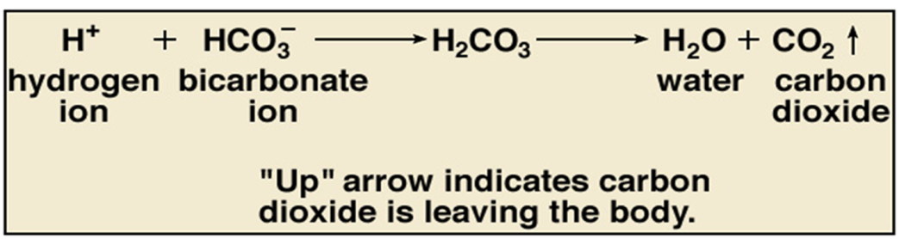

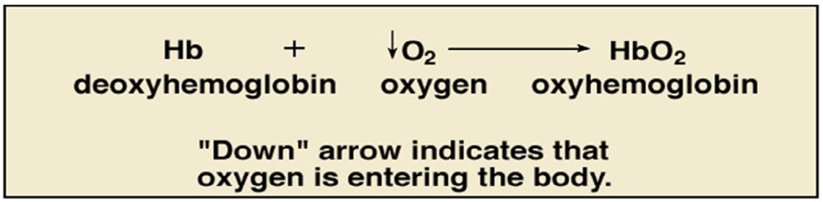

Internal respiration - the exchange of gases between the blood and the systemic tissues. This involves the same processes as external respiration.

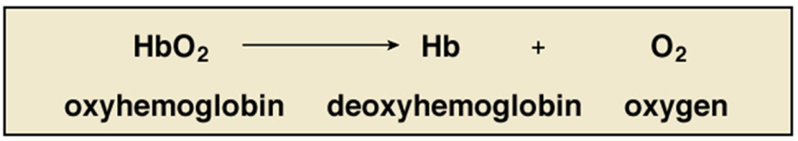

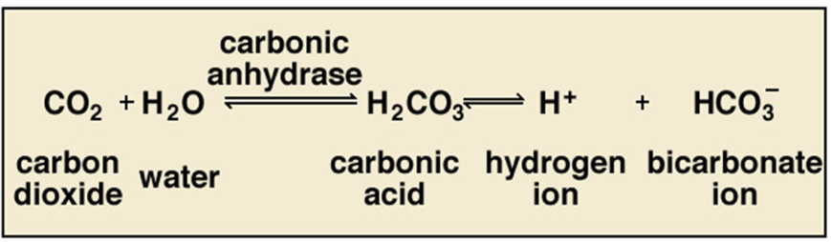

Cellular respiration - the includes the metabolic pathways which utilize oxygen and produce carbon dioxide, which will not be included in this unit.

The Respiratory System

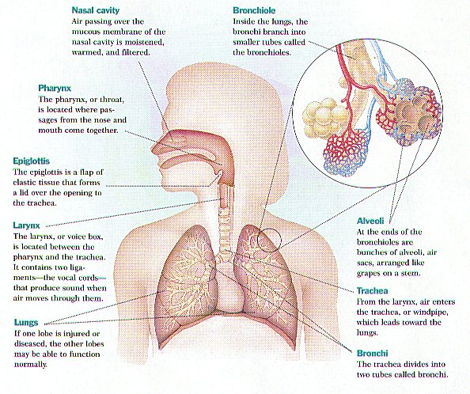

Airways

The airways are pipes that carry oxygen-rich air to the lungs. They also carry carbon dioxide, a waste gas, out of the lungs. The airways include the:

• Nose and linked air passages (called nasal cavities)

• Mouth

• Larynx, or voice box

• Trachea, or windpipe

• Tubes called bronchial tubes or bronchi, and their branches

Air first enters the body through the nose or mouth, which wets and warms the air. (Cold, dry air can irritate the lungs.) The air then travels through the voice box and down the windpipe. The windpipe splits into two bronchial tubes that enter the lungs.

A thin flap of tissue called the epiglottis covers the windpipe when you swallow. This prevents food and drink from entering the air passages that lead to the lungs.

Except for the mouth and some parts of the nose, all of the airways have special hairs called cilia that are coated with sticky mucus. The cilia trap germs and other foreign particles that enter the airways when you breathe in air.

These fine hairs then sweep the particles up to the nose or mouth. From there, they're swallowed, coughed, or sneezed out of the body. Nose hairs and mouth saliva also trap particles and germs.

**Lungs and Blood Vessels**

The lungs and linked blood vessels deliver oxygen to the body and remove carbon dioxide from the body. The lungs lie on either side of the breastbone and fill the inside of the chest cavity. The left lung is slightly smaller than the right lung to allow room for the heart.

Within the lungs, the bronchi branch into thousands of smaller, thinner tubes called bronchioles. These tubes end in bunches of tiny round air sacs called alveoli

Each of these air sacs is covered in a mesh of tiny blood vessels called capillaries. The capillaries connect to a network of arteries and veins that move blood through the body.

The pulmonary artery and its branches deliver blood rich in carbon dioxide (and lacking in oxygen) to the capillaries that surround the air sacs. Inside the air sacs, carbon dioxide moves from the blood into the air. At the same time, oxygen moves from the air into the blood in the capillaries.

The oxygen-rich blood then travels to the heart through the pulmonary vein and its branches. The heart pumps the oxygen-rich blood out to the body. Muscles Used for Breathing

**What Happens When You Breathe?**

**Breathing In (Inhalation)**

When you breathe in, or inhale, the diaphragm contracts (tightens) and moves downward. This increases the space in the chest cavity, into which the lungs expand. The intercostal muscles between the ribs also help enlarge the chest cavity. They contract to pull the rib cage both upward and outward when you inhale.

As the lungs expand, air is sucked in through the nose or mouth. The air travels down the windpipe and into the lungs. After passing through the bronchial tubes, the air finally reaches and enters the alveoli (air sacs).

Through the very thin walls of the alveoli, oxygen from the air passes to the surrounding capillaries (blood vessels). A red blood cell protein called hemoglobin helps move oxygen from the air sacs to the blood.

At the same time, carbon dioxide moves from the capillaries into the air sacs. The gas has traveled in the bloodstream from the right side of the heart through the pulmonary artery.

Oxygen-rich blood from the lungs is carried through a network of capillaries to the pulmonary vein. This vein delivers the oxygen-rich blood to the left side of the heart. The left side of the heart pumps the blood to the rest of the body. There, the oxygen in the blood moves from blood vessels into surrounding tissues.

**Breathing Out (Exhalation)**

When you breathe out, or exhale, the diaphragm relaxes and moves upward into the chest cavity. The intercostal muscles between the ribs also relax to reduce the space in the chest cavity.

As the space in the chest cavity gets smaller, air rich in carbon dioxide is forced out of the lungs and windpipe, and then out of the nose or mouth.

**What Controls The Breathing?**

A respiratory control center at the base of the brain controls the breathing. This center sends ongoing signals down the spine and to the muscles involved in breathing.

These signals ensure the breathing muscles contract (tighten) and relax regularly. This allows the breathing to happen automatically, without you being aware of it.

To a limited degree, you can change the breathing rate, such as by breathing faster or holding the breath. The emotions also can change the breathing. For example, being scared or angry can affect the breathing pattern.

The breathing will change depending on how active you are and the condition of the air around you. For example, you need to breathe more often when you do physical activity. In contrast, the body needs to restrict how much air you breathe if the air contains irritants or toxins.

To adjust the breathing to changing needs, the body has many sensors in the brain, blood vessels, muscles, and lungs.

Sensors in the brain and in two major blood vessels (the carotid artery and the aorta) detect carbon dioxide or oxygen levels in the blood and change the breathing rate as needed.

Sensors in the airways detect lung irritants. The sensors can trigger sneezing or coughing. In people who have asthma, the sensors may cause the muscles around the airways in the lungs to contract. This makes the airways smaller.

Sensors in the alveoli (air sacs) can detect fluid buildup in the lung tissues. These sensors are thought to trigger rapid, shallow breathing.

Sensors in the joints and muscles detect movement of the arms or legs. These sensors may play a role in increasing the breathing rate when you're physically active.

**Human Circulatory System**

The circulatory system consists of blood, a heart, and blood vessels.

**Functions of the Circulatory System**

The circulatory system functions with other body systems to provide the following:

* **Gasses transported**: Oxygen is transported from the lungs to the cells. CO2 (a waste) is transported from the cells to the lungs.
* **Transport other nutrients to cells** - For example, glucose, a simple sugar used to produce ATP, is transported throughout the body by the circulatory system. Immediately after digestion, glucose is transported to the liver. The liver maintains a constant level of glucose in the blood.
* **Transport other wastes from cells** - For example, ammonia is produced as a result of protein digestion. It is transported to the liver where it is converted to less toxic urea. Urea is then transported to the kidneys for excretion in the urine.
* **Transport hormones** - Numerous hormones that help maintain constant internal conditions are transported by the circulatory system.
* Contains cells that fight infection
* Helps stabilize the pH and ionic concentration of the body fluids.
* It helps maintain body temperature by transporting heat. This is particularly important in homeothermic animals such as birds and mammals.

Thus ,the human circulatory system functions to transport blood and oxygen from the lungs to the various tissues of the body. The heart pumps the blood throughout the body. The lymphatic system is an extension of the human circulatory system that includes cell‐mediated and antibody‐mediated immune systems. The components of the human circulatory system include the heart, blood, red and white blood cells, platelets, and the lymphatic system.

**Heart**

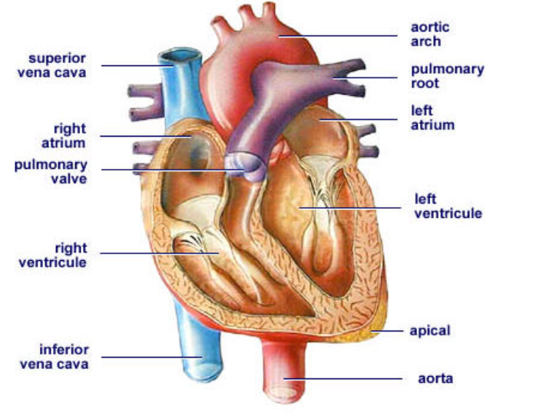

The human heart is about the size of a clenched fist. It contains four chambers**: two atria and two ventricles.** Oxygen-poor blood enters the right atrium through a major vein called the vena cava. The blood passes through the tricuspid valve into the right ventricle. Next, the blood is pumped through the pulmonary artery to the lungs for gas exchange. Oxygen-rich blood returns to the left atrium via the pulmonary vein.The oxygen-rich blood flows through the bicuspid (mitral) valve into the left ventricle, from which it is pumped through a major artery, the aorta. Two valves called semilunar valves are found in the pulmonary artery and aorta.

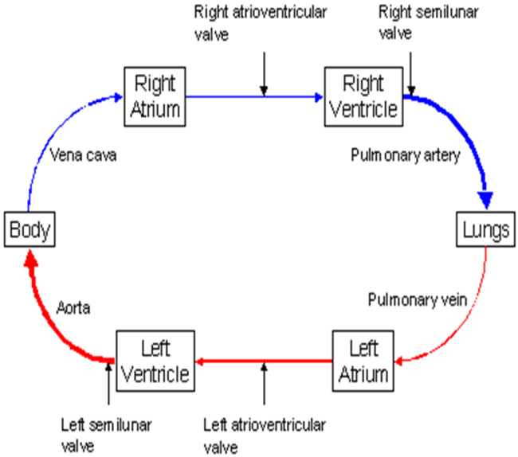

The heart is actually two separate pumps. The left side pumps blood to the body **(systemic circulation) and the right side pumps blood to the lungs (pulmonary circulation). Each side has an atrium and a ventricle**.

The atria function to receive blood when they are relaxed and to fill the ventricles when they contract.

The ventricles function to pump blood to the body (left ventricle) or to the lungs (right ventricle).

The ventricles contract about 70 times per minute, which represents a person's pulse rate. Blood pressure, in contrast, is the pressure exerted against the walls of the arteries. Blood pressure is measured by noting the height to which a column of mercury can be pushed by the blood pressing against the arterial walls. A normal blood pressure is a height of 120 millimeters of mercury during heart contraction ( systole), and a height of 80 millimeters of mercury during heart relaxation ( diastole). Normal blood pressure is usually expressed as “120 over 80.”

Coronary arteries supply the heart muscle with blood. The heart is controlled by nerves that originate on the right side in the upper region of the atrium at the sinoatrial node. This node is called the pacemaker. It generates nerve impulses that spread to the atrioventricular node where the impulses are amplified and spread to other regions of the heart by nerves called Purkinje fibers.

**Blood:** Human blood has two parts, liquid (plasma) and cells.

**Plasma:** Plasma contains dissolved gasses, nutrients, wastes, salts, and proteins.

Salts and proteins buffer the pH so that it is approximately 7.4 and they maintain osmotic pressure.

Plasma proteins also assist in transporting large organic molecules. For example, lipoproteins carry cholesterol and albumin carries bilirubin (produced from the breakdown of hemoglobin when old blood cells are destroyed).

**Red blood cells:** Red blood cells are erythrocytes. These are disk-shaped cells produced in the bone marrow. Red blood cells have no nucleus, and their cytoplasm is filled with hemoglobin.

Hemoglobin is a red-pigmented protein that binds loosely to oxygen atoms and carbon dioxide molecules. (Much carbon dioxide is transported as bicarbonate ions.) Hemoglobin also binds to carbon monoxide. Unfortunately, this binding is irreversible, so it often leads to carbon-monoxide poisoning.

A red blood cell circulates for about 120 days and is then destroyed in the spleen, an organ located near the stomach and composed primarily of lymph node tissue. When the red blood cell is destroyed, its iron component is preserved for reuse in the liver. The remainder of the hemoglobin converts to bilirubin. This amber substance is the chief pigment in human bile, which is produced in the liver.

**White blood cells:** White blood cells are referred to as leukocytes. They are generally larger than red blood cells and have clearly defined nuclei. They are also produced in the bone marrow and have various functions in the body. Certain white blood cells called lymphocytesare essential components of the immune system. Other cells called neutrophils andmonocytes function primarily as phagocytes; that is, they attack and engulf invading microorganisms. About 30 percent of the white blood cells are lymphocytes, about 60 percent are neutrophils, and about 8 percent are monocytes. The remaining white blood cells are eosinophils and basophils. Their functions are uncertain; however, basophils are believed to function in allergic responses.

**Platelets:** Platelets are small disk-shaped blood fragments produced in the bone marrow. They lack nuclei and are much smaller than erythrocytes. Also known technically asthrombocytes, they serve as the starting material for blood clotting. The platelets adhere to damaged blood vessel walls, and thromboplastin is liberated from the injured tissue. Thromboplastin, in turn, activates other clotting factors in the blood. Along with calcium ions and other factors, thromboplastin converts the blood protein prothrombin into thrombin. Thrombin then catalyzes the conversion of its blood protein fibrinogen into a protein called fibrin, which forms a patchwork mesh at the injury site. As blood cells are trapped in the mesh, a blood clot forms.

**Lymphatic system:** The lymphatic system is an extension of the circulatory system consisting of a fluid known as lymph, capillaries called lymphatic vessels, and structures called lymph nodes.Lymph is a watery fluid derived from plasma that has seeped out of the blood system capillaries and mingled with the cells. Rather than returning to the heart through the blood veins, this lymph enters a series of one-way lymphatic vessels that return the fluid to the circulatory system. Along the way, the ducts pass through hundreds of tiny, capsulelike bodies called lymph nodes. Located in the neck, armpits, and groin, the lymph nodes contain cells that filter the lymph and phagocytize foreign particles.

The spleen is composed primarily of lymph node tissue. Lying close to the stomach, the spleen is also the site where red blood cells are destroyed. The spleen serves as a reserve blood supply for the body.

The lymph nodes are also the primary sites of the white blood cells called lymphocytes. The body has two kinds of lymphocytes: B-lymphocytes and T-lymphocytes. Both of these cells can be stimulated by microorganisms or other foreign materials calledantigens in the blood. Antigens are picked up by phagocytes and lymph and delivered to the lymph nodes. Here, the lymphocytes are stimulated through a process called theimmune response.

**Sense Organs**

The sense organs — eyes, ears, tongue, skin, and nose — help to protect the body. The human sense organs contain sensory receptors that relay information through sensory neurons to the appropriate places within the nervous system.

Each sense organ contains different receptors.

**General receptors** are found throughout the body because they are present in skin, visceral organs (visceral meaning in the abdominal cavity), muscles, and joints.

**Special receptors** include chemoreceptors (chemical receptors) found in the mouth and nose, photoreceptors (light receptors) found in the eyes, and mechanoreceptors found in the ears.

Receptors responsible for general (somatic) senses: are classified in to the following types based on their location:

* EXTEROCEPTORS: Lie Close to the Body's Surface (Skin, Mucous Membranes, Connective Tissues), Respond to External Stimuli, Responsible for Hot, Cold, Pressure, pain, Touch
* VISCEROCEPTORS: Located Within the Viscera, Respond to Internal Stimuli, Responsible for Sensations in Organs: Hunger, Nausea, Thirst, Pain in Organs, etc.
* PROPRIOCEPTORS: (Special Type of Visceroceptors) Located in Muscles, Tendons, and Joints

**Touch**

The skin contains general receptors. These receptors can detect touch, pain, pressure, and temperature. Throughout the skin, you have all four of these receptors interspersed. Skin receptors generate an impulse when activated, which is carried to the spinal cord and then to the brain.

The skin is not the only tissue in the body to have receptors, however. The organs, which are made of tissues, also have receptors. Joints, ligaments, and tendons contain proprioceptors, which detect the position and movement of the limbs.

Receptors responsible for special senses are found in special sense organs such as Nose, Tongue, Ears, Eyes

**Types:**

* olfactory receptors
* taste buds
* hearing/equilibrium receptors
* vision receptors

**Smell/Olfaction:**

Olfactory cells line the top of the nasal cavity. On one end, olfactory cells have cilia — hair-like attachments — that project into the nasal cavity. On the other end of the cell, are olfactory nerve fibers, which pass through the ethmoid bone and into the olfactory bulb. The olfactory bulb is directly attached to the cerebral cortex of the brain.

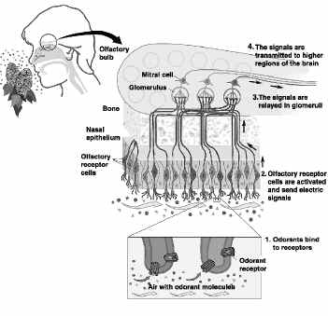

As you breathe, anything that is in the air that you take in enters the nasal cavity: hydrogen, oxygen, nitrogen, dust, pollen, chemicals. You don’t “smell” air or dust or pollen, but you can smell chemicals. The olfactory cells are chemoreceptors, which means the olfactory cells have protein receptors that can detect subtle differences in chemicals.

The chemicals bind to the cilia, which generate a nerve impulse that is carried through the olfactory cell, into the olfactory nerve fiber, up to the olfactory bulb and to the brain. The brain determines what you are smelling. If you are sniffing something that you haven’t experienced before, you need to use another sense, such as taste or sight, to make an imprint in the brain’s memory.

**Taste**

The senses of smell and taste work closely together. If you cannot smell something, you cannot taste it, either. Taste buds on the tongue contain chemoreceptors that work in a similar fashion to the chemoreceptors in the nasal cavity. However, the chemoreceptors in the nose will detect any kind of smell, whereas there are four different types of taste buds, and each detects different types of tastes: sweet, sour, bitter, and salty.

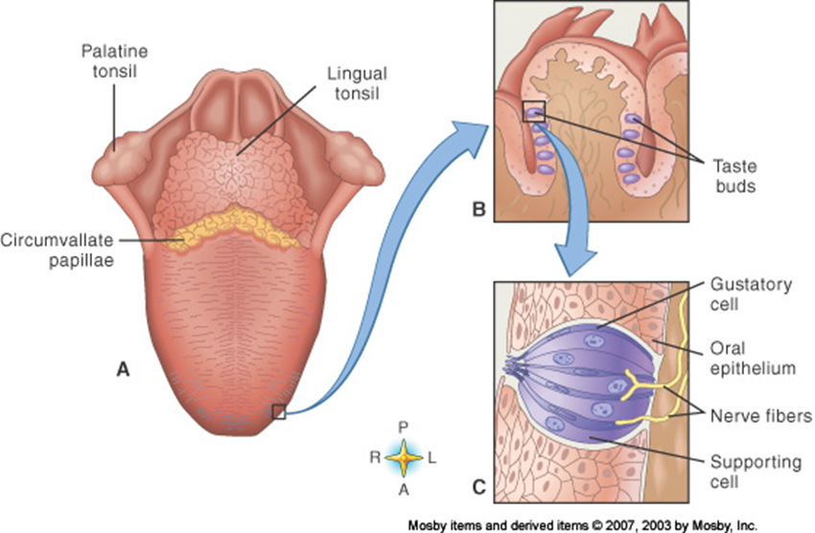

Foods contain chemicals, and when you put something into the mouth, the taste buds in the tongue can detect what chemicals you are ingesting. Each taste bud has a pore at one end with microvilli sticking out of the pore, and sensory nerve fibers attached to the other end. Chemicals from food bind to the microvilli, generating a nerve impulse that is carried through the sensory nerve fibers and eventually to the brain.

**Sound**

The ear not only is the organ of hearing, but it also is responsible for maintaining equilibrium — or balance. To maintain equilibrium, the ear must detect movement. To hear, the ear must respond to mechanical stimulation by sound waves.

The three structural divisions of the Ear are external ear, middle ear and inner ear.

External Ear:

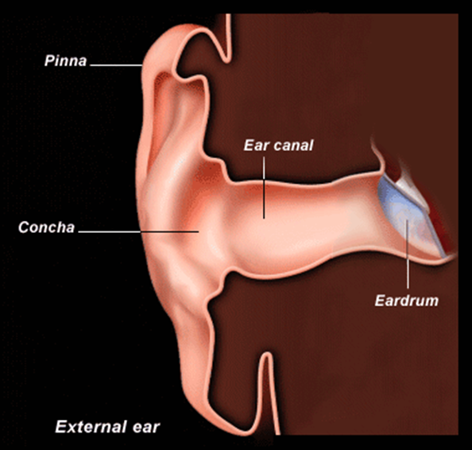

Auricle (pinna): appendage attached to the side of the head

External auditory meatus (Ear Canal): The external ear, which includes the pinna and ear canal, carries out two physiological functions: acoustic and non-acoustic

The external ear plays the role of an acoustic antenna: the pinna (together with the head) diffracts and focuses sound waves, the concha and the ear canal act as a resonator (the prolongation of sound by reflection; reverberation)

The protective function of the ear canal is related, in part, to its anatomical structure. The depth of the canal and its tortuous shape and rigid walls provides protections of the tympanic membrane (and the middle ear beyond) from direct injury.

Middle Ear/Ear Drum- Its function is to transmit sound from the air to the ossicles inside the middle ear, and then to the oval window in the fluid-filled cochlea. Hence, it ultimately converts and amplifies vibration in air to vibration in fluid

Inner Ear is Composed of Bone (Bony Labyrinth) and Membrane (Membranous Labyrinth)

Membranous Labyrinth is Located Within the Bony Labyrinth

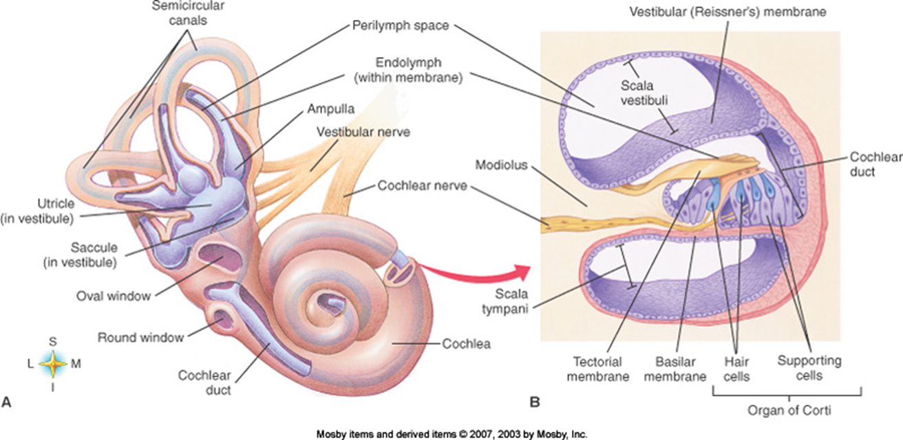

The two fluids that are secreted in the inner ear are **endolymph:** located within membranous labyrinth and **perilymph**: located between membranous and bony labyrinth

**Projection of Sound waves**

* Vibration Creates Sound Waves
* As Sound Waves Pass Through the External Ear, they Travel Through Air,
* As They Pass Through the Middle Ear,they Travel Through Bone, and
* As They Pass Through the Inner Ear They Travel Through Fluid
* Movement of the Fluid of the Inner Ear Stimulates the Hearing Receptors (mechano) in Cochlear Duct
* Once the Hearing Receptors are Stimulated, Nerve Impulses are Conducted Along Cranial Nerve VIII to the Auditory Area of the Cerebral Cortex for Interpretation

**Sight:**

There are two main areas to the eye – the front of the eye and the back, the eyeball. You can see these in the diagram below.

**The front of the eye**

The front of the eye is the bit you can see. A thin, clear, moist membrane called the conjunctiva coats the inner surfaces of the eyelids and the outer surface of the eye.

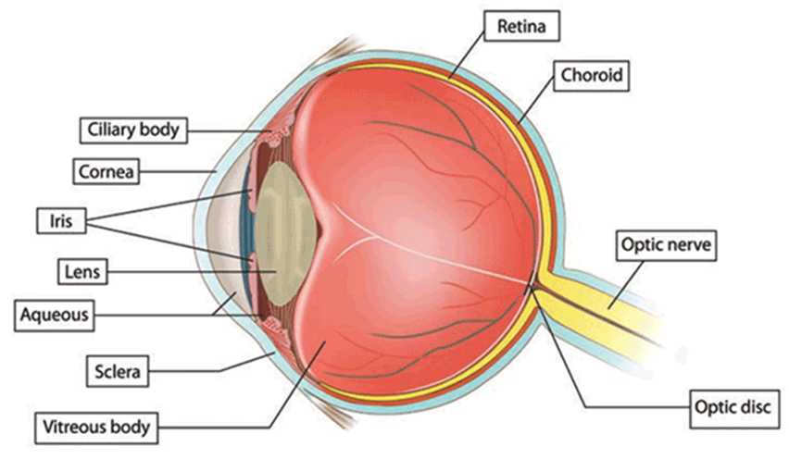

**The eyeball**

The eyeball has three layers sandwiched together:

* The outer white fibrous layer, the sclera
* The middle blood rich layer, the choroid
* The inner coloured (pigmented) layer, the retina

The inside of the eyeball is filled with a clear jelly like substance called vitreous humour. This, and the fibrous white sclera help to keep the shape of the eyeball.

The blood vessels that run through the choroid carry food and oxygen to the cells of the eye.

The retina lines the inside of the eyeball. This is the nerve layer of the eye. The cells of the retina react to light. They send messages to the brain through the optic nerve, making it possible for you to see.

The 3 layers of the eyeball continue round but they make up different structures in the front of the eye.

* The fibrous sclera becomes clear, instead of white. This part of it is called the cornea and covers the pupil and iris.
* The middle choroid layer becomes the iris and the ciliary body. The iris is the coloured part around the pupil that covers the lens of the eye. It controls how much light enters the eye.
* The ciliary body lies just behind the iris. It has two functions. It is the muscle that controls the focusing of the eye. And it makes the clear fluid (aqueous humour) that fills and shapes the front of the eye.

Vision Occurs in 3 Steps

1. FORMATION OF RETINAL IMAGE

2. STIMULATION OF RECEPTORS

3.CONDUCTION OF NERVE IMPULSES TO VISUAL CORTEX (CEREBRAL  
CORTEX

When you look at an eye, the iris is the colored part. The iris actually is a pigmented muscle that controls the size of the pupil, which dilates to allow more light into the eye or contracts to allow less light into the eye. The iris and pupil are covered by the cornea.

Behind the pupil is an anterior chamber. Behind the anterior chamber is the lens. The ciliary body contains a small muscle that connects to the lens and the iris. The ciliary muscle changes the shape of the lens to adjust for far or near vision. The lens flattens to see farther away, and it becomes rounded for near vision. The process of changing the shape of the lens is called accommodation. People lose the ability of accommodation as they grow older, prompting the need for glasses.

Behind the lens of the eye is the vitreous body, which is filled with a gelatinous material called vitreous humor. This substance gives shape to the eyeball and also transmits light to the very back of the eyeball, where the retina lies. The retina contains photoreceptors, which detect light.

Two types of sensors detect light:

* rods detect motion. the rods work harder in low light.
* cones detect fine detail and color. the cones work best in bright light. there are three types of cones: one that detects blue, one that detects red, and one that detects green. color blindness occurs when one type of cone is lacking.

When light strikes the rods and cones, nerve impulses are generated. The impulse travels to two types of neurons: first to bipolar cells and then to ganglionic cells. The axons of ganglionic cells form the optic nerve.

The optic nerve carries the impulse directly to the brain. Approximately 150 million rods are in a retina, but only 1 million ganglionic cells and nerve fibers are there, which means that many more rods can be stimulated than there are cells and nerve fibers to carry the impulses. The eye must combine “messages” before the impulses are sent to the brain.

**Special Biomolecules**

**Hormones:**

Hormone is a chemical messenger produced by a cell that effects specific change in the cellular activity of other cells (target cells). Unlike exocrine glands (which produce substances such as saliva, milk, stomach acid, and digestive enzymes), endocrine glands do not secrete substances into ducts (tubes). Instead, endocrine glands secrete their hormones directly into the surrounding extracellular space. The hormones then diffuse into nearby capillaries and are transported throughout the body in the blood.

The endocrine and nervous systems often work toward the same goal—both influence other cells with chemicals (hormones and neurotransmitters). However, they attain their goals differently. Neurotransmitters act immediately (within milliseconds) on adjacent muscles, glands, or other nervous cells, and their effect is short‐lived. In contrast, hormones take longer to produce their intended effect (anywhere from seconds to days); may affect any cell, nearby or distant; and produce effects that last as long as they remain in the blood (up to several hours).

Hormones can be chemically classified into four groups:

* Amino acid‐derived hormones are modified amino acids.
* Polypeptide and protein hormones are chains of amino acids of less than or more than about 100 amino acids, respectively. Some protein hormones are actually glycoproteins, containing glucose or other carbohydrate groups.
* Steroid hormones are lipids that are synthesized from cholesterol. Steroids are characterized by four interlocking carbohydrate rings.
* Eicosanoids are lipids that are synthesized from the fatty acid chains of phospholipids found in the plasma membrane.

**Mechanisms of hormone action**

Hormones circulating in the blood diffuse into the interstitial fluids surrounding the cell. Cells with specific receptors for a hormone respond with an action that is appropriate for the cell. Because of the specificity of hormone and target cell, the effects produced by a single hormone may vary among different kinds of target cells.

Hormones activate target cells by one of two methods, depending on the chemical nature of the hormone:

**Lipid‐soluble hormones** (steroid hormones and hormones of the thyroid gland) diffuse through the cell membranes of target cells. The lipid‐soluble hormone then binds to a receptor protein that in turn activates a DNA segment that turns on specific genes. The proteins produced as a result of the transcription of the genes and subsequent translation of mRNA act as enzymes that regulate specific physiological cell activity.

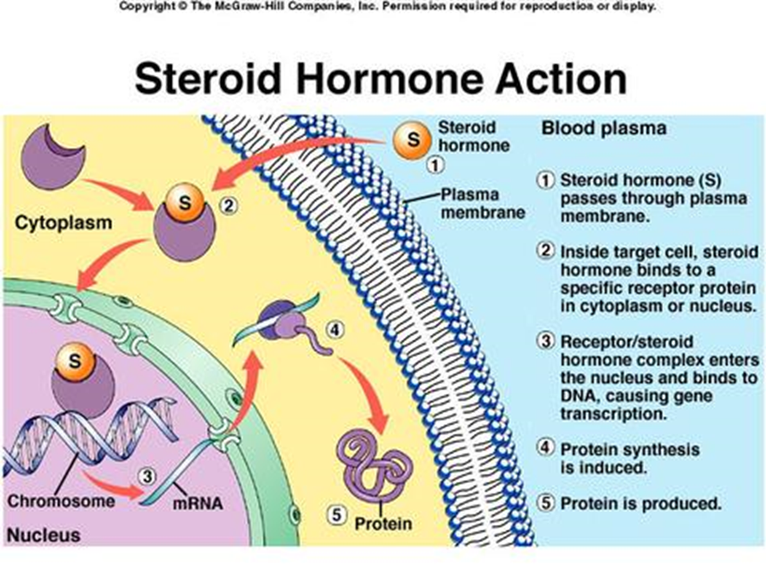

**Water‐soluble hormones** (polypeptide, protein, and most amino acid hormones) bind to a receptor protein on the plasma membrane of the cell. The receptor protein in turn stimulates the production of one of the following second messengers:

* Cyclic AMP (cAMP) is produced when the receptor protein activates another membrane‐bound protein called a G protein. The G protein activates adenylate cyclase, the enzyme that catalyzes the production of cAMP from ATP. Cyclic AMP then triggers an enzyme that generates specific cellular changes.

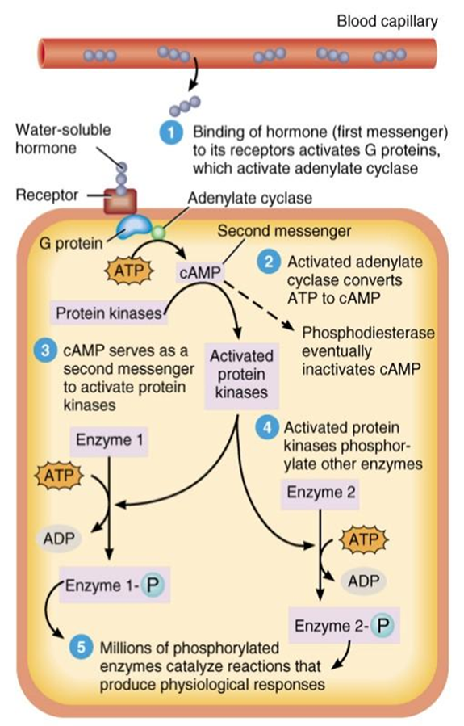

* Inositol triphosphate (IP 3) is produced from membrane phospholipids. IP 3 in turn triggers the release of Ca 2+ from the endoplasmic reticulum, which then activates enzymes that generate cellular changes.

**Control of hormone production**

Endocrine glands release hormones in response to one (or more) of the following stimuli:

* Hormones from other endocrine glands
* Chemical characteristics of the blood (other than hormones)
* Neural stimulation

Most hormone production is regulated by a negative feedback system. The nervous system and certain endocrine tissues monitor various internal conditions of the body. If action is necessary to maintain homeostasis, hormones are released, either directly by an endocrine gland or indirectly via the action of the hypothalamus of the brain, which stimulates other endocrine glands to release hormones. The hormones activate target cells, which initiate physiological changes that adjust body conditions. When normal conditions have been restored, the corrective action (the production of hormones) is discontinued. Thus, in negative feedback, when the original (abnormal) condition has been repaired, or negated, corrective actions decrease or are discontinued. For example, the amount of glucose in the blood regulates the secretion of insulin and glucagons through negative feedback.

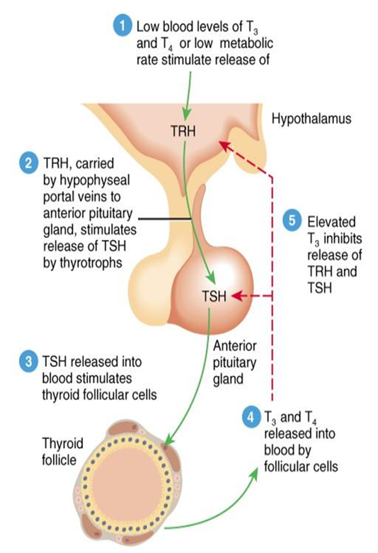

The production of some hormones is regulated by positive feedback. In such a system, hormones cause a condition to intensify (rather than decrease). As the condition intensifies, hormone production increases. Such positive feedback is uncommon but does occur during childbirth (hormone levels build with increasingly intense labor contractions) and lactation (where hormone levels increase in response to nursing, which causes milk production to increase).

**Antibiotics:**

Antibiotics are products of microorganisms that react with and inhibit the growth of other microorganisms. An antibiotic should be selectively toxic to pathogenic microorganisms, should not incite an allergic response in the body, should not upset the normal microbial population of various body sites, and should not foster the development of drug resistance.

Antibiotics that kill bacteria are called "bactericidal"

Antibiotics that stop the growth of bacteria are called "bacteriostatic"

The following are the different classes of antibiotics

* β-Lactam antibiotics. examples: penicillins (e.g. amoxicillin), cephalosporins, carbapenems,
* Tetracyclines . example: tetracycline
* Macrolide antibiotics. example: erythromycin
* Aminoglycosides. examples: Gentamicin, Tobramycin, Amikacin
* Quinolones . example: Ciprofloxacin (a fluoroquinolone)
* Cyclic peptides. examples: Vancomycin, Streptogramins, Polymyxin
* Lincosamides. example: clindamycin
* Oxazolidinoes. example: Linezolid (Zyvox)
* Sulfa antibiotics. example: sulfisoxazole

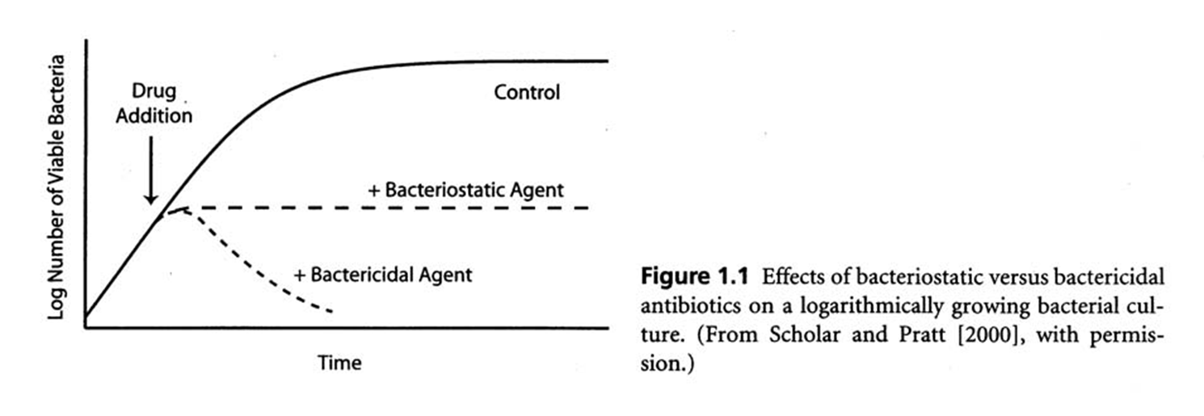

Antibiotics work by blocking vital processes in bacteria, killing the bacteria, or stopping them from multiplying. This helps the body's natural immune system to fight the bacterial infection.

Antibiotics differ in the types of bacteria they work against.

Antibiotics that affect a wide range of bacteria are called broad spectrum antibiotics (e.g. amoxycillin and gentamicin).

Antibiotics that affect only a few types of bacteria are called narrow spectrum antibiotics (e.g. penicillin).

Different types of antibiotics work in different ways. For example, penicillin destroys bacterial cell walls, while other antibiotics can affect the way the bacterial cell works.

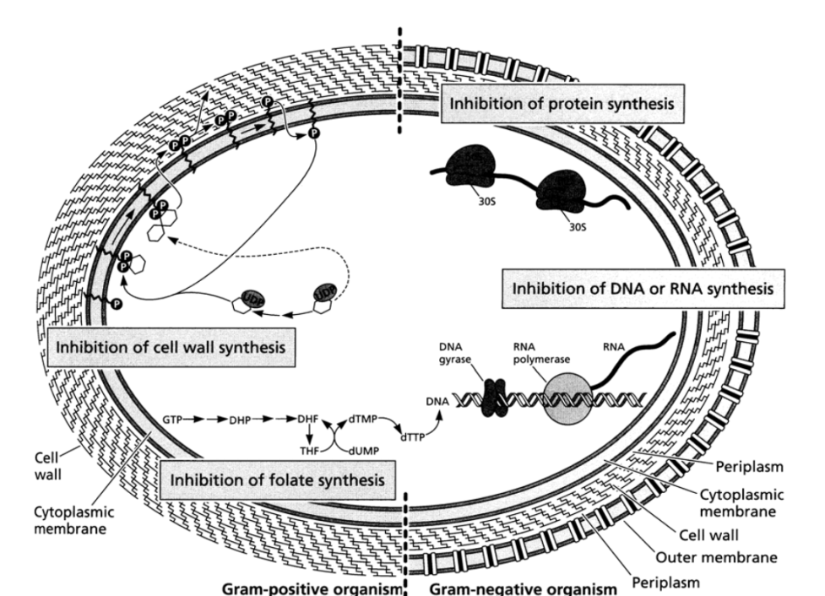

The term “vitamin” is used to describe certain organic compounds that are needed by the body but that cannot be manufactured by the body. They mainly serve as catalysts for certain reactions in the body. The amounts of vitamins required are very small, perhaps hundredths of grams. Vitamins are mainly obtained from our foods.

**CLASSIFICATION OF VITAMINS**

Based on solubility Vitamins are classified as either fat-soluble (lipid soluble) or water-soluble. Vitamins A, D, E and K are fat-soluble Vitamin C and B is water soluble.

**B-COMPLEX VITAMINS**

Eight of the water-soluble vitamins are known as the vitamin B-complex group: thiamin (vitamin B1), riboflavin (vitamin B2), niacin (vitamin B3), vitamin B6 (pyridoxine), folate (folic acid), vitamin B12, biotin and pantothenic acid. TheB vitamins are widely distributed in foods and their influence is felt in many parts of the body. They function as coenzymes that help the body obtain energy from food. The B vitamins are also important for normal appetite, good vision, and healthy skin, nervous system, and red blood cell formation.

**THE FAT-SOLUBLE VITAMINS**, A, D, E, and K, are stored in the body for long periods of time and generally pose a greater risk for toxicity when consumed in excess than water-soluble vitamins. Eating a normal, well-balanced diet will not lead to toxicity in otherwise healthy individuals. However, taking vitamin supplements that contain megadoses of vitamins A, D, E and K may lead to toxicity. The body only needs small amounts of any vitamin. While diseases caused by a lack of fat soluble vitamins are rare symptoms of mild deficiency can develop without adequate amounts of vitamins in the diet. Additionally, some health problems may decrease the absorption of fat, and in turn, decrease the absorption of vitamins A, D, E and K.